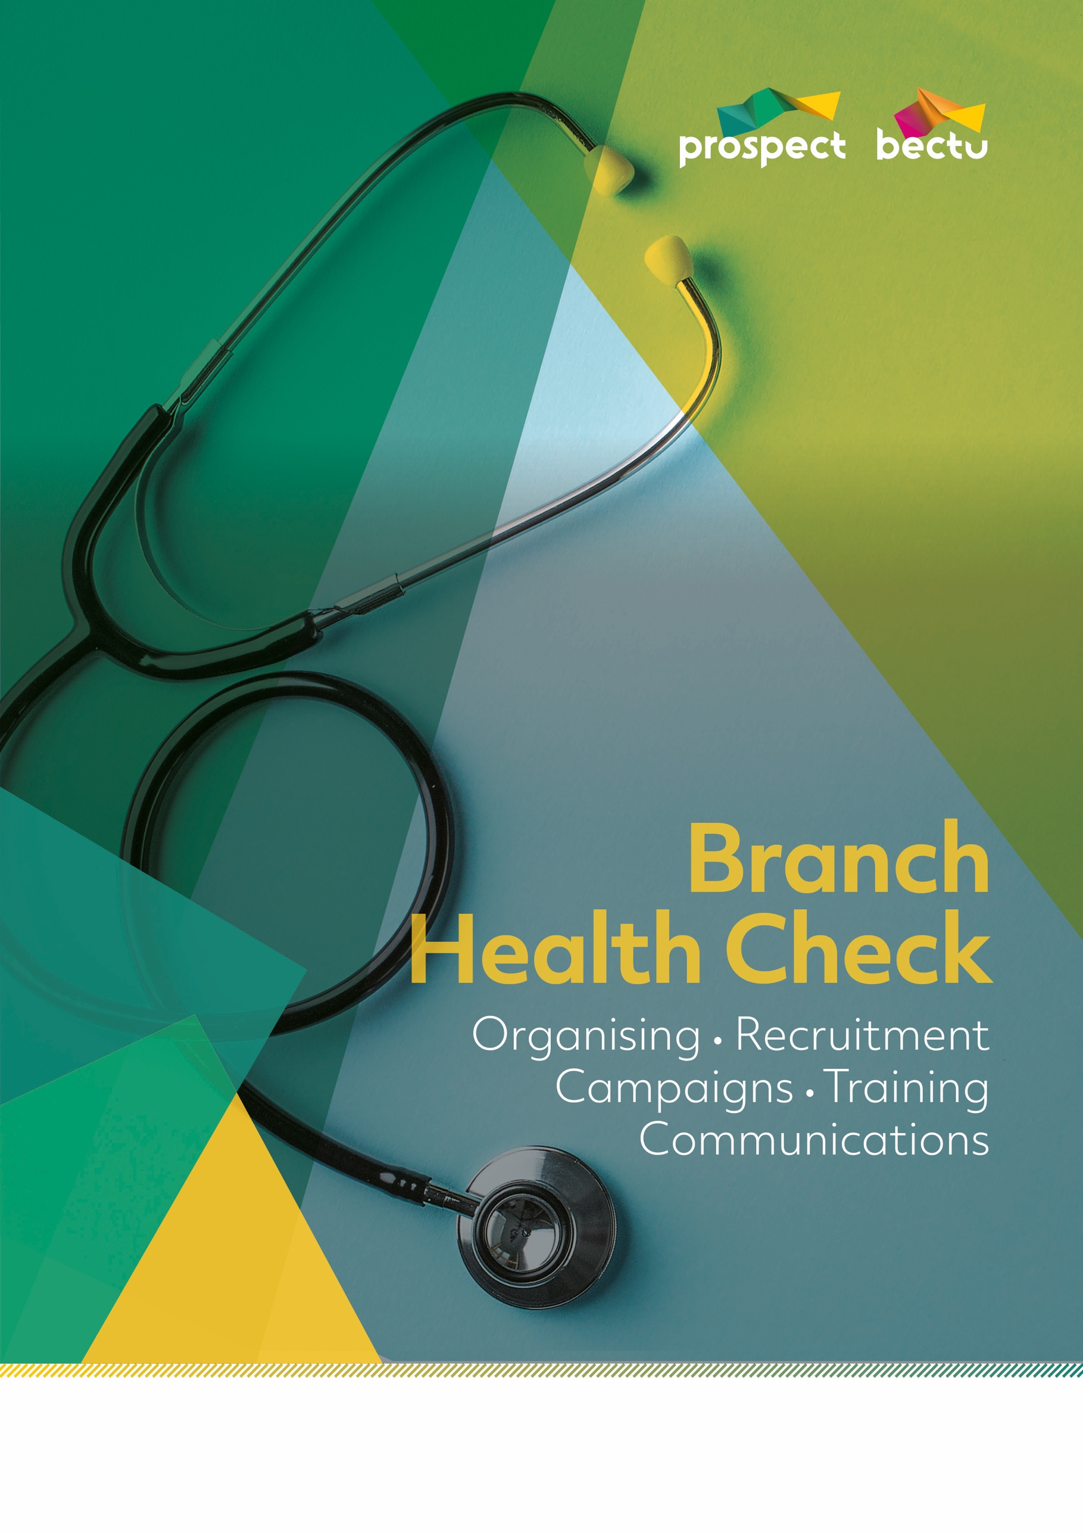
Branch name:
How many different sites does your branch cover?
Do you have a Rep/s active on every site and section?

Are the following posts filled?

Chair/Convener
Vice-Chair/Convener
Secretary
Treasurer
Health and Safety Rep
Equality Rep
Environment Rep
Pensions Rep
Young Workers Rep
Communication Rep
Membership
and Recruitment Secretary/Branch Organiser
Union Learning Rep
Other

Has your branch been successful at encouraging new reps to come forward?
Do you have job descriptions for each role?
Do you hold regular BEC meetings? How often?

Do you hold an annual AGM/BADC? What are your views on the format and attendance?

What are your branch priorities at the moment?

What are your digital priorities?

How many employees are there within your organisation?
How many are Prospect members?
What is the potential membership figure?
Have you noticed any trends in membership, and any reason/s for an increase or decrease in membership?

Are there any target areas/grades/workplaces for improvement?

Have you carried out a branch mapping exercise? If so, how recently was this?

Did you use the opportunity to update membership contact details?

How often do you hold membership and recruitment events?

How do you engage with new entrants? (eg induction presentation, recruitment literature in induction packs, local reps approach new entrants directly)

What activities/events/incentives does the branch employ to recruit new members?
What has been particularly successful/unsuccessful?



How confident does your branch feel in the following areas?
Handling personal cases
Handling cases of bullying and harassment
Recruiting new members
Branch communications (eg social media, newsletters)
eBranch
Negotiating with the employer
Employment law
Promoting equality and tackling discrimination
Health and safety
Pensions
Environment, greening your workplace and corporate social responsibility (CSR)
The union learning agenda
Mapping your branch
Presentation skills
Are there any specific training requirements (for the branch and/or individual reps)?



Are all the noticeboards updated with posters, leaflets, contact details and membership forms?

How often do you refresh your noticeboards?
What digital alternatives do you have to physical means of visibility like noticeboards?

Do you have a branch leaflet? If so, does it need updating?

Do you hold regular open/all-member meetings or events? What format are these events?

Do you hold regular members’ advice surgeries?
Do you hold branch social events?
Do you have an eBranch? How frequently does it get updated?

How many members are registered on your eBranch?
How many members have registered emails?
Have you undertaken any work to increase the number of members with registered emails and web access?

Do you issue a regular newsletter?
Does the branch use the bulk email feature to issue email updates and circulars?
Have you undertaken a branch membership survey?


Are there any current campaigning issues?

Have you undertaken any campaigns recently?

How has the branch used local campaigning issues as a recruitment ‘hook’?



