GROW

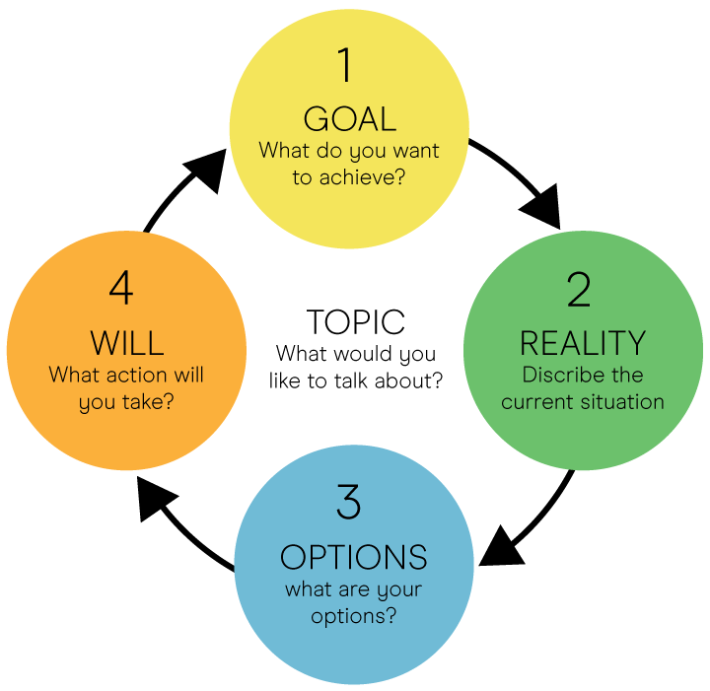

Goal
What do you want to achieve?

Reality
What do you want to change?
Why is this an issue now?
What is working well that you want to keep?
What have you tried?
What are the challenges you expect to meet?
What will be crucial to success?

Options
How would you start?
Have you approached a similar situation before?
In what ways are you limiting your options?
Check back to your goal – what else would you need to do?

Will
From your list of options, which one really jumps out at you?
Which option would have the most impact?
What actions will you take?
How are you going to take that action?
When will you take that action?
What support do you need?
On a scale of 1 to 10 how committed are you to this action?
What would need to happen for this to be a 10?
Opportunities
What are your goals?

External

Internal

Positive

Negative

Threats
What are your obstacles?
Weaknesses
What could you improve?
Strengths
What do you do well?

ROAR

- Right now
What do you specifically want to focus on?
- Options
What are they? What are the upsides and downsides of each. What is your preferred option and why?
- Action
What will be your first step (when, who, where – be specific). What subsequent actions will you need to take? How committed are you on a scale of 1-10 to taking these actions? What would make it a 10?
- Results
What is the desired outcome and how will you know when you have been successful?

