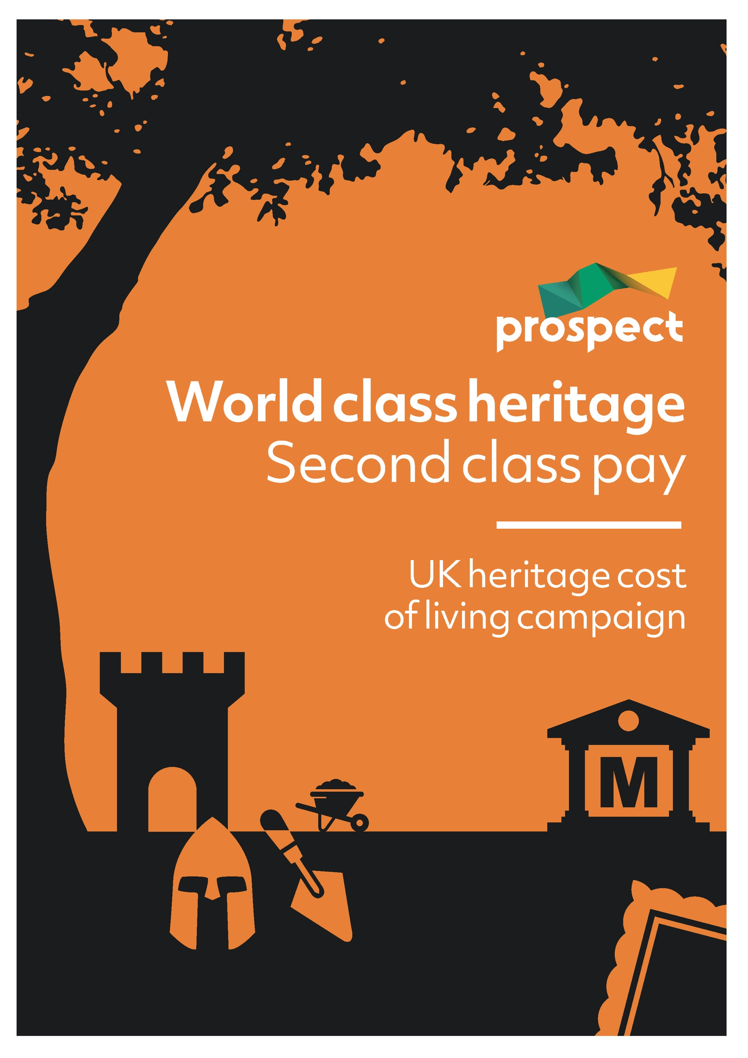
Research briefing

@ProspectEconom www.prospect.org.uk

June 2022

World class heritage
– second class pay

Prospect is proud to represent more than 10,000 professional and specialist members working in the heritage sector in areas such as curatorial, conservation, archaeology and visitor services. They work in museums and galleries, historic gardens, heritage sites, archaeological trusts, natural heritage, unique library collections and historic records.
The contribution they make to our society and our economy is immense. But problems of endemic low pay in the sector mean that the cost-of-living crisis they now face is especially acute.

Why heritage matters
Heritage makes a unique and vital contribution to our society and our economy. Numerous studies have confirmed its importance for health and wellbeing, community cohesion, child development and education, raising growth and productivity, and “levelling up” living standards and quality of life across the country. For example:
- a study of cultural engagement in Scotland found that people attending museums or libraries were around 20 per cent more likely to report good health
- another study found that the positive mental health aspects of visiting museums and heritage sites was most pronounced in areas of high deprivation
- a comprehensive review of evidence found that “historic places and assets, and interventions associated with them, can have a wide range of beneficial impacts on the physical, mental and social wellbeing of individuals and communities”
- 80 per cent of people agree that heritage sites and projects make their town or city a better place to live. Key benefits included “supporting local economies, making local areas more physically attractive, encouraging local pride, and increasing social cohesion.”
Prior to the Covid 19 pandemic, the heritage sector was contributing £14.7bn in direct Gross Value Added to the UK economy – more than agriculture or pharmaceutical manufacturing, and only slightly less than total film and TV production or the entire car industry. In a single year (2015) UK heritage attracted 13.2 million international tourists, spending a total of £7.4.bn.
If indirect and induced impacts are added in, total GVA rises to £36.6bn. Funding for heritage has been found to have particularly high “multiplier” effects. For example:
- on average, £1 of public sector expenditure on heritage-led regeneration generates £1.60 additional economic activity over a ten-year period
- a Transparent Economic Assessment model revealed that grants made from the National Lottery Heritage Fund generated a return of over three times what was originally invested
- a 2013 study by Oxford Economics found that the British Library delivers economic value of £5 for every £1 invested
- for every £1 spent in on Local Authority Planning Archaeology, the local economy benefits from an average return of £15
These impacts are especially important to areas of the country where heritage makes a particularly valuable contribution to local and regional economies, such as the North East, Wales, and Scotland.
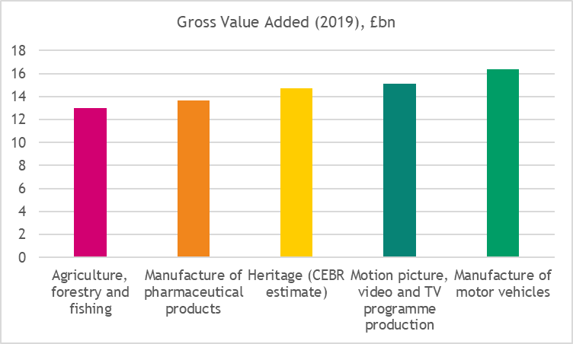
Source: Office for National Statistics; Centre for Economics and Business Research

Our heritage workforce
All these benefits are made possible by the dedication and world-leading expertise of heritage sector workers.
It has been estimated that in 2016 the average heritage worker produced around £67,000 a year in Gross Value Added (GVA) contributions - 61% higher than the UK non-financial sector average. That figure is likely to be even higher today.
Key elements of this workforce include:
- archaeologists
- archivists
- conservators and curators
- botanists and horticulturalists
- education and outreach specialists
- others working at museums, heritage sites and historic gardens, from front-of-house staff to essential technicians
- surveyors, technicians, architects and other specialists supporting heritage projects
They work across a range of different kinds of organisations, large and small, in the public, private and voluntary sectors.
Many of these workers have high-level qualifications, and all have skills and expertise that the sector relies on. But levels of pay in the sector are far from high.
- The Museums Association has described pay in museums as “notoriously low”. Its latest guidelines (published in 2017) put the median wage for Assistant Conservators at £21,303, and for Assistant Curators at £20,395
- The Chartered Institute for Archaeology has stated that “the problem of low pay has the potential to critically impact professional standards”. Starting salaries in the sector are reported to range from £21,000 to £25,000, with senior salaries at £32,000 to £41,000
- The ICON review of Conservators’ salaries found the average salary for all survey respondents, 77 per cent of whom had a Master’s Degree or PhD, was £31,814. 20 per cent of respondents earned less than £25,000
Examples of currently advertised roles in the heritage sector include:
- Learning Volunteer Coordinator at Science Museum London, “responsible for the recruitment and managers of groups of volunteers” with “experience of recruiting and managing a diverse range of volunteers”: £25,000
- Indoor Horticulturalist at Royal Botanic Gardens Edinburgh, “responsible for the maintenance and cultivation of some of RBGE’s research and conservation collections”, with “recognised horticultural qualification at SVQ or higher or equivalent work experience”: £21,213 pro rata
- Senior Collections and House Officer at National Trust Cragside – a “senior leadership role” for an “experienced people manager” with “operational experience of collections management and preventative conservation in a historic environment”: £26,000
- Volunteer Supervisor at Eltham Palace, with “relevant supervisory experience of a large team along with recruitment experience” and “experience of designing and delivering training programmes”: £21,965
- Visitor Experience Team Member at York Museums Trust, “involved in different aspects of the visitor experience; including interacting with visitors on galleries, delivering entertaining talks and tours, ticket sales and retail as well as providing information, supporting events and ensuring the safety of our visitors and security of our buildings and collections”: £19,100 (fte)
- Assistant Inspector of Ancient Monuments at Historic England, with degree in Archaeology and “experience of managing change to archaeology and ancient monuments, including through the planning system”: £32,488
- Contact Centre Advisor, V&A: £20,686 pro rata
- Assistant Curator of Science and Antiquities at Museum of Liverpool, with “broad knowledge of science or horology” and “experience of using and updating collections management systems and a good understanding of museum documentation policies and standards”: £24,896
- Site Manager at Richmond Castle, responsible for “optimising every opportunity to generate income, achieving all site performance targets, including retail, through target setting, training and coaching your team in active selling” as well as “engaging the local community with what’s happening on site as well as ensuring that the site itself and its assets are safe and secure”: £21,548
- Front of House Assistant, V&A: £11 per hour
- Hands On History Crew, Stonehenge: £9.88 per hour
Most of these salaries are well below the UK national median full-time salary for 2021 of £31,285; all are below the UK national mean full-time salary of £38,131. Some are below the independently calculated National or London Living Wage (£9.90 and £11.05). In some cases workers undertaking these roles would qualify to claim in-work Universal Credit, particularly those with children and/or without a higher-earning partner.
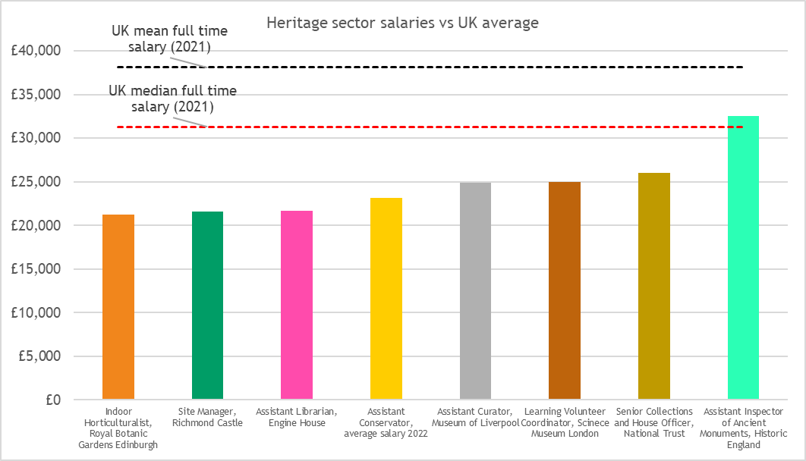
Source: industry surveys and currently advertised vacancies

“I have been employed … in a full-time role for the last two years, working hands-on with their amazing collection, installing shows and working on their extensive loans programme. I am very proud to work in one of London's most renowned and visited institutions. However, my salary .. equates per hour to less than the London Living Wage) feels increasingly inadequate.”
- Heritage worker, London
“I have seen first-hand staff have to leave the unit or the industry all together as they cannot afford rents in the area. We had a trainee leave because all they could afford in the area was a room in a house share that was riddled with damp.”
- Heritage sector supervisor, South East
“I have … been informed that the colleagues have been receiving benefits for years (£300-£400 a month) despite being within the job for over a decade and in full time employment”
- Heritage worker, London
“Low pay” is typically defined by statisticians and policymakers as two-thirds of median pay. Official data suggests that last year this would have stood at around £9.40 per hour gross pay, and that on this basis
- more than one in five jobs at botanical and zoological gardens and nature reserves (over 4,200 in total) were low-paid, paying just £9.16 an hour or less
- one in ten museum jobs – around 2,700 in total – paid £9.50 an hour or less, suggesting that most of these would count as officially low paid
- one in five jobs at historical sites and buildings – around 2,400 in total – paid £9.60 or less, suggesting that many of these were low paid

Recent trends in heritage sector funding and pay
The UK heritage sector has been under significant financial pressure for much of the past decade. Factors have included:
- cuts to government funding – for example, a 15 per cent cut to DCMS funding for national museums between 2010 and 2014 and further in subsequent years. and a 27 per cent cut in local authority funding for museums between 2010 and 2020
- cuts to funding for English Heritage and Historic England funding that have left it “hopelessly overstretched”

- the impact of the Covid-19 pandemic and associated opening and travel restrictions on heritage sector revenues. Academic research has found that key heritage sectors including museums, botanical and zoological gardens, and historical sites and buildings were among the worst-hit sectors of the economy, with drops in activity of 20 to 40 per cent in 2020
Earnings have been stagnating in real terms for most of the UK workforce over the past decade. However ONS data indicates that heritage sector occupations or areas of employment, where these can be isolated, have suffered particularly sharp falls, in many cases falling below the UK median during this period. For example
- Average hourly pay for “Archivists and curators” fell 18 per cent from £19.75 (in today’s money) in 2011 to £16.23 in 2021
- Average hourly pay for “Conservation professionals” fell 25 per cent from £19.35 (in today’s money) in 2011 to £14.43 in 2021
- Average hourly pay for museum workers fell 9 per cent from £14.86 (in today’s money) in 2011 to £13.49 in 2021
The only exception to this are those employed in the “Operation of historical sites and buildings and similar visitor attractions” – as these are the lowest paid, it seems likely that this is because of the impact of rises in the statutory National Living Wage, which has pushed up earnings in the very lowest-paid occupations relative to others over the past decade.
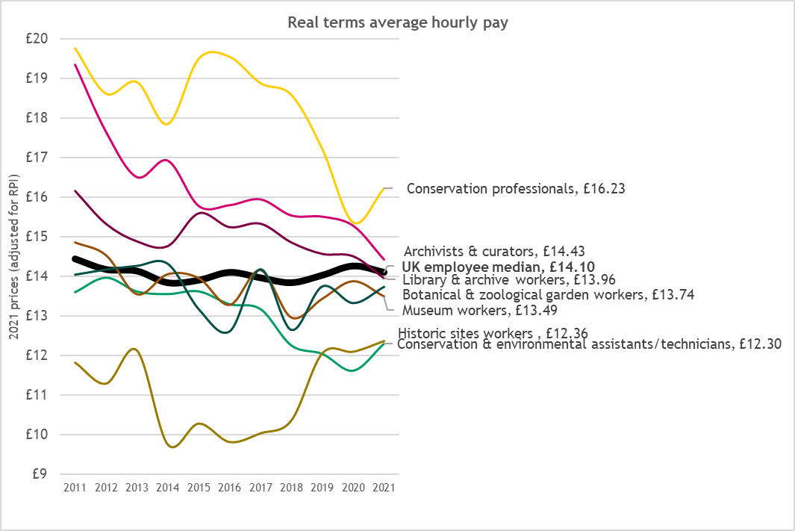
Source: Prospect analysis of ONS earnings data
These trends have contributed to high turnover, staff and skill shortages, and rising workloads across the sector.
“By necessity I have been looking at other positions and opportunities- I find this stressful as I genuinely enjoy what I do, but it doesn't appear financially viable … We have lost 4.5 curators from our team since the start of the Covid pandemic, through voluntary exit/ early retirement, completion of major projects and career progression. It has been made apparent due to lack of resources, these roles will not be replaced, but the demands on the team's resources, and workload has not changed accordingly.”
- Heritage worker, London
“I've noticed that proportionately people are having to have injury time off site a lot more frequently: I know fieldwork is a physical job but I suspect it's because our existing field team are overworked.”
- Heritage worker, South East

The outlook for 2022
The cost-of-living is now increasing at rates not seen in the UK for decades. The Bank of England has forecast CPI inflation to reach 10 per cent this year; RPI inflation, typically 2 per cent or more higher than CPI, will likely be even more. The latest data from the ONS showed that already in May CPI had reached 9.1 per cent, and RPI 11.7 per cent.
The impact of such inflation rates on the living standards of heritage workers will be severe. For example:
- a senior Archaeologist earning the minimum recommended salary of £31,600 faces a fall in the real value of their salary to around £28,500, a loss of around £3,000
- a Conservator earning a typical salary of £28,630 faces a fall in the real value of their salary to around £26,000, a loss of around £2,750
- a Science Museum Learning Volunteer Coordinator earning the currently advertised salary of £25,000 faces a loss in the real value of their salary to around £22,500, a loss of around £2,500
- an entry-level Archaeologist earning a salary of £21,000 faces a fall in the real value of their pay to around £19,000, a loss of around £2,000
Even these figures understate the impact on some people, with poorer households facing effective inflations rates of up to 2 per cent more than the headline measure because they spend a larger part of their income on items like food and fuel.
The effect of accelerating inflation will be compounded for most heritage workers this year by changes to tax and National Insurance rates and, for some, policies on Universal Credit and other benefits:
- Additional employee National Insurance Contributions of 1.25% equate to more than £200 a year for those on median full-time salaries, and around £100 a year for those on around £20,000 a year
- Those receiving Tax Credits or Universal Credit will see a fall in the real terms value of their entitlement (against CPI) of 4.2 per cent or more, as a result of the Government’s decision to uprate benefits by just 3.1 per cent. For the average household in receipt of Universal Credit recipient this equates to around £7.50 a week, or £400 a year. This comes on top of the £20 a week cut to payments in October.
It remains to be seen how far heritage workers will be able to offset these impacts by bargaining for higher pay awards this year.
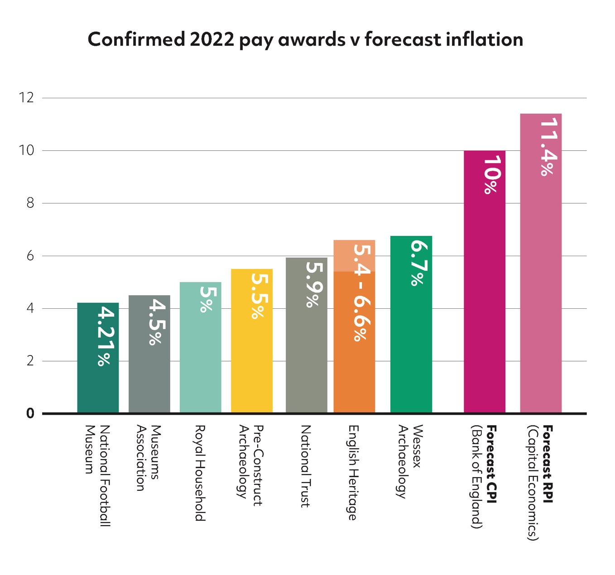
Independent labour market surveys indicate that average pay awards across the economy could be higher than usual this year. Prospect has been able to secure higher-than-usual pay awards for some heritage workers, in some cases above 5 per cent. However, these still fall well short of forecast inflation rates for the year of 10 per cent and above. They are also not likely to be matched in the many museums, galleries and other heritage sector employers covered by the Government’s civil service pay policy, which limits awards to 2 per cent (or 3 per cent if needed “to address specific priorities in their workforce and pay strategies”).
“I'm resigned to never being able to purchase a house on this income. My rents going up and utilities are too … I love doing this work but I don't see how it can be feasible long term and I'm required to start looking outside archaeology I think if I want to actually prosper.”
- Heritage worker, South East
“With the cost-of-living crisis it's hard to see how the archaeological sector is going to cope, the industry already has an acknowledged shortage of staff, if the staff we do have cannot afford food or decent accommodation and find higher paid work elsewhere”
- Heritage worker, South East
“colleagues are reporting to me that they are now skipping meals and are weighing up whether to commute to work or eat.”
- Heritage worker, London
“I have had to stop paying for counselling/therapy as I cannot afford this as well as putting food on the table ... The toll this has taken on my mental health is immense.”
- Heritage worker, Scotland

What Prospect is campaigning for
Prospect believes it is time we properly valued the experts and specialists who bring so much value to our lives and add so much value to our economy. This means:
- Greater value and recognition given to heritage and heritage workers, with improved funding to address historic low pay levels and the current cost-of-living crisis.
- Greater employer flexibility on pay, terms and conditions, to enable wages to better reflect skills, qualifications, knowledge and experience.
- Meaningful pay progression mechanisms to ensure heritage staff can progress their careers and earnings.
To find out more visit our website at https://prospect.org.uk/heritage/

Notes and references

https://gem.org.uk/our-work/value-of-heritage-education/
https://www.gov.scot/publications/healthy-attendance-impact-cultural-engagement-sports-participation-health-satisfaction-life-scotland/
https://bmjopen.bmj.com/content/11/9/e045512
https://whatworkswellbeing.org/wp-content/uploads/2020/01/heritage-briefing.pdf
https://www.heritagefund.org.uk/sites/default/files/media/attachments/20_years_in_12_places_main_report_0.pdf
https://historicengland.org.uk/content/heritage-counts/pub/2020/heritage-and-the-economy-2020/
https://www.ons.gov.uk/economy/grossvalueaddedgva/datasets/nominalandrealregionalgrossvalueaddedbalancedbyindustry
https://www.heritagefund.org.uk/sites/default/files/media/research/20160927_-_the_impact_of_heritage_tourism_on_the_uk_economy_-_final_repo.pdf
https://historicengland.org.uk/content/heritage-counts/pub/2020/heritage-and-the-economy-2020/
https://historicengland.org.uk/content/heritage-counts/pub/Impact-HE-Regeneration
https://www.heritagefund.org.uk/about/insight/evaluation/ten-years-impact-heritage-grants-programme-2002-2007
https://www.algao.org.uk/sites/default/files/documents/Archaeology_in_Development_Management.pdf
https://www.heritagefund.org.uk/sites/default/files/media/research/20160927_-_the_impact_of_heritage_tourism_on_the_uk_economy_-_final_repo.pdf
https://historicengland.org.uk/content/heritage-counts/pub/2020/heritage-and-the-economy-2020/; https://www.ons.gov.uk/economy/grossvalueaddedgva/datasets/nominalandrealregionalgrossvalueaddedbalancedbyindustry
https://historicengland.org.uk/content/heritage-counts/pub/2019/skill-gaps-needs-in-the-heritage-sector-pdf/
https://ma-production.ams3.digitaloceanspaces.com/app/uploads/2020/06/18145318/31102017-salary-guidelines-2017.pdf
https://www.prospects.ac.uk/job-profiles/archaeologist
https://www.icon.org.uk/resource/conservation-salaries-survey-2022.html
https://www.icon.org.uk/resource/conservation-salaries-survey-2022.html
https://www.sciencemuseumgroup.org.uk/work-for-us/
https://www.rbge.org.uk/about-us/working-with-us/vacancies/
https://careers.nationaltrust.org.uk/OA_HTML/a/#/vacancy-detail/120688
https://www.english-heritage.org.uk/about-us/jobs/job-search/default-job-page/?jobRef=14274
https://www.yorkmuseumstrust.org.uk/about-us/our-people/jobvacancies/
https://historicengland.org.uk/about/jobs/vacancies/job/?title=Assistant+Inspector+of+Ancient+Monuments&ref=10249
https://www.vam.ac.uk/vacancies
https://www.liverpoolmuseums.org.uk/jobs
https://www.english-heritage.org.uk/about-us/jobs/job-search/default-job-page/?jobRef=14271
https://www.vam.ac.uk/vacancies
https://www.english-heritage.org.uk/about-us/jobs/job-search/default-job-page/?jobRef=14252
https://www.ons.gov.uk/employmentandlabourmarket/peopleinwork/earningsandworkinghours/datasets/regionbyoccupation4digitsoc2010ashetable15
https://www.livingwage.org.uk/calculation
Add in web addresses here
See for example https://www.ons.gov.uk/employmentandlabourmarket/peopleinwork/earningsandworkinghours/bulletins/lowandhighpayuk/2020
https://www.ons.gov.uk/employmentandlabourmarket/peopleinwork/earningsandworkinghours/datasets/industry4digitsic2007ashetable16
https://www.museumsassociation.org/museums-journal/news/2010/10/20102010-comprehensive-spending-review-museums/
https://www.museumsassociation.org/museums-journal/news/2015/06/09062015-cost-cutting-measures-will-impact-museums/
https://www.museumsassociation.org/campaigns/advocacy/la-funding-report/
https://www.architectsjournal.co.uk/archive/english-heritage-very-disappointed-by-10-funding-cut
https://www.architectsjournal.co.uk/news/fears-for-built-heritage-as-historic-england-snubs-grade-ii-buildings
https://historicengland.org.uk/coronavirus/heritage-sector/survey/; https://committees.parliament.uk/writtenevidence/6909/pdf/
https://www.sheffield.ac.uk/news/covid-19s-impact-arts-culture-and-heritage-sector-revealed-landmark-report
https://www.ons.gov.uk/economy/inflationandpriceindices/timeseries/d7g7/mm23
https://www.ons.gov.uk/economy/inflationandpriceindices/timeseries/czbh/mm23
https://ifs.org.uk/publications/16058
https://www.resolutionfoundation.org/app/uploads/2022/03/Living-Standards-Outlook-2022.pdf
https://www.bankofengland.co.uk/monetary-policy-report/2022/may-2022; https://www.reuters.com/world/uk/uk-pay-settlements-heading-highest-since-2008-xperthr-2022-04-27/; https://www.incomesdataresearch.co.uk/resources/news/more-higher-end-rises-push-up-median-pay-rise; https://www.cipd.co.uk/knowledge/work/trends/labour-market-outlook
https://www.gov.uk/government/publications/civil-service-pay-remit-guidance-2022-to-2023/civil-service-pay-remit-guidance-2022-to-2023

