Reducing project Carbon Footprint
Redesign of a HVAC system to reduce cost and carbon footprint

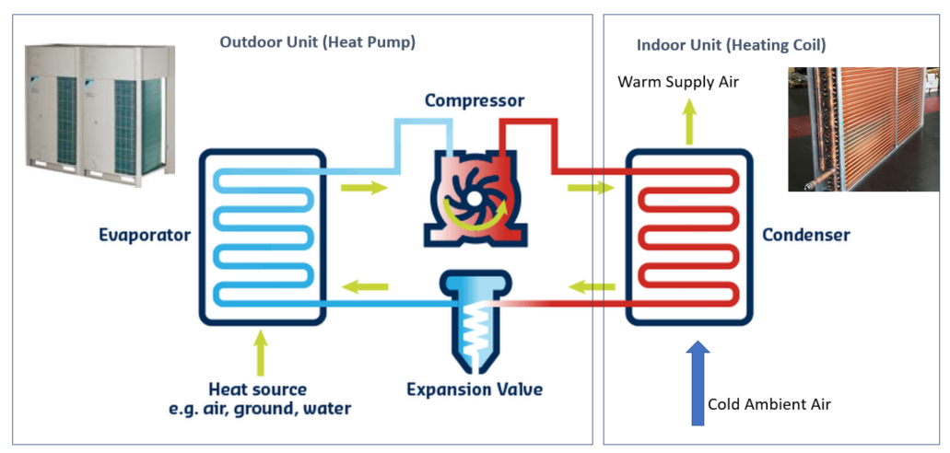

What is the Programme and Project Partners (PPP)?
Sellafield is home to the largest and most complex nuclear facility in the United Kingdom, and what was once the first commercial nuclear power station, is now cleaning up the birthplace of the UK’s nuclear industry. With an annual spend of £2.2bn, the UK Government expects Sellafield Ltd to deliver projects faster and provide better value for money for the taxpayer. In response, Sellafield Ltd created an industry-leading approach to procurement, forming the Programme and Project Partners (PPP). Sellafield Ltd has one of the most complex portfolios of construction projects in the world. In pursuit of its mission to create a clean and safe environment for future generations, PPP is responsible for delivering projects faster and with better value for money. The partnership brings together KBR, Jacobs, Morgan Sindall Infrastructure, Altrad Babcock and Sellafield Ltd, as one team, to deliver up to £7 billion of critical national infrastructure, differently, over a span of 20 years.

What was the challenge that needed to be solved?
The Box Encapsulation Plant Product Store No.2 (BEPPS2) and the Lightly Shielded Store No.1 (LSS1) facilities will operate for approximately 100 years and play a key role in Sellafield Ltd’s mission to create a clean and safe environment for future generations, therefore this influenced many of the expected project design decisions. Traditionally designs on the Sellafield site have utilised the steam mains for their heating, ventilation, and air conditioning (HVAC) systems; however this was identified as an inefficient supply source for energy utilisation and carbon emissions, particularly in getting the steam to the required pressure.

What was the goal or objective of the scheme?
The project teams set out to find innovative approaches to design that would improve the environmental footprint of the projects across their entire lifetime, to support the Sellafield and PPP net-zero carbon ambitions.

Who was involved?
The project design teams collaborated with other site teams and identified an opportunity to positively challenge the use of steam supply for future facilities and began to develop an improved system that stood up to our sustainability ambitions. The HVAC system for the facility inputs were considerably different from existing facilities on site, therefore design development was undertaken, and the team worked collaboratively to select the best solution for continual resilient operations.

What approach was taken?
Through rigorous engineering assessment and optioneering, the Direct Exchange (DX) Air Source heat pump system was selected as the preferred method of heating the facility. The design incorporated the use of heat recovery Air Handling Units to reduce energy consumption and reduce carbon impacts. The team challenged the requirements of the system, to develop and provide the most robust process and enable optimum operational performance.

This redesign will also provide the possibility of reskilling staff at Sellafield Ltd, as suppliers of the HVAC systems will train on-site teams to be able to undertake inspections, diagnostics and maintenance. This is a great success and creates new opportunities for Sellafield Ltd personnel to develop skills the industry needs now and in the future.

Were there any risks to overcome?
The use of Direct Exchange (DX) Air Source heat pump systems for a nuclear facility of this scale has been untested on the Sellafield site. As well as needing to substantiate the design, the teams needed to positively challenge the prevailing approach to design and influence the mindset that let the team explore new approaches that would benefit the facility.

What was the outcome?
A fresh approach to a new waste storage building HVAC system implementation is set to lead Sellafield Ltd to a substantially reduced carbon footprint, achieving up to a 75% reduction of the energy requirement compared to traditional approaches, equating to approximately 400 tCO2e (tonnes (t) of carbon dioxide (CO2) equivalent (e)) per year. The design team behind the new approach have calculated that this could also save up to £12m overall through heat recovery and reduced flow rates over the lifetime of the 2 BEPPS2 and LSS1.

