

Effective communication skills for union reps

Contents
Welcome to communication skills for union reps 4
Learning outcomes 4
Course timetable 4
Trade union terminology 6
About Prospect 7
What happens on trade union courses? 8
The tutor’s role 8
Your role 8
Using your knowledge and skills 9
Equality and diversity statement 10
Communicating the benefits of union membership 11
Session 1 12
Activity A – Introductions 12
Session 2 14
Activity B – Branch health check (pre–work) 14
Session 3 15
How Prospect communications work 15
How might a branch communicate to its members? 15
Why does it matter what branch you are in? 15
What communications happen when a new member joins Prospect? 16
Welcoming new members 16
Branch reps 18
Prospect structure of communications 18
Support for branches 19
Session 4 20
The communications roles within a branch, section, or sub section 20
Non-rep role 20
Types of communications reps 20
Activity C, part 1 – What are the types of digital tools and channels of communication? 23
Activity C, part 2 – What do effective communications look like? 24
Code of practice for Prospect representatives 25
Data protection 26
Session 5 30
Activity D – What would you do if… 30
Common forms of union communications – an overview 32
Social media and comms best practice 38
Creating newsletters 39
General points and accessibility 39
Activity E – Story writing 40
Ingredients of union influence 42
Action plan 43
Appendix 1: Useful links 44
Prospect 44
TUC 44
Other 44
Appendix 2: welcome emails 45
Thank you for joining Prospect 45
Your Prospect membership details 45
An online event for new members 45
How to contact us 46
Help us grow and earn rewards by recruiting other members 46
Special offers for members 46
Your subscription payment 46
Changing or cancelling your membership 46
Some other bits you may need to know... 47
That's it for now! 47
Thank you for joining Bectu 47
Your Bectu membership details 48
How to contact us 48
Connect with us on social media 48
Your Direct Debit payment 49
Bectu – Part of Prospect 49
Changing or cancelling your membership 49
Some other bits you may need to know... 49
That's it for now 50

Welcome to communication skills for union reps
Welcome to Prospect’s Communication Skills training for union representatives.
As well as attending some formal training courses with us, other local union reps and full-time officers will support your ongoing development as a trade union representative.
Our aims of the course are to equip our reps with further knowledge on how to communicate with members effectively, looking at a variety of ways in which this can be done and how you can put your branch on the communications map!
We will help you to be an effective and confident communications rep able to support members through timely and relevant information, build good relationships at work and a build stronger union organisation at branch level.
The training is very informal and there is no pressure on anyone to do anything they are not comfortable with.
There is plenty of discussion and problem solving, as these are the most effective methods in adult learning.

Learning outcomes
- What makes a good communicator?
- The variety of union communication roles and their purpose
- Exploring the communication channels and tools available
- Your access to communication channels & how to use them
- Run a ‘communications’ Health check and plan next steps in your branch.

Course timetable
Session 1
- Introductions and objectives
Session 2
- Health Check
- What do effective communications look like?
Session 3
- How Prospect communications work
Session 4
- Communications roles and their purpose
- GDPR/Rep code of practice
Session 5
- Movement/ Branch Knowledge Hub
- Website
- Social media
- Surveys and Thought Exchange
- Creating newsletters
- Communications and the reps’ role
- Action Plan

Trade union terminology

ACAS – The Advisory, Conciliation and Arbitration Service – a public body that provides free and impartial information and advice to employers and employees on all aspects of workplace relations and employment law. https://www.acas.org.uk/
Ambition page – For logos, published templates, social media packs. https://bectu.org.uk/ambition; https://prospect.org.uk/ambition;
Bargaining unit – The 'bargaining unit' is the group of employees that will be represented by the union. The employer and the union can agree who is in this unit as part of their negotiations. If the employer and the union do not agree, the Central Arbitration Committee (CAC) will decide.
Branch – Branches are the key organising unit in the union. Branches form the basis of representation to other advisory or policy-making bodies in the union structure.
Branch Knowledge Hub – a member website offering a personalised view of content shared with your sector, branch, section, or according to your rep/committee role. It also features a searchable resource library, and branch web pages where you can publish content for your members. It’s where you view branch/section membership data and access the login to Movement, to email your members.
Collective agreement – Where collective bargaining has led to an agreement, for example pay increase, these agreements are called collective agreements. Collective agreements within the workplace can cover both union and non-union staff as trade unions often negotiate on behalf of the staff employed in a specific group. This group is known as the bargaining unit.
Communications administrator – Supports the communications rep and any necessary branch communications
Communications rep – A branch member who is the main communicator of branch business, ensuring all members are informed and up to date. Has access to the bulk mail function.
Conference – Prospect’s national conference is held every two years. Delegates discuss and agree the union’s policies and priorities.
Industrial action – usually happens when a dispute in the workplace can’t be resolved through negotiation. There are three main forms of industrial action:
- strike – where workers refuse to work for the employer.
- action short of a strike – where workers take action such as working only to the terms of their contracts, overtime bans or callout bans (sometimes called work to rule).
- lock-out – a work stoppage where the employer stops workers from working.
Linktree – If you are establishing a branch Linktree, then it is best to include relevant national links (for example a link to the Member Recruit Member page) as well as information about the branch. https://linktr.ee/joinprospect
Movement – A new email tool developed with and for trade unions. A way of bulk mailing members in your branch, section, employer or workplace.
Prospect Data Protection Compliance Officer – The person who handles data requests and data on behalf of Prospect. datacompliance@prospect.org.uk
Prospect’s Member Contact Centre (MCC) –
a service for members to have their queries answered. Tel. 0300 600 1878 info@prospect.org.uk
Social media – A variety of forms are available, useful in order to raise profile/make a point or general contact. More commonly used types; Facebook, Instagram, X (formerly Twitter).
Slack – Slack is a messaging program designed specifically for the office, but has also been adopted for personal use
Surveys (Research) – Examine and record the area and features of, to construct a map, plan, or description. Survey of members is useful to ascertain feelings on a subject or proposal. Surveys can be produced via the research department. Liaise with your organiser/officer for access.
ThruText – is a text messaging platform that allows you to hold text conversations with members and is particularly useful if you want to go beyond a single text reminder.
Trade Union Congress (TUC) – the umbrella body for the majority of unions in England and Wales.It has 48 member unions representing around 5.5 million people. https://www.tuc.org.uk/
Union recognition – Employers who recognise a union will negotiate with it over members’ pay and conditions.
Yammer – an internal type of social media used for some organisations.

About Prospect
Most of the larger unions in the UK have grown and evolved through mergers and acquisitions with other unions, staff associations and professional bodies – either through necessity or strategy.
Prospect is no exception, having absorbed various groups of professional and specialist staff. It is now the tenth largest union in Britain out of the sixty-six affiliated to the Trades Union Congress – the umbrella body for Britain’s unions – and the most diverse.
Prospect was formed in 2001 through the merger of the Engineers and Managers Association and the Institution of Professionals, Managers and Specialists. IPMS originated from the Royal Corps of Naval Constructors of 1916, so the new union inherited extensive history.
The EMA’s power station managers and electricity distribution engineers complemented the IPMS demographic (scientists, engineers and managers in the defence, energy, heritage, environment and transport sectors) and strengthened our bargaining power.
Prospect merged with the telecoms professionals in Connect union in 2010 and with Aspect, which represents professionals in education, children’s services and social care in 2012. In January 2017, Bectu, the media and entertainment union, joined us to create a sector which includes broadcasting, cinema, film, digital media, independent production, leisure, IT and telecoms, theatre and the arts.
Despite the expansion, the union has managed to maintain four key principles of industrial relations that are consistently important to members, whichever union they originated from:
- we represent professional staff
- we are not affiliated to any party political
- one of our objectives is ‘…to promote the advancement and efficiency of industries and organisations where members are employed’
- as an affiliate, we enjoy the resources of the TUC.

What happens on trade union courses?
For many trade union activists, Prospect courses mark a return to education, sometimes when previous experiences have been less than positive.
Trade union education places great value on the knowledge that union reps bring to the course and seeks to enhance this by working co-operatively to gain new knowledge.
We place great emphasis on team working and involving everybody in the learning process. This not only makes learning interesting and challenging but is rooted in well-researched and tested educational methods.
As part of this approach, we will:
- encourage a cooperative approach to learning
- allow workplace experiences to be reflected and valued throughout the programme
- help you to build a useful resource pack to support your union activity
- encourage a collective approach to your role as a Prospect representative.

The tutor’s role
Trade union tutors are qualified to teach in the ‘learning and skills sector’ (adult education outside of university) and will also have extensive practical experience as trade unionists.
They should be inspiring, accessible and empowering – you should learn from them! Your tutor will:
- make sure that the expected learning outcomes are clear
- encourage and facilitate everyone’s participation
- introduce you to new ideas and concepts
- giving guidance on how to become an accredited rep
- help you understand your own preferred learning styles and ensure that everyone can participate and benefit.

Your role
The focus of trade union education is 'learning' rather than 'teaching'. The focus is on you and your colleagues as learners rather than on the tutor (although their role is absolutely vital) as teacher. In particular, we hope you will:
- feel confident to participate fully
- be able to support your colleagues
- enjoy the learning process
- add to your existing knowledge and skill
- use your new knowledge and skills to support Prospect’s aims in your workplace.
We ask that you take an active part in the course, support your fellow reps and course members when you can and be respectful of other delegates during the course – this will help you promote collective and co-operative activity at your own workplace.
We respect whatever pronoun you wish to be referred to during the course – please write it on your name card.

Using your knowledge and skills
Learning and knowledge are valuable in their own right – they need no justification but as practical people we want to encourage you to develop further.
First, we want your experience of learning with us to encourage you to engage in other forms of learning.
Second, we hope you will use your learning to make a difference at work – for the better.
To help you put your learning to good use we will provide you with a small ‘action plan’ for you to apply at your workplace. We will also support you to carry it out.

Equality and diversity statement
Prospect is dedicated to providing training for all its representatives and activists that aspires to the highest standards of respect for difference and diversity.
This statement is inspired by our trade union values of justice, fairness, democracy, solidarity and equality. As a trade union, we oppose any view, action or organisation that undermines the ability of working people to act collectively to pursue their democratically determined policies and objectives.
We are opposed to discrimination against people on the basis of their gender, nationality, ethnicity, religion, disability, sexual orientation, marital status, social class, age, politics or education.
We defend the right to freedom of expression and to political opinions and beliefs except where these conflict with, or tend to undermine, the freedom of other people from discrimination on the grounds listed above.
In particular, we are opposed to sexist, racist and fascist ideologies and will not permit such views to be promoted at Prospect education events.
We will seek to ensure that all Prospect training is accessible to all who wish to attend. Recruitment to courses will be open, fair and in line with our commitments above.
All courses will allow opinions to be put forward and defended (consistent with the statement above). All members who attend Prospect courses are entitled to respect.
Members who want to raise issues relating to our commitment to equality and diversity, or if they wish to lodge a complaint about any incident or failure concerning this policy, should use the following procedure:
- any issue occurring during a course to be raised with the tutor
- if this is not practicable, or if the complaint is not dealt with to the satisfaction of the member, it should be raised with Prospect’s education officer or the education and skills manager
- if a member is not satisfied, the matter should be referred to the General Secretary.

Communicating the benefits of union membership
Unions have brought significant changes to society, including:
- a national minimum wage
- the abolition of child labour
- improved worker safety
- improved living standards by reducing the number of hours in the working week and encouraging a healthy work/life balance
- improved parental leave
- equality legislation
- better protection of migrant workers and a reduction in exploitation
- minimum holiday and sickness entitlements.
You are better off in a workplace that recognises a union because wages are higher, health and safety is better and union workplaces usually offer more training and development.
Pay: Union members, on average, earn more per hour than those who are not part of a union.
In the most recent surveyed time period, the difference in hourly wages amounted to 10.3%.
See http://bit.ly/union-wage-premium
Health and safety:
www.tuc.org.uk/research-analysis/reports/union-effect
Union workplaces offer more training to their staff: www.tuc.org.uk/sites/default/files/Skils_and_training.pdf
How unions and collective bargaining create great jobs:
www.tuc.org.uk/research-analysis/reports/great-jobs-are-union-jobs
TUC research found that for every £1 spent on training, the economy got £12.87 back: https://www.tuc.org.uk/sites/default/files/2020-11/TheFutureUnionLearningFund.pdf
You can ask for support from your organiser/organising team. Details can be found at:
https://prospect.org.uk/about/organising-team
When you are trying to persuade a colleague to join, always mention local issues that have been won or that the union has campaigned on. Sometimes the best thing to say is why you joined.

Session 1

Activity A – Introductions
The tutor will ask you to introduce yourself.
Please relay the following:
- Your name
- Why the communication role is important to them
- What you want from the course

Name
Company
Work role
Why is the communications role important to you?
What forms of communications are currently used?
What would you like to get from the course?

Session 2

Activity B – Branch health check (pre–work)
One a scale of 1-10, how well do you think your branch communications are working?
Give a reason for the number chosen
Are you reaching the right people?
What might success in your branch look like?

Session 3

How Prospect communications work
Prospect is an independent union and is not affiliated to any political party. Its objectives are set out in its rules. It exists to:
- protect and promote members’ interests
- maintain and improve their conditions of employment and relations between them and their employer
- provide and maintain services for the benefit of members.
As a union is democratic, it has to have a structure that makes that possible. The first part of that structure is the branch.

How might a branch communicate to its members?
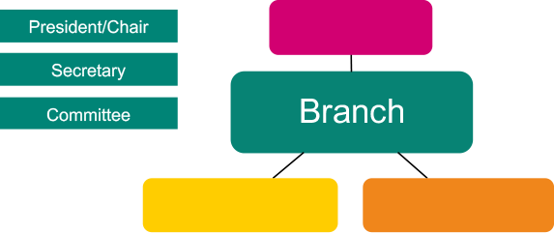
A branch is a usually made up of members who work for one employer.

Why does it matter what branch you are in?
It is very important that members are in the right branch/bargaining unit so that they can speak or vote on issues that affect them. It also means that the union and its reps can better ‘group’ members together and make it easier to help them and deal with issues.

What communications happen when a new member joins Prospect?
A new member is put into the appropriate branch.
- What do they receive?
- How do we know we have a new member?
- What do you need to know from members?
- How can you get this information?
- What will be your ‘foghorn message’ to member to get them to engage?
- How can members contribute?
- Members can manage their communications preference
Prospect is one of the country’s fastest growing trade unions. We only grow because of the hard work of reps in all our branches to recruit new members. Once members have joined, one of the most important activities is to welcome new members to the branch.

Welcoming new members

Why do we welcome new members?
New members are often still forming their opinions of the union.
A warm welcome affirms members’ desire to be part of something positive. This initial contact is likely to give new members a good first impression, allow them to put a face to the union and to share any concerns - all of which increase the chances they will remain a member in the longer term.
Of course, building relationships offers the chance to spot members who want to do more in the union – they may be happy to share information with colleagues and that’s one of the first steps to becoming a rep in future.
New members may have valuable or new skills that a branch can use. New members are often the most enthusiastic and some bring valuable or new skills to the branch. We find that some of our best recruiters under our Member Recruit Member scheme are new members.

How can I find out who my new members are?
The Prospect Branch Knowledge Hub allows certain reps roles to generate a list of members who have joined in the last three months. You can set a reminder every quarter to generate this list.

How can I contact new members?
New members receive a welcome email shortly after they join from the membership department (see Appendix 2).
It’s vital that branches welcome their new members too because:
- Many members join to know about what is happening in their workplace. They can bring insight and influence.
- A standard email is quite impersonal. Branches and reps can tailor their communications to local circumstances and encourage a two-way conversation.
There is no one-size fits all approach to communicating with new members. Branches develop their own approach depending on their size, the areas they work in, the number of workplaces they cover and what works well for their particular are
More guidance on the resource page Tips for reps: A practical guide to branch communications.

Branch reps
Under the union’s rules, a branch has to elect a president or chair (or Convenor) responsible for:
- the proper conduct of any branch meeting
- ensuring that business is kept moving and every member gets a chance to speak if they want to
- clarifying that clear decisions are reached and recorded.
Another role needed under union rules is a secretary, whose duties include:
- calling branch conferences or annual general meetings (AGM) or any other branch meeting and making the arrangements
- preparing and circulating agendas, minutes and action lists
- being the conduit between the branch and Prospect as a whole
- maintaining branch records.
To protect members’ data and to avoid sending out emails that members may not be interested in, Prospect nationally sends the majority of correspondence to branch secretaries.
In smaller branches, the secretary is usually in charge of the membership records; larger branches may have a dedicated membership secretary or organiser. More on the different roles later…

Prospect structure of communications
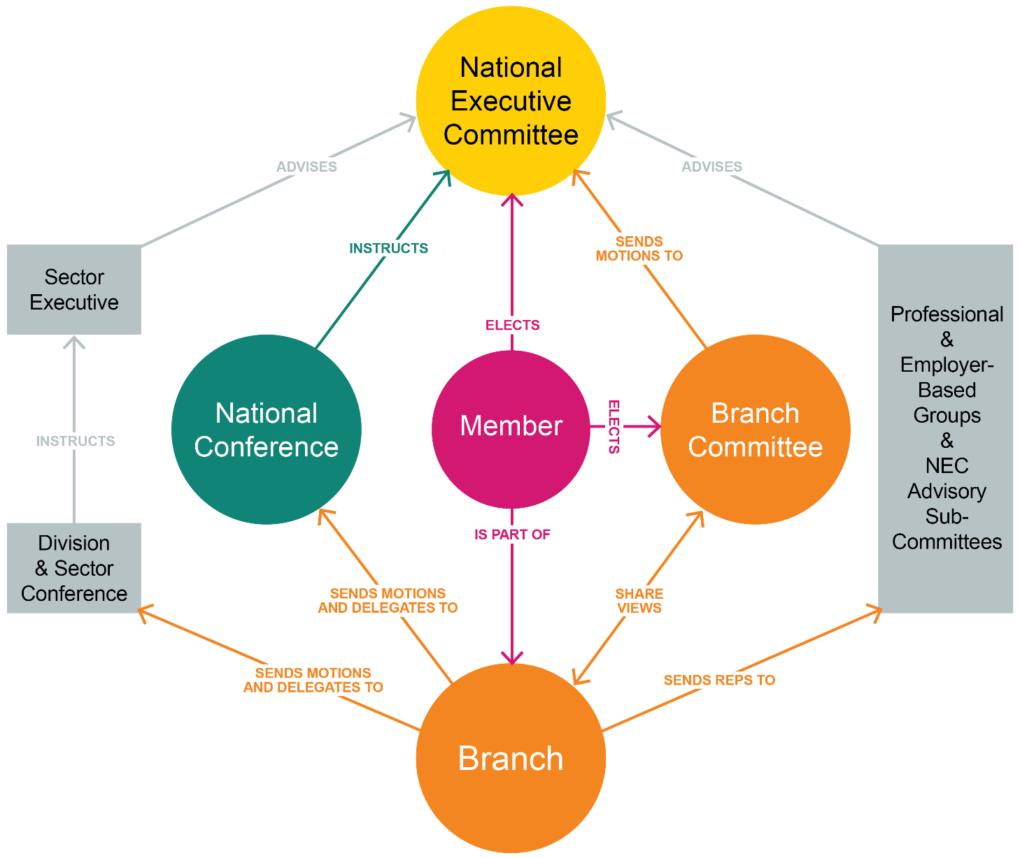

Support for branches
Branches can call on Prospect for support. Most branches in the union has an organiser and a negotiator. These staff have further support from anyone in the comms team.
If you’re looking for a specific task/resource. Here is an overview of what the comms team cover. Please ask your organiser to help find the right area to assist you and your branch.

Session 4

The communications roles within a branch, section, or sub section
Every rep is the link between the union and its members. We are always conscious reps are volunteers. Some can give a little, others can give a lot. Each rep must find their own boundaries.
Prospect prides itself on its reps and the good work they do. This session looks at the roles in more detail

Non-rep role
These roles are ideal for a member who would like to get more involved in the union but without having to take on reps training
Communications administrator
This role combines the more traditional ‘paper’ communications often used for branches to communicate to members. This could be via distributing Prospect information like a newsletter or updating a notice board in a popular meeting venue like a canteen or conference hall or maybe outside a union office. This role is equally vital in a digital world as this role is tasked with keeping the union as visible as possible.

Types of communications reps

Communication rep
A rep role created to raise the profile of the union in individual workplaces through the communication with members. This role can be done by anyone who likes communicating at a higher level to engage members but also enjoys creating newsletters, posters, movement information.
We would request that communications reps liaise with the branch officers either during/following a branch meeting to ensure any necessary communication to member is needed
There are many different types of rep – you can do as much or as little as you want. Not all reps have a recognised job description. Some can simply be described as ‘contacts’: the face of the union in a particular workplace or location. But others have very specific responsibilities, usually defined in the branch rules.
As a communication rep you still have a responsibility to.
- act as a focal point for Prospect/Bectu in their area
- eliciting and conveying members’ views to the branch or section
- maintaining the local noticeboard (with Comms administrator if you have one)
- distributing Prospect information (with comms administrator if you have one)
- ensuring non-members are approached to join, keeping a record of approaches made and, if unsuccessful, the reason
- ensuring changes in members’ details and location are passed to the branch or section membership secretary and updated.

Branch officers
In the paragraphs that follow, for ‘branch’ you can read ‘section’ or ‘sub-section’ as appropriate.

Chair/President/Convenor
The Chair (or president, or convenor in some Scottish branches) presides at all branch conferences or committee meetings and is responsible for:

- the proper conduct of the meeting
- ensuring that business is kept moving
- clarifying the issues under discussion
- ensuring that clear decisions are reached and recorded

Vice-President/Chair
The vice-president acts as chair in the absence of the president. Smaller branches may choose not to have a vice-president.

Secretary/Chief steward and Assistant secretary/Assistant steward
This is the key role in most branches. The secretary’s duties include:
- calling branch committee meetings, branch conferences or annual general meetings and making all associated practical arrangements
- preparing and circulating agendas, minutes and action lists
- submitting to the committee matters referred to him/her by Prospect headquarters or by any member or body with which the branch is associated
- during meetings, assisting the president/chair by presenting information and introducing items for which they are responsible
- maintaining branch records
- dealing with correspondence
- liaising with Prospect headquarters.
Some branches have an assistant secretary or minutes secretary to help with administration. In most branches, the secretary is an experienced rep with a wider representational role in negotiations or consultation.

The below roles all have branch knowledge hub/movement permissions and have access to view the membership lists and distribution list on movement but cannot manage content:

Membership and recruitment secretary/Branch organiser
A membership and recruitment secretary’s duties include:
- maintaining local membership records
- liaising with Prospect headquarters on recruiting eligible people into membership
- organising recruitment in the branch and reporting regularly to the branch committee on this
- where relevant, keeping in close touch with sections about their membership position and helping them to organise their recruitment effort.

Branch organiser/Organising rep
The additional duties of a branch organiser include:
- mapping the workplace: establishing how many non-members there are and where
- organising and co-ordinating recruitment campaigns
- overseeing the network of local reps and identifying gaps and training needs
- developing and maintaining a branch development plan which summarises the objectives and actions needed to strengthen organisation and increase membership.
The below role all have branch knowledge hub/movement permissions and have access to manage content on the knowledge hub membership lists and distribution list on movement for the bulk mail function.

Communication rep
A rep role created to raise the profile of the union in individual workplaces through the communication with members. This role can be done by anyone who likes communicating at a higher level to engage members but also enjoys creating newsletters, posters, movement information.
We would request that communications reps liaise with the branch officers either during/following a branch meeting to ensure any necessary communication to member is needed
There are many different types of rep – you can do as much or as little as you want. Not all reps have a recognised job description. Some can simply be described as ‘contacts’: the face of the union in a particular workplace or location. But others have very specific responsibilities, usually defined in the branch rules.
As a communication rep you still have a responsibility to.
- act as a focal point for Prospect/Bectu in their area
- eliciting and conveying members’ views to the branch or section
- maintaining the local noticeboard (with Comms administrator if you have one)
- distributing Prospect information (with comms administrator if you have one)
- ensuring non-members are approached to join, keeping a record of approaches made and, if unsuccessful, the reason
- ensuring changes in members’ details and location are passed to the branch or section and updated.

Activity C, part 1 – What are the types of digital tools and channels of communication?
Explore the variety of options of which reps are already aware.

The common forms of communication within a union
- Website
- Knowledge hub - Branch’s own website/webpage
- Social media
- Newsletter
- Movement Email/Bulk Email
- Members portal https://prospectorguk.sharepoint.com/sites/it-support-team-site/sitePages/Members'-portal.aspx
- Polls/Surveys
- Zoom/Teams
- Face to Face
- Telephone
- Branch meetings - webinars-workshops
- Doodle poll
- WhatsApp group and ThruText
- Rep coach recruitment tool https://app.repcoach.org.uk

Activity C, part 2 – What do effective communications look like?
Using the jam board/flipchart displayed by your tutor and the list on page 15 to help you, add a form of communication you/your branch currently use and add where it would sit.
- Useful
- Frequent
- Not useful
- Not frequent
Are there any forms you no longer believe are relevant/useful based on this activity?
Make any notes here that may be useful.
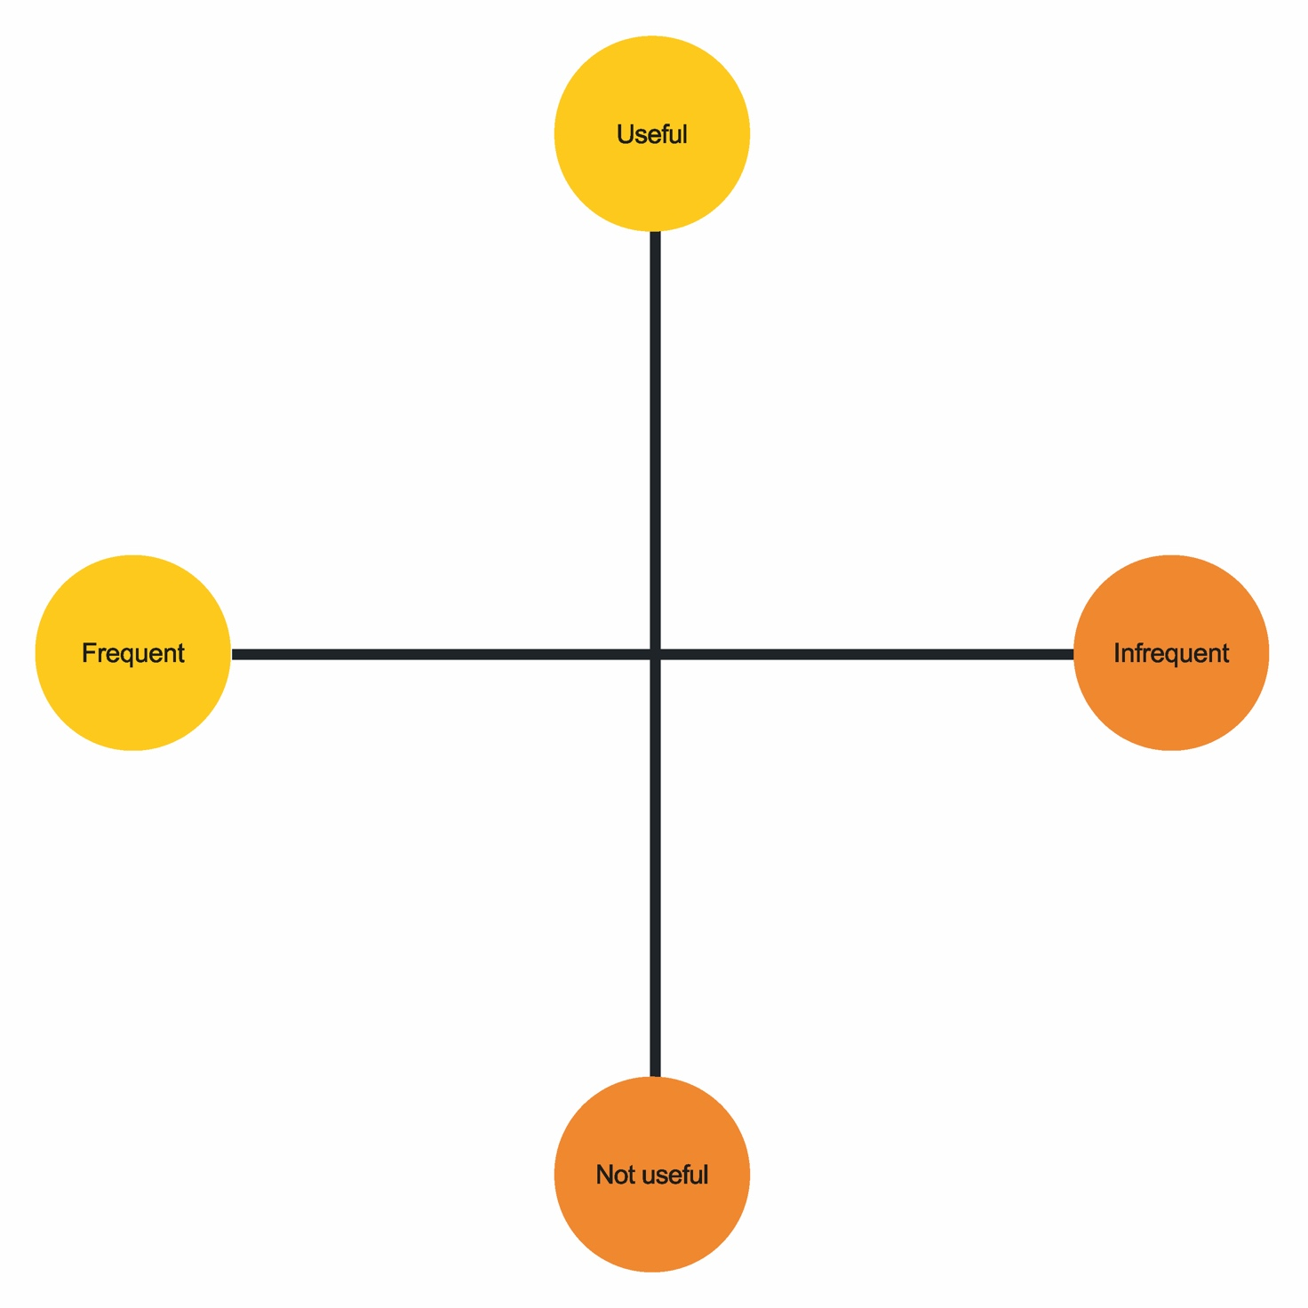

Code of practice for Prospect representatives
In November 2021 a code of practice was created for all Prospect/Bectu representatives. It aimed to:
- provide you with clarity about your responsibilities to ensure the respect of others.
- inform you about your rights if you feel you are not being treated with respect.

It places the following responsibilities
Representatives must:
- Act honestly, responsibly and with integrity.
- Communicate respectfully and honestly.
- Treat others with fairness, dignity, and respect.
- Encourage the open expression of views at meetings but accept collective responsibility for all decisions and policies once finalised.
- Not behave in ways that may cause physical or mental harm or distress to another person, such as verbal abuse, physical abuse, assault, bullying, or discrimination or harassment.
In representing Prospect, representatives must:
- Only speak or act on behalf of Prospect when authorised to do so and clarify the capacity in which you are speaking.
- Always be mindful of their responsibility to maintain and develop Prospect’s ethos and reputation.
- Declare any interests that may conflict with their role in Prospect, for example in a professional or political capacity.
- Respect confidentiality and ensure GDPR compliance in dealing with any documents, material, or devices containing confidential information.
- Not bring Prospect into disrepute, including through the use of email, social and mainstream media and other internet sites.
The expected values and behaviours of all representatives.
- Respectful
- Positive
- Good listener
- Clear communicator
- A sounding board for ideas
- Non-judgemental
- Flexible
- Integrity
- Supportive
- Honest
- Able to network

Data protection
Prospect is covered by the UK General Data Protection Regulations 2021 (UK GDPR) and the Data Protection Act 2018.
This legislation sets out the rules by which personal data can be used by individuals and organisations, including the principles that have to be met and the rights individuals have.
For advice and assistance on any data protection issue please contact the Data Protection Compliance Officer (DPCO) on datacompliance@prospect.org.uk
Here is a list of common-sense dos and don’ts to ensure you comply with the legislation.

Do:
- be aware the legislation applies to information held on paper, electronically, recordings of telephone conversations, audiotapes, photographs, websites, and social networking media (Facebook, twitter, LinkedIn etc)
- remember that membership of a trade union is special category data and requires a higher level of protection
- check your recognition agreement to see whether it contains data protection measures, including the sharing of data with the union
- mark all correspondence, electronic or otherwise, as private, and confidential
- treat personal data held about individuals as if it was your own
- be open with people about information held about them. Let them know that you hold personal data about them and tell them why you need to do so (fair processing)
- respect confidentiality and the rights of the member
- review personal data in on-going cases from time to time and at least annually.
- ensure all personal data is disposed of as confidential waste and find out how you do this within your workplace – what access?
- remember when writing reports, emails, minutes etc, the individual has a right to see information relating to them; even deleted emails may be retrieved and revealed to those about whom they are written
- refer all requests for access to your Prospect full-time official or the Data Protection Compliance Officer
- familiarise yourself with Prospect’s data retention schedule (reproduced below).

Don’t:
- reveal personal data to third parties without the data subject's permission or justification
- reveal trade union membership of individuals without their consent
- put personal data about a member on the Internet without his/her permission
- disclose any personal data over the telephone unless necessary
- send personal data outside the European Economic Area (EEA) without taking advice from Prospect
- leave personal data insecure in any way, whether it is physical files or information held electronically
- take personal data home without ensuring that it can be securely stored
- collect personal data for one purpose and then use it for something else
- keep personal data longer than necessary, delete old lists when no longer needed.

UK GDPR: Seven points to remember
- Always use the bulk mail function or ‘bcc’ members in group emails. Don’t assume just because two members sit together, that they each know the other is a member of the union.
- Ensuring if you’re using a workplace computer, understand who controls this information. The company will be the data controller for the computer system but will be the processor of union information.
- Seek permission from manager/company to request facilities in order to do your union role in a safe way. Can you have a lockable room, secure email, filing cabinet, notice boards etc.
- If sending list of union members’ details, always password protect the document – remember this hold secure information. Send the password protected email attachment and then send the password in a separate email.
- If you think you may have a data breach, contact the data protection officer at Prospect on datacompliance@prospect.org.uk as soon as possible, so they can help and minimise the impact. We have 72 hours to assess and report the breach to the ICO.
- Whatever media platforms you use as a branch ensure the union is aware and obtain the necessary permissions if required. On-line media may involve personal data being transferred overseas. Inform Prospect’s DPCO on datacompliance@prospect.org.uk
- Social media accounts should inform Comms and be followed by Comms.

Principles
- Lawfulness, fairness and transparency
- Purpose limitation – data should only be collected for specific, explicit and legitimate purposes.
- Data minimisation – only collect data that is adequate, relevant and limited.
- Accuracy – ensure data is kept up to date and correct.
- Storage limitation – only keep data for as long as necessary.
- Integrity and confidentiality – ensure data is kept secure

Individual rights
All members and non-members whose personal data we process have the following rights under the regulations:
Right to be informed
Individuals have the right to be provided with information about how their personal data is being processed. (Prospect privacy notice).

Right of access
Individuals have the right to obtain confirmation that their personal data is being processed and to be provided with a copy of that data. A request can be made in writing or verbally.
If you receive a request, it should be forwarded to Prospect to the Data Protection Compliance Officer on datacompliance@prospect.org.uk. We have a month to respond from the date the request is received, so it’s important a request is forwarded as soon as possible.
Right to rectification
Individuals have the right to correct information held about them if they believe it is factually incorrect. They also have the right to have incomplete personal data completed by means of providing a supplementary statement.
Right to erasure
This is also known as ‘the right to be forgotten’. In certain circumstances it allows individuals to ask for their personal data to be deleted or removed.
If you receive an erasure request, it should be forwarded to Prospect to the Data Protection Compliance Officer on datacompliance@prospect.org.uk. We have a month to respond from the date the request is received, again it’s important a request is forwarded as soon as possible.
Right to restrict processing
In certain circumstances individuals have the right to stop us processing their personal data. The data can be stored but cannot be used until a dispute is resolved.
Right of data portability
This is a new right that allows individuals to access and move their personal data for their own benefit across different services. This only applies to data provided electronically by automated means.
Right to object
Individuals have the right to object to the processing of their personal data, on grounds relating to their particular situation. Therefore, we must stop the processing unless we have a legitimate reason to continue to use the data.
Automated decision making and profiling
Right not to be subject to a decision based solely on automated processing or profiling.
Right to opt out of direct marketing
Members have the right to opt out of receiving direct marketing, but make sure this doesn’t include ballot papers.

Prospect’s retention schedule
Destroy closed case files after:
- six years – equal pay cases
- seven years – employment related cases
- seven years – personal injury cases
- 12 years – industrial disease.
You can find more information in our briefing: https://library.prospect.org.uk/id/2016/01617

Session 5

Activity D – What would you do if…
Individually, look at the situations below and decide what course of action could be taken.
    - Your branch secretary has asked you to upload the latest pay information on the movement tool, but you know many members do not access this information. What can you suggest?
    - Your branch is looking to run a recruitment campaign. What steps might you suggest keeping members informed and engaged, and how would you share a positive result?
    - A member comes to you as they feel their privacy is being invaded due to another member sharing a photo of them at work without their consent. What would you do?

    - A new rep approaches you as they think they may have breached GDPR with some information they have shared. What would you advise?
    - You’ve supported a member with a personal case resulting in a successful change in current policy, who would you tell?

Common forms of union communications – an overview
Since 2020, reps and branches across the union has used a range of digital tools to meet, organise and campaign across the union.
This briefing aims to give a snapshot of different tools, both ones provided by Prospect, and those generally available online that branches may find useful to grow their membership and influence in the workplace.
We are always interested in how branches are developing their communications with members, if you have been using any other tools successfully in your branch then please do let us know: comms@prospect.org.uk

Knowledge Hub
Most GDPR compliant way of contact reps via bulk mail, with updated minutes, newsletters etc….
https://prospect.org.uk/how-to-use-the-the_union-knowledge-hub/
Go over the functionality. (Communications role access rights for this area of work)
Please note the Secretary/assist, Chair/vice, membership and recruitment secretary all have automatic access to the membership lists, new joiner and leavers.

A note on data protection
Several of the tools in this guide involve accessing sensitive personal data about other members. This means that reps must be always mindful of data protection.
You can access our rep’s guide to GDPR and data protection here: https://library.prospect.org.uk/download/2022/00712
However most importantly be cautious and seek advice if you are in any way unsure. Your full-time officer should be able to help, and our Data Protection Office can be contacted on dataprotection@prospect.org.uk

Email
Email is one of the most important ways that branch reps can communicate with members.
We currently have email addresses for most members; members can choose whether they prefer to receive email to their work or personal email addresses.

Movement (our new email tool)
Movement is a new tool, developed with and for trade unions.
This will allow the production of more modern and attractive emails, with a more user-friendly interface.
The link for the full guide is here,
https://prospect.org.uk/movement-email-guide-for-reps/?s=Movement&f=all
Log in is here, Prospect - Movement
You can see more at: https://www.movement.industries

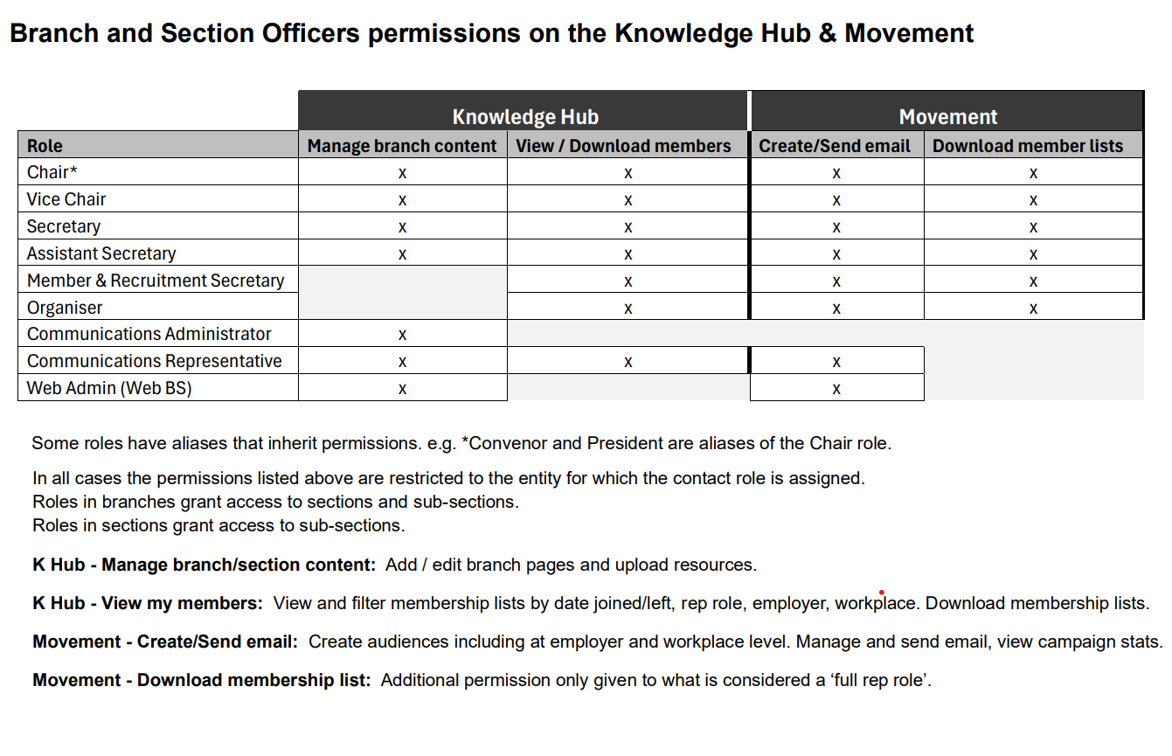

Video meetings and webinars
Video meeting tools can a great way to keep in touch with your branch, whether that’s in smaller catch ups or bigger meetings.
Some of the most common platforms are Zoom, Microsoft Teams or Google Meet.
Employers may or may not allow some of these tools to be used on employer provided IT.
Branches should consider the data protection and privacy implications of using any employer provided video meeting platform, especially if no agreement exists as part of a facilities agreement.
Prospect provides pitches/divisions with access to Zoom and Teams accounts that can be used to organise calls without using employer systems. Please speak to your full-time officer.
While Zoom and other platforms do have tools for online voting or polls these may not be suitable for all occasions. For example, they do not necessarily allow us to check whether everyone voting is eligible or that members do not vote twice, so they should be use cautiously.
Snapshot polls though might be appropriate to informally gauge members’ views on a call to help inform discussions by a branch committee.
If you are planning on conducting formal branch meetings online then you should speak to your Prospect full-time officer, to discuss the best way forward.

How to organise a branch webinar
The union has a small number of Zoom accounts that can host webinars for up to 500 members. These accounts are prioritised for the Prospect and Bectu Live events but, where account and staff resources allow, we’ll try to support branch events. Please discuss your options with your full-time official.
It’s worth checking which platform your workplace uses and whether they’d allow you to use it. Microsoft Teams live events functionality offers many of the same features as webinars in Zoom.
There are more tips for webinars in: Tips for reps: A practical guide to branch communications

Branding and logos
A whole range of branding for is available at prospect.org.uk/ambition and bectu.org.uk/ambition
Some of what is available:
- Prospect and Bectu logo and social media packs
- Video conference backgrounds
- Microsoft PowerPoint templates
- Microsoft Publisher templates
- Prospect/Bectu email signatures
- Prospect branch welcome email template in Word

Branch networking
Branches use a range of channels to engage with members. This often varies by what is already widely used within an organisation or company. But Yammer, Workplace, WhatsApp, Teams chat, Slack, as well as more traditional Intranets are all in use.

Text messaging (SMS)

ThruText
ThruText is a text messaging platform that allows you to hold text conversations with members and is particularly useful if you want to go beyond a single text reminder. Once set up it provides users with “stock” replies to specific questions, as well as the ability to free text, and is very user friendly and can involve reps in the process of communication.
It allows for multiple users so spreads the workload for branches trying to hold a conversation with large numbers of members. We have used it to good effect to progress ballots and surveys.
Set up is facilitated through your full time officer or Organiser

SendMode
We can use the SendMode tool to send mass reminder messages to members, for example on voting in industrial action ballots. Messages must be set up through the comms team: comms@prospect.org.uk

Surveys
Surveys can be an excellent way to understand the views of a branch membership and identify issues for campaigning and collective bargaining.
A range of tools can be used to set up branch surveys. Reps should think about why they are collecting information and what they will use it for, making sure surveys are not over long or excessively frequent. This will make sure members are most likely to engage.

Survey Monkey
This tool can be used for free for small surveys, however Prospect has access to a paid account, and it is best to speak to your full-time officer about getting your survey set up on a paid account. This means we can make sure the data can be managed securely.
Survey Monkey is best for simple, short surveys and many members will find the interface familiar. surveymonkey.com

Snap Surveys
This is the tool we use indicative ballots and other formal ballots that can be completed online (statutory ballots must generally be done by post). It offers a more secure platform than Survey Monkey. Requests for Snap Surveys should be made to your full-time officer, but will generally be set up by a member of staff at Prospect HQ.

Microsoft and Google Forms
These tools can create basic online forms to gather information and populate a spreadsheet. Microsoft Forms needs a paid Microsoft 365 account, but Prospect staff members have access and can set up forms if needed by branches. It is important that a clear process is established so information from members can be acted on, and for time-limited campaigns forms are closed when the campaign is over.

Other tools

Megaphone
A shared petitioning platform for TUC affiliated trade unions, run in partnership with Australian union organisation VHTC. The TUC can help unions run online actions to back up industrial campaigns.
Petitions can be started directly on Megaphone, however the Prospect comms team can raise questions/issues with the TUC is required: comms@prospect.org.uk
Prospect strongly recommends the use of Megaphone over change.org or using Parliamentary petitions. Access it at: https://www.megaphone.org.uk
We have also worked in partnership with 38degrees on larger campaigns, again it is best to speak to the Prospect comms team in the first instance.

iParl
iParl allows us to set up a Prospect branded website, for members to email their MP on issues of concern. Members input their post code and Prospect supply a model text which they can customise before sending the email to their MP.
This tool must be set up by the Prospect comms team, but campaigns should be discussed with your Full Time Officer in the first instance.

Linktree
Several branches have successfully use Linktree to collect relevant information for branch members.
This national level Linktree demonstrates how a Linktree can work: https://linktr.ee/joinprospect
If you are establishing a branch Linktree, then it is best to include relevant national links (for example a link to the Member Recruit Member page) as well as information about the branch.

Stream – TUC Education
Reps can access online learning from the TUC on a range of topics through their Stream platform. https://tuc.curatr3.com/dashboard

Lighthouse
Although primarily aimed at union officials working in digital, branches running more complex digital projects my find the Lighthouse tool useful to help evaluate a data or technology project you are currently running: https://lighthouse.prospect.org.uk

Eventbrite
Eventbrite is an online service used to register people for offline and online events. It means members can sign up on a link, and reps can track how many plan to attend and share reminders and further information with attendees. There is a small charge for events for over 100 people: https://www.eventbrite.co.uk

Relevant Prospect guides and further reading
- Tips for reps: A practical guide to branch communications
- Members guide to media and social media
- Movement https://prospect.org.uk/movement-email-guide-for-reps/?s=Movement&f=all
- Branch Knowledge Hub https://prospect.org.uk/how-to-use-the-the_union-knowledge-hub/
- Members guide to email, internet and social media at work
- Guide to data protection for Prospect reps
- TUC Digital Lab: https://digital.tuc.org.uk
We have a public facing website https://prospect.org.uk/

The member website
As well as the movement tool and access to the branch knowledge hub from the membership system, this site currently also hosts sector and industry pages, which link to relevant national news stories and resources that are specifically designed to support members. There is also the resources section of the member site which houses a library where members can access all our guides, posters and leaflets, research reports, campaign resources and more.
It's important to encourage members to register on this website to ensure they get the most out of their membership and communications.

The public-facing website
We see our new site as our ‘shop window’ showcasing what we are doing to the public, as well as support members through a new clean design. If a potential new member has any questions about the union or the work that Prospect is doing this website will answer their questions as clearly as possible and show what worthwhile work our members are doing across the spectrum of sectors we represent.
We also have a set of templates for members and reps to use at https://prospect.org.uk/about/ambition/ where you can download resources to help you with all your digital comms. There are social media packs, PowerPoint presentation templates, logos, Word templates, recruitment flyers, benefits leaflets and even bunting. There’s a reps area with information around training, conference and more and you can also access campaign resources for our cross union campaigns such as on the climate emergency and Right to Disconnect, at each of our campaign pages in the Get Involved section of the site.
If members or potential members have a quick question around workplace guidance, they can find it in the Get Support area.
On both websites there is information about Prospect Networks, both in terms of what they are campaigning on and how you can get involved.

Website (Bectu)

The public-facing website
We see our new site as our ‘shop window’ showcasing what we are doing to the public, as well as support members through a new clean design. If a potential new member has any questions about the union or the work that Prospect is doing this website will answer their questions as clearly as possible and show what worthwhile work our members are doing across the spectrum of sectors we represent.
We also have a set of templates for members and reps to use at https://prospect.org.uk/about/ambition/ where you can download resources to help you with all your digital comms. There are social media packs, PowerPoint presentation templates, logos, Word templates, recruitment flyers, benefits leaflets and even bunting. There’s a reps’ area with information around training, conference and more and you can also access campaign resources for our cross-union campaigns such as on the climate emergency and Right to Disconnect, at each of our campaign pages in the Get Involved section of the site.

Using your own website (branches and freelancers)
We appreciate that for some industries, a dedicated, bespoke website is more useful. Some freelance branches have their own website to keep industry news specific to members in an area. It’s important to check these points before setting up your own website:
- Are there any Pros/cons to the website – will members be able to access it and find it useful?
- Have you sought permission from Prospect/Bectu Comms teams to set up your own website (as representatives of the union)?
- Is the software/member login data compliant? Our data protection officer can check the permission needed for the software to run.

‘Shadow tech’
- If ever in doubt, ensure you ask your official or contact the DPO (details in the terminology page) if a piece of software is safe to use. Check eligibility.
- What’s the comms used for?
- Is the union already using something similar/is there a need for this?
- If in doubt, contact your official/IT
- Be mindful of uploading membership data on other third party tech.
- If in doubt, please always check!

Union induction
You may have an agreement with your employer/workplace so you can promote the union in a formal recognised way by engaging new starters in outlining why the union is present and what the purpose is.
We’ve included a checklist for this in the resources – contact your official for additional resources including a PowerPoint.

Social media and comms best practice
Social media is a great way to broaden the reach of your audience but there are some key steps to follow if you’re going to use it effectively.

Step 1: Consistency
Regular posting. Everyone is busy so the best way to maintain consistency on a channel is to use a scheduling tool. This way you can allot time to set up your schedule for the week and let it roll whilst you get on with your day job. Of course, it’s also important to be as reactive as you can to things happening which you could comment on and will get traction. But you can’t be everywhere at once and scheduling will ensure you have regular content going out for your audience.

Step 2: Engagement
As well as reaching a wide audience with regular posting you need to think about engagement. Some ways you can promote your content organically is to share and retweet branch posts on your own social accounts shortly after they’ve been put out. This builds momentum and if you share a post with a quote yourself to contextualise it, starts and furthers conversation within your own audiences.
You could look to formalising this with a social media group of 3-5 people who are responsible for posting but also then sharing a post once it’s gone up. To formalise this, you could set up a WhatsApp group to give people a heads up that you’ve posted so they know to hop on and retweet or share.

Step 3: Tone of voice
It’s important to remember that each channel has a different role and therefore a different tone:
- X is great for reacting to contemporary events or getting people to spread the word about something and works best when you’re concise and a bit knowing
- Facebook is the place where you could start discussions – encouraging people to comment or share their own posts and can be chatty
- Instagram is primarily visually, and design led so think about what you’re saying with your image
- LinkedIn is great for sharing articles and thought leadership and is a more professional, expert tone.

Step 4: Go where your audience is
With limited time there’s a danger you could spread yourself too thin so go where your audience is. There’s no point setting up an incredible Instagram account if no one in your workplace uses it! Or if the work that you’re doing isn’t visually stimulating (although I’m sure very important!). Ask your members where they are and then focus making that channel the best it can be.

Best practice
The first rule of social media is ‘don’t say anything on social which you wouldn’t say in a workplace’.
The second rule of social media is ‘don’t say anything on social which you wouldn’t say in a workplace’.
As great as social media is at getting people on board, it’s also a very easy way to put your foot in it even when what you’re saying seems right!
You must remember that however intimate it feels, it’s a public space and for all that you can delete posts, once you’ve put something out there, it’s out there.
That’s not to say that you can’t develop a unique tone of voice, social media is much more successful when it sounds human, but if it’s about something potentially contentious it’s usually a good idea to check it with another branch member first, or just someone other than yourself who can be an outside eye and sense check.

Creating newsletters
Newsletters are great ways to keep in touch with your members and with digital newsletters you can do many different things with them. If you have one particularly big letter item you want to tell members about, you can do a one item piece. If you have a few news items to talk about you can do a news round up. If you want to profile a win, or a member who has done brilliantly in something you can prioritise a case study. It’s about what you think will make an interesting read, not just putting in everything that you feel people need to know about.

Calls to action
Good newsletters are driven by human interest stories but most importantly they must include a call to action. With the amount of emails people receive there has to be a compelling reason to open an e-newsletter and once people have done, you want to capitalise on your audience’s time.
The question ‘What do I want my reader to do?’, should be at the heart of every newsletter and lead your call to action: the answer to this could be supporting a campaign, sharing content on social media, turning up to an event, donating to a cause or taking part in a survey. You should also think about how you’re going to reflect back engagement to members, so they see that their action was noticed and has gone towards helping your end goal.
This will make your newsletter an engaging two way communications channel and not just a static broadcasting tool. It will mean more people open your newsletter because people like to feel engaged and involved and again it underlines the idea that as members of the union their voice and actions are at the heart of what we do and what we can do.

Consistency
In the same way that consistency in a social media plan is key, so regularity in a newsletter schedule is vital. It doesn’t matter if you only do four a year, or one a month, or one a week. It’s just essential that if you set up a schedule you stick to it. You could try doing a quarterly newsletter with longer term interest stories and campaigns and then keeping the single item – call outs to support a campaign/invitation to an event – newsletters on a more responsive basis, which can fit into that structure as and when you feel you need them.

General points and accessibility
Creating accessible comms means reaching the widest audience possible and being inclusive. But these rules of thumb also form the basis of good clear communications across the board. They are by no means exhaustive but are a good place to start. If you feel you’re not sure if something is accessible don’t be afraid to sense check it with someone.

Use a readable font size
Small text is harder to read, so it’s best to stick to at least 12pt in printed documents. If the text won’t fit into the space you have, it’s better to cut some text so the font can be kept larger, rather than reducing its size.

Use plain language
Plain language is reader-friendly because it's clear, concise, and precise; it means using short, action-driven sentences free of jargon to make language accessible and easy to understand. The average reading age in the UK is nine years old (source ONS), so making your message easier to read will help you reach a broader audience. Online text editors such as Hemingway can help to simplify your message.

Use good colour contrasts
Poor colour contrast can make it difficult for people to understand your text or diagrams. For example, light grey text on a light background would be hard to see. If you’re unsure about a contrast you can always check online using tools like Accessible Colors.

Make your hyperlinks descriptive
People without impairment can scan pages to find links to useful information from within the context of a page. However, for people who use assistive technology, like screen readers, it will not be possible to quickly do the same unless the hyperlinked text is clear. Rather than write “click here”, which could become confusing, if there is more than one link on a page, use descriptive hyperlinks that clearly state what you are downloading such as linking the title of the document itself.

Describe images and use transcripts for videos
Alternative text, known as ‘alt text’, is a simple text description of an image and for members using a screen reader it means they will be able to hear and understand what the image is of. In the same way providing transcripts for videos means that those whose are deaf or hard of hearing will be able to successfully experience and understand the content. Platforms like Otter.ai can be used to create transcripts of meetings and are free to use.

Activity E – Story writing
How would you change this article for a blog, a headline for a newsletter or social media posting in your branch?

Write about the following topic:
Mrs Ruby Jones thought she had landed her dream job. It was a nice, clean office with a window, kind colleagues, decent amounts of time off and it wasn’t too far from where she lived. She was a single mum with two children under ten, so she could get home in time for tea with the children after her mum had picked up the kids from school. For the first few weeks, everything seemed fine.
Then a new manager appeared on the scene. Let’s call her Jennie. Ruby started to sense that Jennie the manager didn’t like her. It started with passive aggressive remarks about her time keeping, then Ruby felt that she was always being asked to stay late, to perform extra tasks, and even on one occasion to travel to another office 30 miles away to attend a meeting, which meant she didn’t get home until 9pm. Jennie started to have an impact on Rub’s mental well-being. She became withdrawn and quiet. She dreaded coming into work. She as signed off with depression by her GP and found little sympathy from her boss.
After about 3 months, Ruby decided to approach her Prospect workplace rep. She explained what had been going on and the rep, let’ call her Susan, made representations to the management. Ruby felt at last someone was on her side and started to feel better. Susan persuaded the company’s management to move Jennie to another office. The new manager, let’s call him Andrew, was far fairer and more professional in his dealings. Ruby is proud to be a member of Prospect. She is training to be a workplace mental health first aider and attends union branch meeting when she can.
She says ‘just when I thought no one cared, Prospect showed me that someone was on my side. I understood what constitutes bullying and harassment, and no longer felt it was all my fault somehow. Now, coming to work is no longer a nightmare, and some days I positively enjoy the office!’

Ingredients of union influence
Various factors give a union influence in the workplace, and communications reps can increase that influence.
The ingredients are:
- membership density
- engaged members
- visible profile
- constructive dialogue
- representative membership
- representatives.

The virtuous circle
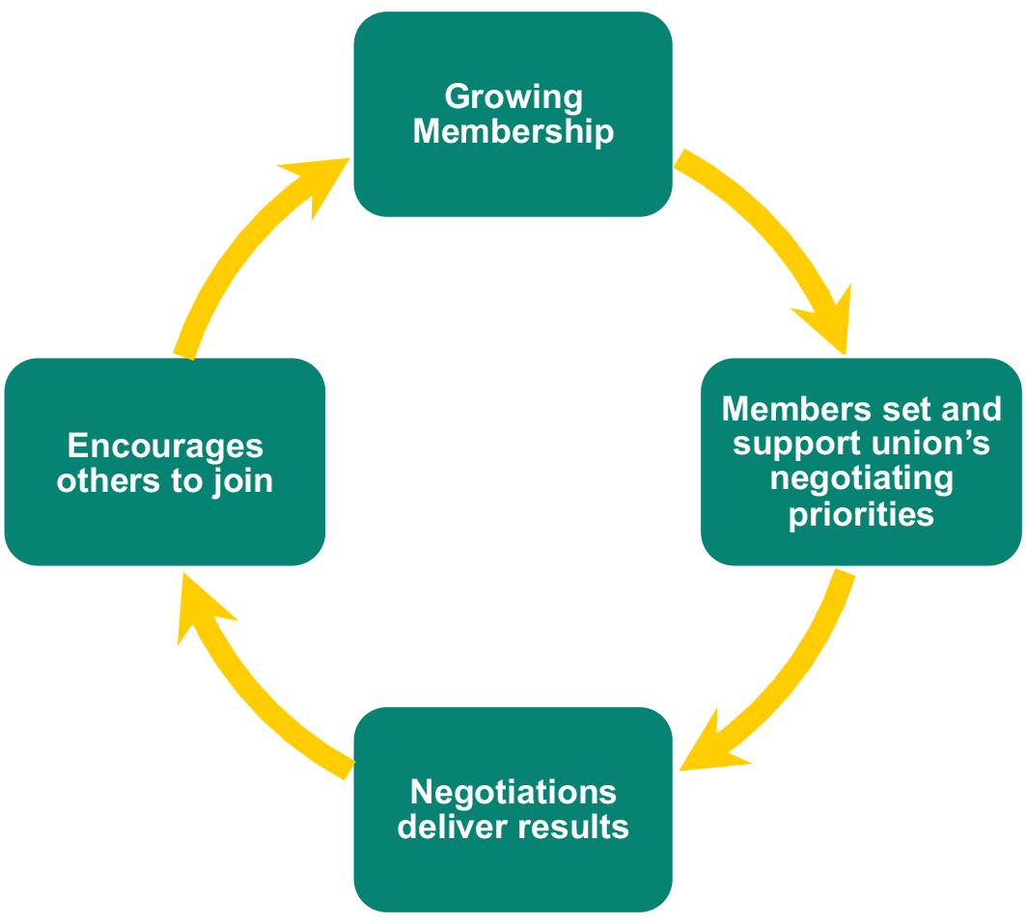
Effective local organisation and communication – meaning reps like you – are at the heart of Prospect’s ability to keep the virtuous circle going.

Next steps

Action plan
Spend a few minutes thinking about what you would like to do when you get back to your workplace and what you need to achieve this.
Task
Following on from this training, what do you need to know to help improve your comms role with the branch?

What might be some of the pros and cons to consider?

What areas of communication may you start to use based on this training?

Does your branch, section or sub section have a communications strategy?

What further support do you need to carry out your role in communications effectively?

After attending this course, what will you stop doing?

After attending this course, what will you continue to do?

Based on your new knowledge, what three practical things will you do?
1.
2.
3.

Appendix 1: Useful links

Prospect
Prospect rep’s handbook – https://library.prospect.org.uk/download/2009/00650

Benefits and services leaflet – https://library.prospect.org.uk/download/2014/01255
Logos, templates posters and other resources – https://prospect.org.uk/ambition/
Members’ guides – https://members.prospect.org.uk/resources/guides-factcards/members-guides

TUC
TUC – www.tuc.org.uk
Worksmart – https://worksmart.org.uk
Union reps forum – https://unionreps.org.uk
Health and safety, union effect – see www.tuc.org.uk/research-analysis/reports/union-effect
Training – www.tuc.org.uk/sites/default/files/Skils_and_training.pdf
Collective bargaining and great jobs –
www.tuc.org.uk/research-analysis/reports/great-jobs-are-union-jobs
Training benefit to economy – www.tuc.org.uk/sites/default/files/Skils_and_training.pdf

Other
ACAS code of practice 3 – http://bit.ly/acas-time-off
ACAS – www.acas.org.uk
Union wage premium – http://bit.ly/union-wage-premium
Government – www.gov.uk

Appendix 2: welcome emails



Thank you for joining Prospect
Dear insert name
Thank you for choosing to join Prospect. We've now completed processing your membership.
Here is everything you need to know.
- Your Prospect membership details
- An online event for new members
- How to contact us
- Recruiting other members
- How to get more involved
- Special offers and discounts
- Your subscription and payment
- Make changes to your membership

Your Prospect membership details
Membership number: insert membership number
Name: insert name
Employer: insert employer’s name
Branch: insert branch name
You can update your details or access your digital membership card on our member portal website.

An online event for new members
We run a regular online webinar for newer members and those who want to know more about the basics of how trade unions work. The webinar will explain what we do and a little about the areas Prospect works in. We will also answer your questions about Prospect.
Check out up the upcoming dates and sign up

How to contact us
We’re here to help. For advice about workplace issues, member benefits or anything else you can get in touch with the specialist in our Member Contact Centre:
email: membership@prospect.org.uk
phone: 0300 600 1878
post: See our website

Help us grow and earn rewards by recruiting other members
Unions are stronger when more people join them. For each colleague you ask who goes on to join, we'll send you a £10 gift voucher. To get the voucher, just ask them to quote your name when they join. Find out more.

Special offers for members
Explore the full range of special offers and discounts for Prospect members on the website. Make sure you’re logged in to get the deals!

Your subscription payment
You will receive an email shortly that will confirm your Direct Debit payment schedule and all the relevant details.

Changing or cancelling your membership
It is important that we have the correct details for you – including contact details and employment details. It is also important that you let us know when you should be paying a different membership rate for example because of a promotion at work or because you are taking parental leave.
You can update your details on our member portal.
You can also email us (membership@prospect.org.uk) or call our Contact Centre (0300 600 1878) and we can help make the changes you need.
And if there’s ever anything else you need, visit our website, email us, or call and we’ll do everything we can to help.

Some other bits you may need to know...
Prospect membership is subject to our terms and conditions, which can be found in our rule book on our website.
Please review the Members Code of Conduct which can be found on our library.
There is also some information you need to know if you seek legal assistance upon joining Prospect. This can be found on our legal services webpage.

That's it for now!
You should have everything you need to get started as a member – if you think you're missing something, do let us know using the contact details above.
Thanks again for joining,
Prospect Membership Team
0300 600 1878 • membership@prospect.org.uk • prospect.org.uk
Preferences



Thank you for joining Bectu
Dear insert name
Thank you for choosing to join Bectu. We've now completed processing your membership. By joining you’ve made the right choice for help and support at work and an investment in your future in the creative industries.
Bectu membership gives you professional advice and representation at work, whether you are a freelancer or employee, including on pay and conditions, equality, training and health and safety.
Bectu are also experts in the creative sector and lobby on your behalf to improve the industry and to make it a great place for all of us to work.
Here is everything you need to know.
- Your Bectu membership details
- How to contact us
- Connect with us on social media
- How to get more involved
- Special offers and discounts
- Your Direct Debit payment
- Bectu – a part of Prospect
- Make changes to your membership

Your Bectu membership details
Membership number: insert membership number
Name: insert name
Employer: insert employer’s name
Branch: insert branch name
You can update your details or access your digital membership card on our member portal.

How to contact us
If you need to contact Bectu's Head Office, please:
email: membership@bectu.org.uk
phone: 0300 600 1878, then chose option 2 to speak to membership
post: See our website

Connect with us on social media
Join our growing community on Facebook, Twitter, Instagram and LinkedIn.
Special offers for members
Explore the full range of special offers and discounts for Bectu members on the website. Make sure you’re logged in to get the deals!

Your Direct Debit payment
You will receive a payment plan via email shortly that will confirm your Direct Debit payment schedule and all the relevant details.

Bectu – Part of Prospect
Bectu is a sector of Prospect, a trade union representing over 150,000 members in a whole range of industries. This means if you pay by Direct Debit it will have ‘Prospect’ as the payee and some of your Bectu benefits will be delivered through the Prospect Plus online portal.
Working as part of Prospect means we can maximise the benefits for members that being part of a bigger union brings, while keeping the specialist expertise and reputation that Bectu has in the creative industries.

Changing or cancelling your membership
It is important that we have the correct details for you – including contact details and employment details. It is also important that you let us know when you should be paying a different membership rate, for example because of a promotion or because you are taking parental leave.
Just email us (membership@bectu.org.uk) or call our Contact Centre (0300 600 1878) and we can help make the changes you need.
And if there’s ever anything else you need, visit our website, email us, or call and we’ll do everything we can to help.

Some other bits you may need to know...
Bectu membership is subject to our terms and conditions, which can be found in our rule book on our website.
Please review our Members Code of Conduct which can be found on our library.
There is also some information you need to know if you seek legal assistance upon joining Bectu. This can be found on our legal services webpage.
You may also like to find out about Prospect’s political fund and how you can opt-in to contribute.

That's it for now
You should have everything you need to get started as a member – if you think you're missing something, let us know.
You are joining over 35,000 other members, as a not-for-profit organisation run by members on behalf of members, we always value your feedback and hope that you will be able to become involved in your Bectu branch.
Finally, if you know a colleague who isn’t a member yet then please do let them know about the benefits of being part of Bectu; the more members we have the more we can do for our members.
Thanks again for joining,
Bectu Membership Team
0300 600 1878 • membership@bectu.org.uk • bectu.org.uk
You are receiving this email as it contains essential information about your Bectu membership. You can find out more information in our Privacy Policy.
Communication preferences

