

Tech Workers Survey, Autumn 2025
A Prospect briefing • 25 Nov 2025



Tech workers survey
Autumn 2025
A Prospect briefing • 25 November 2025
Contents
Overview 3
Headlines 3
Survey demographics 4
International workers 6
Working time 9
Learning & development 11
AI in tech 12
Now and next 15
Prospect
100 Rochester Row
London SW1P 1JP
Tel: 0300 600 1878
prospect.org.uk

Overview
This report is based on a survey of just over 250 tech workers – primarily Prospect members – over a period of 3 weeks in August 2025.
That’s a small sample relative to 3,000 members in our Tech Workers Branch, and tiny compared to estimates of the UK tech workforce running (variably) into the millions. The tech sector is notoriously difficult to define and thereby to measure, and due to its fragmentation across many organisations and interests, difficult to study in depth. Even a small survey, therefore, can provide useful glimpses of worker experience in this economically and culturally important sector.
We recommend caution in interpreting or extrapolating these results, and we look for coherence with other studies of the sector to help verify our findings. However, this survey adds to our understanding of the sector with rich, qualitative insights scaffolded on the union’s established knowledge of how industries and employers (mis)behave.
The tech sector, most of the businesses within it, and the workforce itself are relatively young and inexperienced in employment practice, workers’ rights, and how these interact with industrial strategy and regulation. As a union we can monitor emerging issues and, while we can’t always forecast exactly how they’ll play out in the tech context, we often know the right questions to ask. Moreover, we can educate our members about their own rights at work and the standards they should expect of any UK employer, and we equip them to hold their managers and HR teams to do better.

Headlines
- 8 out of 10 non-UK born workers feel their workplace welcomes them, and 7 out of 10 feel valued by their employer, but only a third feel the UK is a welcoming environment for international workers.
- 9 out of 10 respondents tell us that working time is an important factor in their career choices, and yet half have been asked to opt out of the working time regulations.
- The majority of respondents say that their employer encourages them to use AI, and is training and hiring staff to work with AI, but only 27% feel they have effective systems of AI governance.
- Three quarters of respondents agree that the use of AI is a threat to the quality of tech sector outputs.

Survey demographics
We asked a very limited set of questions on respondents’ personal characteristics (age, gender, country of birth). We have previously surveyed the branch on equalities issues, asking for a more complete set of characteristics, but this time we were looking for a few reference points, including some basic employment characteristics and company size, to help us calibrate our survey sample against the demographics of the sector.
For example, the gender split of our sample - 76% men, 20% women, and 4% non-binary or third gender - is broadly in line with estimates of the sector, bearing in mind that there’s little consensus either on the classification of gender, or on the definition of the industries and workforces that make up UK tech. The small numbers of responses from women, and especially from non-binary people remind us to go carefully on any segmentation of the survey sample.
The age profile of the survey sample peaks in the 30 to 39 years range, and 25% of respondents are 50 or over. That leans a little older than estimates of the tech workforce, and older than our Tech Workers Branch. It’s not surprising if older workers have a lot to say about working conditions in tech. One report from CW Jobs claims that 41% of tech and IT workers have experienced age discrimination and stereotyping, and that age at which they start to experience ‘old-age discrimination’ is just 29 years.
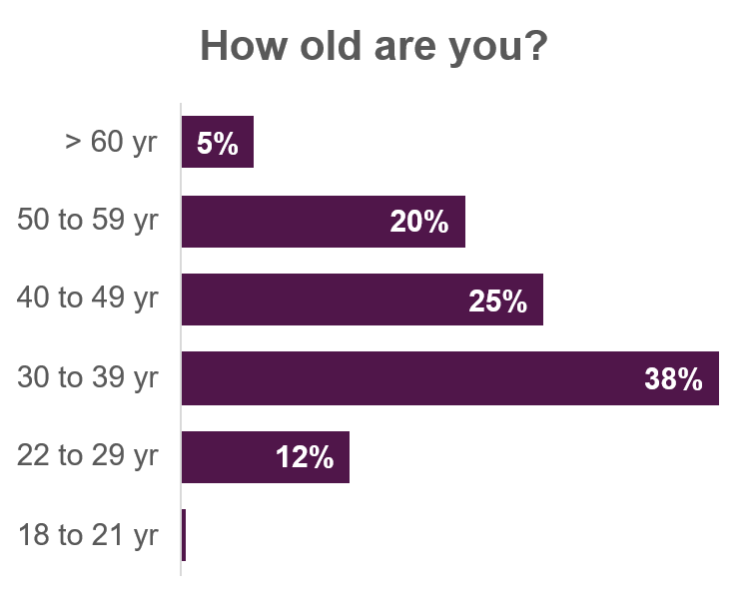
The breakdown by employer size is quite different to our estimates of job distribution across the sector, based on official counts of businesses by number of employees. We estimate that the tech workforce is weighted into the extremes of the company size spectrum: with very many microbusinesses each employing few people (or none at all in the case of sole traders), and a few titans each employing very many staff. Our survey appears to underrepresent workers in smaller businesses (fewer than 100 employees) and overrepresent larger ones. The greatest disparities are in the smallest and the biggest companies.
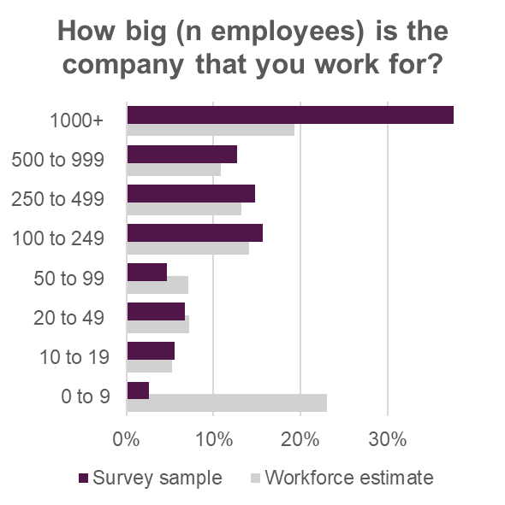
We can put this distribution in the context of the changing shape of the tech sector, where the most reliable growth over the 15 years for which we have official statistics, and especially in the wake of the pandemic, has been among middle-sized businesses. There are two tests of interest:
a) Does our understanding of the sector, and do we as a union represent the tech workforce as it is today?
b) Do they represent the tech workforce where it’s going next?
We could benefit from bringing forward more insight from workers in smaller businesses, keeping a close eye on those burgeoning middle-sized businesses, and thinking about our relationship with and the issues faced by the huge freelance workforce in the tech sector.
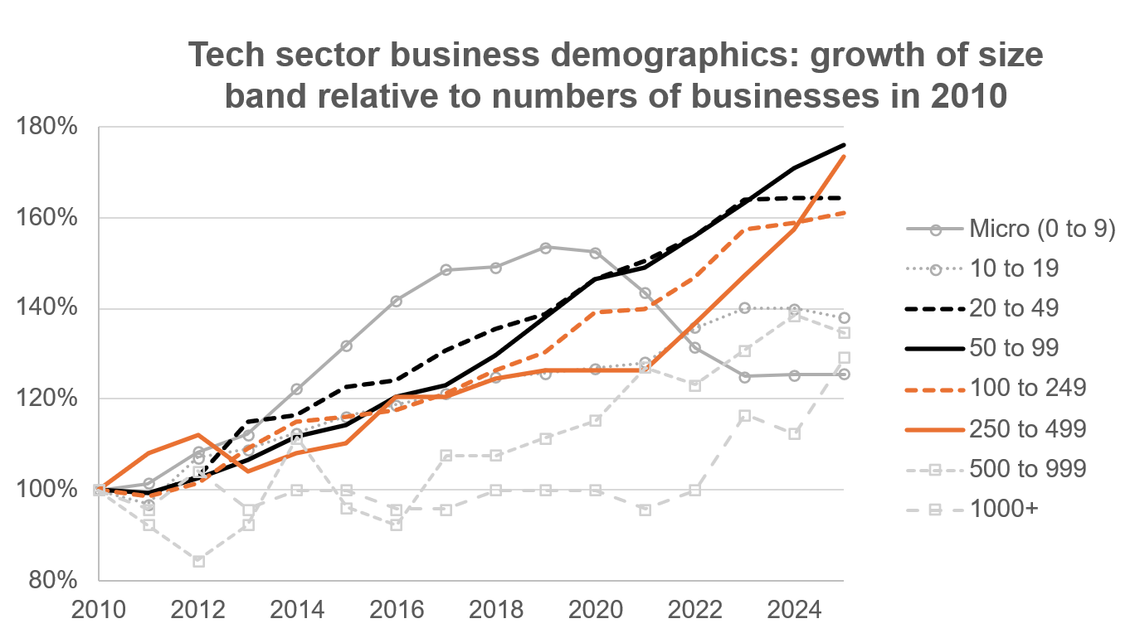

International workers
The tech sector is known to employ a higher proportion of migrant workers than the national average. A recent Migration Advisory Committee (MAC) report, to which Prospect’s Tech Workers Branch contributed, described international workers’ contribution to the sector and the economy in positive terms: a contrast to much of the prevailing political rhetoric. The report is clear that hiring international workers does not reflect a failure to hire from the domestic workforce, but does help to address skill shortages, and brings in valuable talent. It also makes clear that international tech workers make a significant contribution to the UK economy, through their above average earnings (and therefore taxes and NI) and below average use of public services and benefits.
21% of respondents to our survey are non-UK born workers: 9% from EU countries, and 12% from elsewhere. For comparison, the figures given in the MAC review of the sector are 25%, 8% and 17% respectively.
In the figure below, we see how the survey sample measures up against the country-of-birth make-up of a selection of tech occupations. These are based on England and Wales census data, categorised by the Standard Occupational Classification (SOC 2020), which is used for national (and international) statistics, and for the analysis feeding the MAC’s reviews of the economic impacts of international workforces. It’s worth noting that the SOC is a relatively stable controlled vocabulary (10 year review cycle). That’s a valuable quality in the production of official statistics, but makes for a brittle representation of fast evolving sectors and occupations.
The SOC is known to be weak on the emergent occupations and professions of the tech sector. This is a serious risk where it’s used as the basis for policy decisions and design, such as an immigration regime that seeks to protect a priority growth sector such as tech. For example, you could have an acute shortage of User Experience professionals overlooked by economic statistics because they do not have their own distinct classification. Similarly, broad brush or outdated assumptions and methodologies may mishandle specific occupations. Current reviews of the visa regime have binned SOC categories as ‘high-skilled’ (to be handled by skilled worker visa salary thresholds) and ‘medium-skilled’ (to be handled by temporary shortage lists). In the chart below, numeric codes beginning 2* are counted as high-skilled occupations, while those beginning 3* are considered medium-skilled. This may come as a surprise to some of the highly qualified and highly specialised data analysts and DBAs working in research and technical industries.
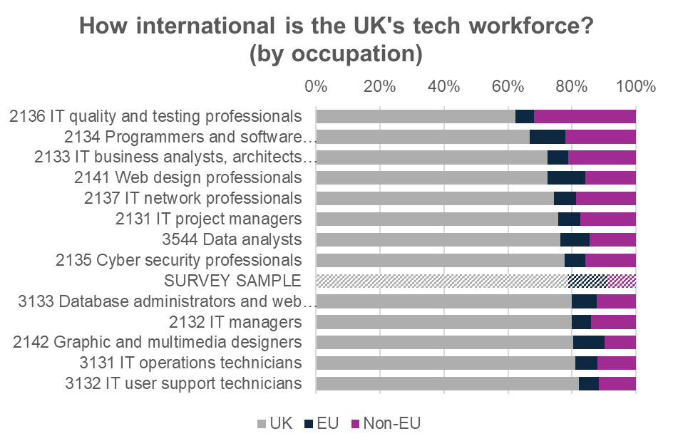
The prevalence of international workers among IT quality and testing professionals is particularly notable when we consider that at least 50% of the occupational workforce, and 60% of women in the workforce are on salaries below the threshold for skilled worker visas, making this an occupation particularly sensitive to any increases in those thresholds, as are expected to be proposed by the end of the year.
The salary distribution of IT business analysts, architects and systems designers is bunched close to the visa salary threshold, making this group, which is in strikingly high and growing demand, also sensitive to increases in the threshold. Only 20% of the workforce (30% of women) fall below the current threshold, but we estimate that those figures could rise by 10% for every hypothesised £5,000 increase.
We asked non-UK born respondents about their experiences of working in the UK. A clear majority responded positively about their workplace as a welcoming environment, and their employers’ recognition of their skills and experience. 4 out of 5 agreed or strongly agreed that they have no immediate plans to leave the UK.
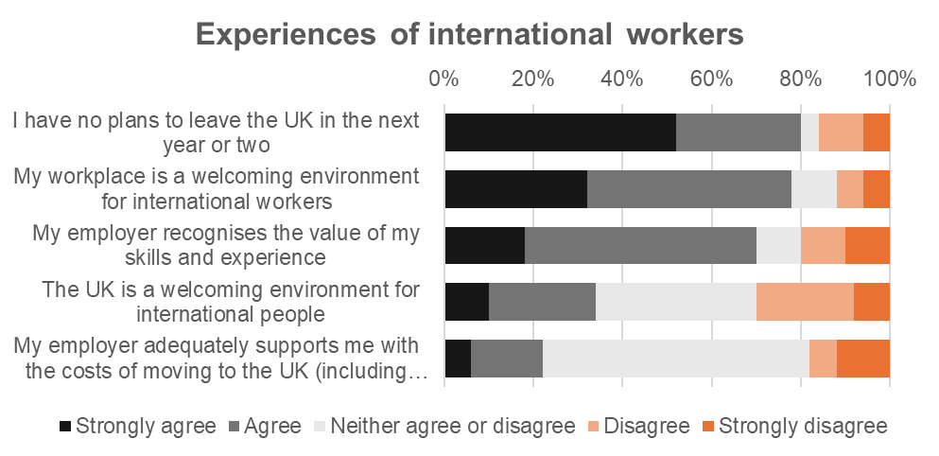
Respondents were much more ambivalent about the UK as a welcoming environment for international people, with an even split between positive, negative and neutral responses. Free text comments showed a common view that the UK’s attitude to international workers has been deteriorating in recent years. The responses were split on employer support with relocation costs, including visa fees, but the majority of respondents were neutral on the subject.
There is the suggestion of a difference in the responses of EU workers and non-EU workers, with EU workers tending to be more positive about their workplace and the UK as welcoming environments, and about their employers’ recognition of their skills. We must take care how we interpret this distinction, based on a fraction of a fraction of a small survey, but it hints at an issue – possibly discriminatory – that may be worth further investigation.

Working time
The tech industry has a reputation for long and antisocial hours, and poor work-life balance, particularly for early career workers and among tech start-ups.
We compared our survey respondents contracted working hours with their hours worked over the previous seven days. There was a much wider spread in the hours worked, with a third of respondents working more than 40 hours, and 7% working more than 50 hours. Broadly, this is a picture familiar to workers in other sectors as well. Where the tech industry is more unusual is in its structural disregard for norms and even regulation of working time. Half (49%) of our respondents told us that they have been asked to opt out of the Working Time Regulations. This is not at all normal in other sectors.
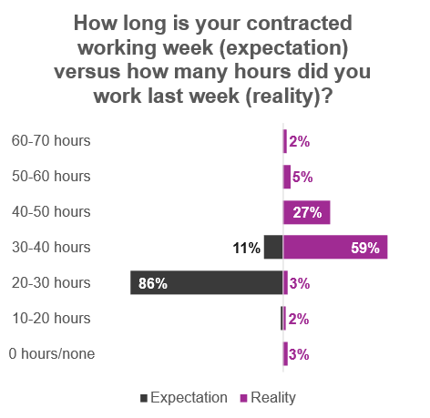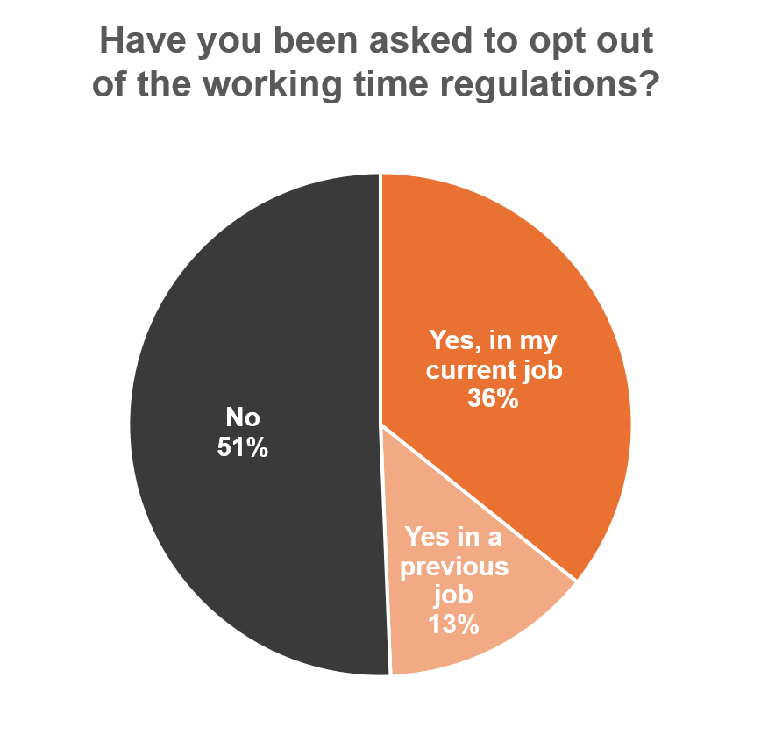
The working time regulations set out the maximum weekly hours an employee can be required to work, minimum rest breaks during the working day and over the working week (between working days), and holiday entitlements. They exist to protect health, safety and wellbeing, but they are widely understood to underpin the accessibility of work. Recent research commissioned by DSIT noted inflexible work as “a key barrier to retaining women, caregivers, disabled, older, and neurodivergent technologists in the tech industry”, ie: a clear majority of the potential workforce.
Working time is important is clearly significant at the individual level, as well as systemically. An overwhelming majority of respondents told us that working hours are an important factor in their career choices: 50% strongly agree; 42% agree. (Note that in the following charts, the colour scale reverses for the last question, which switches into a negative phrasing. Blacks and greys represent positive responses and oranges represent negative responses throughout.)
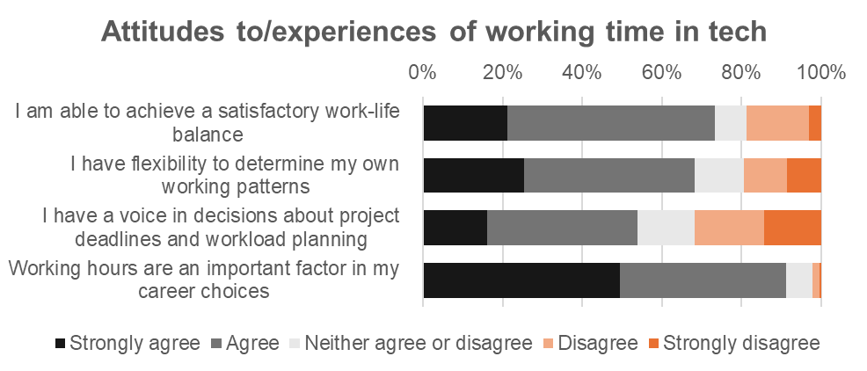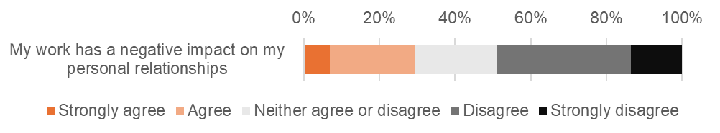
Around two thirds agree or strongly agree that they are able to achieve satisfactory work-life balance, and that they have flexibility to determine their own working patterns. They are more split on whether they have a voice in decisions about deadlines and workload planning: 54% agree; 31% disagree.
Disturbingly, 3 out of 10 respondents say their work has a negative impact on their personal relationships: 23% agree; 7% strongly agree. There does appear to be a shift in the experience of this issue between workers in small to medium, large, and very large businesses. 31% of workers in companies below 250 employees agreed or strongly agreed, compared to 14% in companies with more than 1000 employees. It’s worth reminding ourselves that statistics can be a cold way to describe this very human experience, and that these numbers represent 70 Prospect members telling us that their work is damaging them in a material and potentially lasting way.
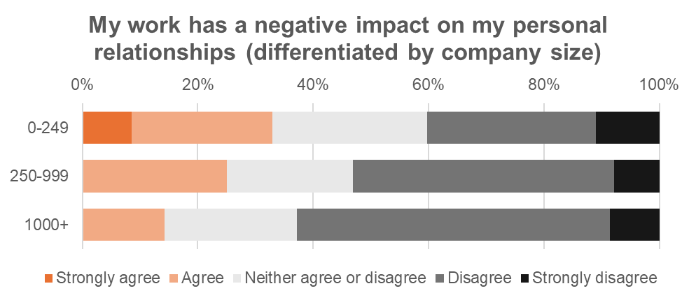

Learning & development
The majority of respondents are positive about the learning and personal development opportunities open to them, but a significant minority are not. 60% tell us that their employer covers the costs and time of role-related training and development, but a third say that have not been offered any training or development for their role.
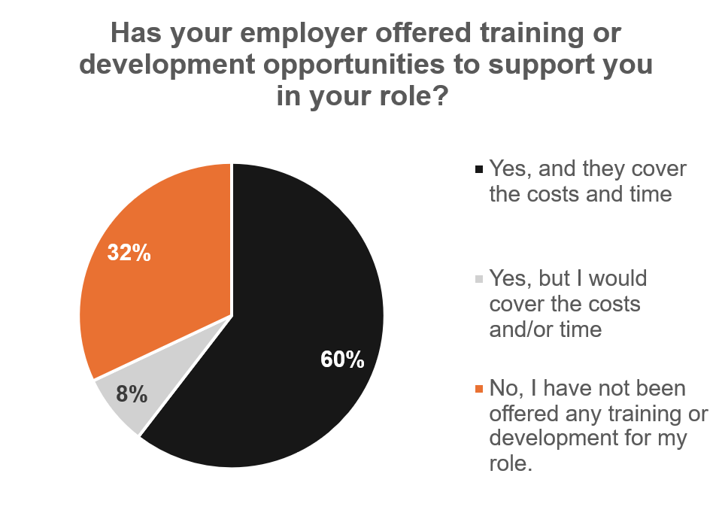
Relatedly, 68% agree or strongly agree that they have opportunities for learning and development in their role, but 21% disagree or strongly disagree. A clear majority (73%), spanning all ages, say that learning and development opportunities are important factors in their career choices. Our findings are more ambivalent about opportunities for career advancement within organisations, and perceptions of fairness in hiring and promotion systems.
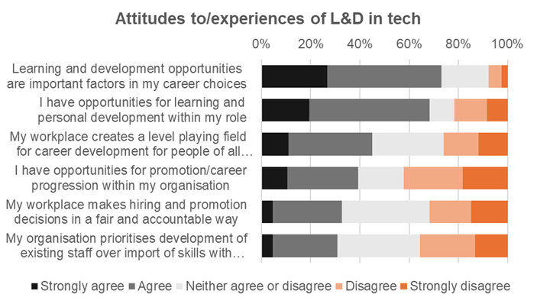

AI in tech
We might reasonably expect tech businesses, and their workforces, to be the vanguard of AI adoption and its most savvy customers. A clear majority of survey respondents (68%) tell us their employer encourages them to use AI in their role, but slimmer majorities agree that their employer is training existing staff (53%) and/or hiring for the skills (52%) to work effectively with AI. Only 28% agreed, against 43% who disagreed that their employer uses AI to compensate for staff shortages (it’s debateable whether that’s a good thing or not).
To the clearly negatively cast statements, 30% report agree or strongly agree that their employer is using digital surveillance tools to monitor activity or attendance, and a non-trivial 18% say their employer is using AI to justify hiring freezes.
It’s both fascinating and rather alarming to set these employers’ enthusiasm for AI deployment against the lacklustre assessment of their governance capabilities. 28% disagreed, and 16% strongly disagreed that their employer has effective systems of AI governance, compared to 20% who agreed and just 7% who strongly agreed. That seems like a risk to companies’ products, services and security, and in the use of tech-enabled management, including employee surveillance, hiring, and performance assessments, it’s a risk to workers’ rights and protections.
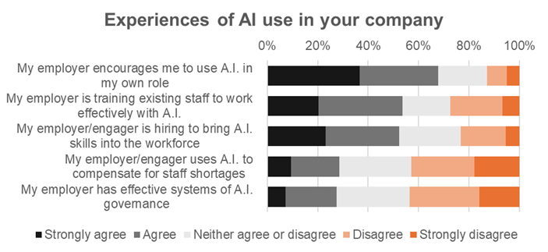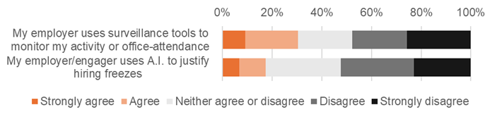
On the subject of benefits to the sector more widely, responses came out slightly more positive than not on the use of AIs to individuals’ own working practice. Respondents were evenly split on whether the use of AI is improving the productivity of the sector overall: 38% agreed that it is; 38% disagreed. It’s worth noting that these contrasting perspectives may not be entirely contradictory. The right application of the right tool, in the hands of a skilled practitioner, under the right governance may certainly be beneficial, while that same tool could be causing havoc elsewhere.
As one respondent commented, it may be counterintuitive, but the use of AI can, on occasions, harm productivity through ‘workslop’ and rework. Evidence is also emerging that, in some cases, the forecasts of economists, and machine learning experts wildly overestimate the benefit to software developer productivity (Expectation: 40% speed-up. Observed result: 20% slow-down).
“There is a huge gap between the claims executives make about LLM-powered tools in the tech sector and the actual experience of using those tools. The output is extremely inconsistent, and often the process of reviewing and validating LLM output is more time consuming than doing the same work without an LLM involved (this is not necessarily obvious, because the person who caused the LLM to produce output is not necessarily the person who has to validate that output, e.g. in a code review process).”
Overwhelmingly, respondents disagreed that AI helps makes hiring processes fairer and more robust: only 2% agreed and nobody strongly agreed, against 32% who disagreed, and 42% strongly disagreed.
Responses to our negatively cast statements are striking. Half of respondents say they feel ‘under pressure’ to use AI in their work (compare this to the 68% who earlier said that their employer ‘encourages’ it), against a quarter who disagree. In tune with recent reports, 60% agree that AI is displacing more entry level jobs than it creates, against just 8% who disagree. And an incredible 32% agree, and 42% strongly agree that the use of AI is a threat to the quality of tech sector outputs. Perhaps it’s time for the sector to get serious about those effective systems of governance!
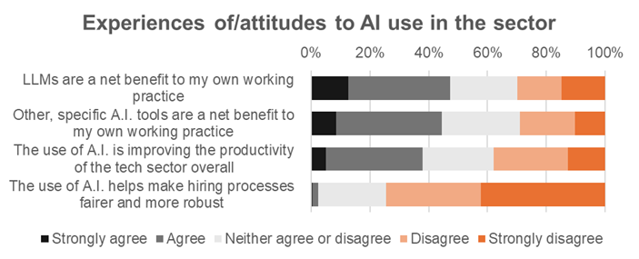
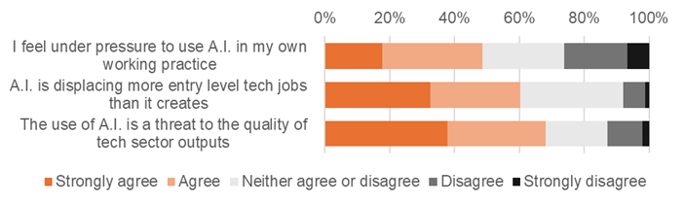

Now and next
Given the centrality of tech to the government’s industrial strategy, we asked for suggestions on what action they should take to promote secure growth in the sector. Many comments related to sovereign technology:
- “Prioritise UK built products in tender processes… strengthen worker IP protections to ensure UK innovation remains in the UK”
- “Invest in sovereign [core-funded] AI infrastructure and core-funded institutions to provide independent consultancy to UK businesses in a non-competitive, technology-agnostic.”
- “Focus on the good, well-paid jobs in the creation of new technologies. The UK has many chip design and software design roles which are good roles with large tax contributions. The attention on data centres, which produce relatively few jobs, is misplaced.”
- “It's no good having an expensive data centre if there are only a small number of employees.”
- “Offer tax breaks for using fairly paid employees in the UK rather than AI/overseas contractors.”
- “Ensure there are compute infrastructure options not owned by billionaires in a foreign country.”
Others focussed on workforce skills development and retention:
- “Drop the AI obsession and focus on core skills development training for youth and for people either looking for work or looking to change careers.”
- “The UK gov should support efforts such as the National Centre for Computing Education so that the next generation is well prepared - even if they don't end up in tech themselves.”
- “More targeted tax breaks/incentives to enhance existing staff via training, particularly new starters. Make it a better option than outsourcing.”
- “Simplify the visa process for overseas workers”
- “Remember the Engineering Industry Training Board? Fund specific classes for school-leavers in large numbers, giving them blended education in digital skills and work experience.”
- “Support juniors and young professionals, make benefits for companies which are hiring juniors - because if we’ll not have juniors in the next 5-10 years, we’ll not have any seniors in 15-20 years.”
- “Offer something similar to apprenticeships for older people wanting to retrain into other areas.”
Tech literacy (and independence) of the government themselves:
- “The government has NO idea about 'tech' and keeps getting caught up in the quick-fixes offered by the snake oil salesmen. Whether it is Blockchain, Quantum or AI, they are utterly taken in EVERY time.”
- “Increase diversity in the house of commons. Anyone with any software background would have called out the idea that Horizon's software was flawless.”
- “Use real technical experts in government”
- “Stop being so gullible when speaking with hype merchants and con men”
Regulation of the sector and the use of its products:
- “Stronger workers council regulations i.e., Germany's 'Workers Council' to ensure work is safe and extra hours worked are compensated.”
- “Ensure that proper legislation to restrict AI is in place, not allow the UK to become a Wild West where legal and social norms are tossed aside to get a quick AI sugar rush… it will not be sustainable and will harm tech but also the wider economy in the long run.”
- “Preventing the use of AI to displace workers, for example, by freezing layoffs for a year from when the employer adopts AI”
Other recurring themes included supporting diversity in the tech workforce; flexible working and work-life balance; and funding and tax reliefs for small businesses and freelancers.
Several responses challenged the political nature of the question itself. While Prospect is a politically-independent trade union, we do have to be politically engaged. Our core business of employment and industrial relations takes place in a political, economic and industrial context, and our ability to influence workplace rights and conditions over the long term is often augmented by our critical engagement with national and sectoral policy agendas.
Finally, we invited respondents to rank issues according to which should be the main priorities for the branch agenda and follow-up research. The table below organises these issues according to what proportion of respondents put them in their individual ‘Top 3’.
Reward packages is the clear favourite, with half of respondents putting it in their Top 3, and a third ranking it 1st. ‘Worker voice’ also holds its 2nd place whether counted by rank 1 or Top 3 scores. Workforce skills, however, was few people’s first choice, but many more people’s 2nd or 3rd choice, putting it up to third as measured by Top 3 placement. Conversely, tech regulation and tech industrial strategy were joint 3rd by rank 1 placement, but industrial strategy drops to a distant 5th place in people’s Top 3.
This is a messy picture: it suggests a couple of clear rule-ins for branch priorities – reward packages and worker voice – but it’s weaker on the rule-outs! Branch members should keep in mind that there will continue to be support, and opportunities for engagement at the union scale, on issues that might not be foremost on the branch agenda.
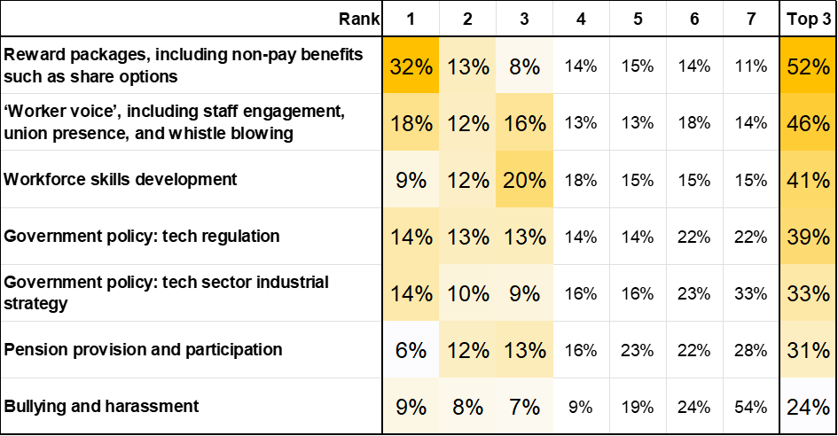

State of the Tech Workforce UK, CompTIA 2024. https://www.comptia.org/en-gb/resources/research/state-of-the-tech-workforce-uk-2024/
Economic Estimates: Employment in the Digital Sector, January 2024 to December 2024, Department for Science, Innovation and Technology, July 2025. https://www.gov.uk/government/statistics/economic-estimates-employment-in-the-digital-sector-january-2024-to-december-2024
Diversity in Tech Report 2024, Tech Talent Charter, 2024. https://www.techtalentcharter.co.uk/reports/diversity-in-tech-report-2024/
Diversity in tech: landscape research findings. Novel Design Ltd for Department for Science, Innovation and Technology, December 2024 https://assets.publishing.service.gov.uk/media/6853ec1fa3a28280485814fc/diversity-in-uk-tech.pdf
Everyday ageism in the tech industry. CWJobs, 2019. https://www.cwjobs.co.uk/advice/ageism-in-tech
Professionals in IT and engineering. Migration Advisory Committee, May 2025. https://www.gov.uk/government/publications/professionals-in-it-and-engineering-review/professionals-in-it-and-engineering-accessible
SOC 2020 volumes and related information, Office of National Statistics https://www.ons.gov.uk/methodology/classificationsandstandards/standardoccupationalclassificationsoc/soc2020
Diversity in tech: landscape research findings. Novel Design Ltd for Department for Science, Innovation and Technology, December 2024 https://assets.publishing.service.gov.uk/media/6853ec1fa3a28280485814fc/diversity-in-uk-tech.pdf
AI-generated “workslop” is destroying productivity. Harvard Business Review, September 2025 https://hbr.org/2025/09/ai-generated-workslop-is-destroying-productivity
Measuring the impact of early-2025 AI on experienced open-source developer productivity. Becker, J., Rush, N., Barnes, E., Rein., D in METR, 2025 https://metr.org/blog/2025-07-10-early-2025-ai-experienced-os-dev-study/
Gen Z faces ‘job-pocalypse’ as global firms prioritise AI over new hires, report says, Guardian, 9 October 2025 https://www.theguardian.com/money/2025/oct/09/gen-z-face-job-pocalypse-as-global-firms-prioritise-ai-over-new-hires-report-says

