
Welcome to key skills for union reps
Welcome to this introductory course for Bectu representatives which forms part of your induction training.
As well as attending some formal training courses with us, other local union reps and full-time officers will support your ongoing development as a trade union representative.
Our aims are to welcome you to Bectu, help you understand what the union stands for and give you a clear idea of your place in that.
We will help you to be an effective and confident union rep able to support members, build good relationships at work and a build stronger union organisation at local level.
The training is very informal and there is no pressure on anyone to do anything they are not comfortable with.
There is plenty of discussion and problem solving, as these are the most effective methods in adult learning.
Learning outcomes:
- know a what a trade union is and how to increase membership
- know the role of a rep
- know your rights as a rep
- know how the union can be a force for good in your workplace
- know the structure of Prospect and Bectu.

Course timetable
- Introductions and objectives
- What is a trade union?
- How Bectu works
- The role of a rep
- Reps’ rights
- Ingredients of union influence
- Building a stronger union
- Branch action plan/end of day housekeeping
Table of Contents
Course timetable 2
Trade union terminology 5
About Prospect 6
What happens on trade union courses? 7
The tutor’s role 7
Your role 7
Using your knowledge and skills 8
Equality and diversity statement 9
Session 1: Activity A – Introductions 10
Session 2: What is a trade union 12
Recognition in the workplace 12
Your right to join a trade union 12
The general benefits of union membership 12
Activity B: Compare a trade union to other options 13
Activity C: What can a union negotiate on? 13
Activity D: Servicing or organising – describe your workplace 14
Session 3: How Prospect works 15
Watch the video – How Prospect works 15
What is a branch? 15
Why does it matter what branch you are in? 15
What happens when a new member joins Prospect/Bectu? 16
Sectors 16
Divisions 16
Branch reps 16
Branch meetings 17
How branch democracy works 17
Support for branches 18
National executive committee 18
NEC advisory sub-committees 19
Prospect/Bectu structure 19
Session 4: The role of a rep 20
Activity E: What do union reps do? 20
Types of rep 20
Bectu’s eSite system 23
A number of well-trained reps make a strong branch 24
Session 5: Reps’ rights 25
Extract from ACAS Code of Practice 3 25
Duties 25
Activities 25
Responsibilities 26
Facilities agreements 26
Activity F: What are your rights? 27
Activity G: What would you do if… 29
Session 6: Ingredients of union influence 31
Activity H: What are the ingredients that increase the union’s influence 31
The virtuous circle 31
Local union reps… 32
Activity I: Why people don’t join a union 32
Ten good reasons to join Bectu 33
Session 7: Building a stronger union 34
Activity J: Staff room talk 34
Activity K: How well organised is your workplace? 35
Activity L: Mapping the workplace 36
Identifying potential activists 38
How members can help 38
Any questions? 38
Putting what you’ve learnt into practice 39
Appendix 1: How do you get Bectu to do something in your branch? 40
National conference – making or changing Bectu policies 40
Appendix 2: How to write conference motion 41
Appendix 3: Data protection 42
Appendix 4: Updating members using the Bectu website 44
Contacting branch members 44
Editing the branch pages 47
Appendix 5: Useful links 48

Trade union terminology
ACAS – The Advisory, Conciliation and Arbitration Service – a public body that provides free and impartial information and advice to employers and employees on all aspects of workplace relations and employment law.
Bargaining unit – The 'bargaining unit' is the group of employees that will be represented by the union. The employer and the union can agree who is in this unit as part of their negotiations. If the employer and the union don’t agree, the Central Arbitration Committee (CAC) will decide.
Branch – Branches are the key organising unit in the union. Branches form the basis of representation to other advisory or policy-making bodies in the union structure.
Case handler – A rep that is trained to represent a member in a personal case.
Central Arbitration Committee (CAC) – Its main function is to adjudicate on applications for statutory recognition and derecognition of trade unions for collective bargaining purposes.
Collective agreement – Where collective bargaining has led to an agreement, for example pay increase, these agreements are called collective agreements. Collective agreements within the workplace can cover both union and non-union staff as trade unions often negotiate on behalf of the staff employed in a specific group. This group is known as the bargaining unit.
Collective bargaining – If a union is formally recognised by an employer, it can negotiate with the employer over terms and conditions. This is known as 'collective bargaining'.
Conference – Prospect’s national conference is held every two years. Delegates discuss and agree the union’s policies and priorities.
Convenor – See trade union rep.
Facilities agreement – An agreement between the employer and the union setting out the provision of facilities and facility time for trade union officials, representatives and members.
Industrial action - usually happens when a dispute in the workplace can’t be resolved through negotiation. There are three main forms of industrial action:
- strike – where workers refuse to work for the employer
- action short of a strike – where workers take action such as working only to the terms of their contracts, overtime bans or callout bans (sometimes called work to rule).
- lock-out – a work stoppage where the employer stops workers from working.
Lay reps – members of the union who represent their colleagues in union work in companies that have a collective bargaining agreement with Prospect
National executive committee – Prospect’s NEC is elected every two years and is made up of representatives who make key decisions about what and how we deliver for our members.
Prospect Data Protection Compliance Officer – The person who handles data requests and data on behalf of Prospect datacompliance@prospect.org.uk
Prospect’s Member Contact Centre (MCC) – a service for members to have their queries answered. Tel. 0300 600 1878
Trade union – An organisation made up of members (a membership-based organisation) and its membership must be made up mainly of workers.
Trade Union Congress (TUC) – the umbrella body for the majority of unions in England and Wales.It has 48 member unions representing around 5.5 million people.
Union recognition – Employers who recognise a union will negotiate with it over members’ pay and conditions.
Union rep/shop steward – Trade union reps are elected directly by their fellow workers and act as their representatives in individual and collective dealings with management. Trade union reps aren’t paid but they do get paid time off to do their work as a rep.

About Prospect

Most of the larger unions in the UK have grown and evolved through mergers and acquisitions with other unions, staff associations and professional bodies – either through necessity or strategy.
Prospect is no exception, having absorbed various groups of professional and specialist staff. It is now the tenth largest union in Britain out of the sixty-six affiliated to the Trades Union Congress – the umbrella body for Britain’s unions – and the most diverse.
Prospect was formed in 2001 through the merger of the Engineers and Managers Association and the Institution of Professionals, Managers and Specialists. IPMS originated from the Royal Corps of Naval Constructors of 1916, so the new union inherited extensive history.
The EMA’s power station managers and electricity distribution engineers complemented the IPMS demographic (scientists, engineers and managers in the defence, energy, heritage, environment and transport sectors) and strengthened our bargaining power.
Prospect merged with the telecoms professionals in Connect union in 2010 and with Aspect, which represents professionals in education, children’s services and social care in 2012. In January 2017, Bectu, the media and entertainment union, joined us to create a sector which includes broadcasting, cinema, film, digital media, independent production, leisure, IT and telecoms, theatre and the arts.
Despite the expansion, the union has managed to maintain four key principles of industrial relations that are consistently important to members, whichever union they originated from:
- we represent professional staff
- we are not affiliated to any party political
- one of our objectives is ‘…to promote the advancement and efficiency of industries and organisations where members are employed’
- as an affiliate, we enjoy the resources of the TUC.

What happens on trade union courses?
For many trade union activists, Bectu courses mark a return to education, sometimes when previous experiences have been less than positive.
Trade union education places great value on the knowledge that union reps bring to the course and seeks to enhance this by working co-operatively to gain new knowledge.
We place great emphasis on team working and involving everybody in the learning process. This not only makes learning interesting and challenging but is rooted in well-researched and tested educational methods.
As part of this approach we will:
- encourage a cooperative approach to learning
- allow workplace experiences to be reflected and valued throughout the programme
- help you to build a useful resource pack to support your union activity
- encourage a collective approach to your role as a Bectu representative.

The tutor’s role
Trade union tutors are qualified to teach in the ‘learning and skills sector’ (adult education outside of university) and will also have extensive practical experience as trade unionists.
They should be inspiring, accessible and empowering – you should learn from them! Your tutor will:
- make sure that the expected learning outcomes are clear
- encourage and facilitate everyone’s participation
- introduce you to new ideas and concepts
- giving guidance on how to become an accredited rep
- help you understand your own preferred learning styles and ensure that everyone can participate and benefit.

Your role
The focus of trade union education is 'learning' rather than 'teaching'. The focus is on you and your colleagues as learners rather than on the tutor (although their role is absolutely vital) as teacher. In particular, we hope you will:
- feel confident to participate fully
- be able to support your colleagues
- enjoy the learning process
- add to your existing knowledge and skill
- use your new knowledge and skills to support Bectu’s aims in your workplace.
We ask that you take an active part in the course, support your fellow reps and course members when you can and be respectful of other delegates during the course – this will help you promote collective and co-operative activity at your own workplace.
We respect whatever pronoun you wish to be referred to during the course – please write it on your name card.

Using your knowledge and skills
Learning and knowledge are valuable in their own right – they need no justification but as practical people we want to encourage you to develop further.
First, we want your experience of learning with us to encourage you to engage in other forms of learning.
Second, we hope you will use your learning to make a difference at work – for the better.
To help you put your learning to good use we will provide you with a small ‘action plan’ for you to apply at your workplace. We will also support you to carry it out.

Equality and diversity statement
Bectu is dedicated to providing training for all its representatives and activists that aspires to the highest standards of respect for difference and diversity.
This statement is inspired by our trade union values of justice, fairness, democracy, solidarity and equality. As a trade union, we oppose any view, action or organisation that undermines the ability of working people to act collectively to pursue their democratically determined policies and objectives.
We are opposed to discrimination against people on the basis of their gender, nationality, ethnicity, religion, disability, sexual orientation, marital status, social class, age, politics or education.
We defend the right to freedom of expression and to political opinions and beliefs except where these conflict with, or tend to undermine, the freedom of other people from discrimination on the grounds listed above.
In particular, we are opposed to sexist, racist and fascist ideologies and will not permit such views to be promoted at Bectu education events.
We will seek to ensure that all Bectu training is accessible to all who wish to attend. Recruitment to courses will be open, fair and in line with our commitments above.
All courses will allow opinions to be put forward and defended (consistent with the statement above). All members who attend Bectu courses are entitled to respect.
Members who want to raise issues relating to our commitment to equality and diversity, or if they wish to lodge a complaint about any incident or failure concerning this policy, should use the following procedure:
- any issue occurring during a course to be raised with the tutor
- if this is not practicable, or if the complaint is not dealt with to the satisfaction of the member, it should be raised with Bectu’s education officer or the education and skills manager
- if a member is not satisfied, the matter should be referred to the General Secretary.

Session 1: Activity A – Introductions

The tutor will split you into pairs.
Please gather the following information from your partner:
- their name
- the company they work for
- their current work role
- why they first become involved in the union
- their current union role and how long they have been active in that role
- what they want from the course
- an interesting fact about the person (preferably not work-related).

The tutor will ask you to introduce your partner to the other course participants.
Please complete this form for the person you interview, not yourself.

Name
Company
Work role
Why they got involved in the union
Current union role
What does the person you are interviewing want from the course?
Interesting fact about the person

Session 2: What is a trade union
The definition of a trade union is: An organised association of workers in a trade, group of trades, or profession, formed to protect and further their rights and interests.

Recognition in the workplace
Employers are not obliged to bargain with unions. They can voluntarily recognise a union or a union can gain statutory recognition by meeting certain criteria and applying to the Central Arbitration Committee.
With a recognition agreement in place, the employer ‘recognises’ the union for collective bargaining purposes. Statutory recognition is limited to pay, hours and holidays.

Your right to join a trade union
You have the right to:
- choose to join, or not join, a union
- decide to leave or remain a member of a union
- belong to the union you choose, even if it’s not the one your employer negotiates with on pay, terms and conditions
- belong to more than one union.
Your employer is not allowed to:
- offer you a benefit to leave a trade union
- threaten to treat you unfairly if you don’t leave a union or stop doing union activities.

The general benefits of union membership
Unions have brought significant changes to society, including:
- a national minimum wage
- the abolition of child labour
- improved worker safety
- improved living standards by reducing the number of hours in the working week and encouraging a healthy work/life balance
- improved parental leave
- equality legislation
- better protection of migrant workers and a reduction in exploitation
- minimum holiday and sickness entitlements.
You are better off in a workplace that recognises a union because wages are higher, health and safety is better and union workplaces usually offer more training and development.
Pay – Union members, on average, earn more per hour than those who are not part of a union. In the most recent surveyed time period, the difference in hourly wages amounted to 10.3%. See – http://bit.ly/union-wage-premium
Health and safety – see www.tuc.org.uk/research-analysis/reports/union-effect
Union workplaces offer more training to their staff www.tuc.org.uk/sites/default/files/Skils_and_training.pdf
How unions and collective bargaining create great jobs – www.tuc.org.uk/research-analysis/reports/great-jobs-are-union-jobs
TUC research found that for every £1 spent on training, the economy got £12.87 back –https://www.tuc.org.uk/sites/default/files/2020-11/TheFutureUnionLearningFund.pdf
Download a leaflet which sets out our legal team’s successes between November 2018 and November 2019 – https://library.prospect.org.uk/download/2019/01668
When you are trying to persuade a colleague to join, always mention local issues that have been won or that the union has campaigned on. Sometimes the best thing to say is why you joined.

Activity B: Compare a trade union to other options
As a group discuss the benefits of being in a trade union as opposed to the following options:
- Facebook group or other social media groups
- workers’/employees’ forum
- single employee action
- professional body.

Activity C: What can a union negotiate on?
In your groups make a list of what a trade union can do.
In three groups, focus on one area and have one-person feedback to the rest of the group.
- What can you expect to be informed on?
- What can a union negotiate on?
- What should you be consulted on?

Activity D: Servicing or organising – describe your workplace
The tutor(s) will provide a brief explanation as to what servicing and organising means.
Read the statements overleaf and tick those which describe your branch at the moment. You may tick both sides, leave blank those that don’t apply.

Servicing model | √? | Organising model | √?
The union is seen as external – as a third party that comes in to do things and then leaves again. |  | Members see themselves as the union and do things themselves rather than ask the union to do things for them.
Union officials tell members ‘the union’ will sort out problems on their behalf. |  | Members identify their own issues, organise to solve them together and only ask for help if they need it.
The union relies on the employer to provide lists of workers’ names to the union official. |  | Union members ‘map’ the workplace themselves – names and information are provided by workers.
Relies wholly on employer for workplace access. |  | Some organising can be done outside work.
The union relies on ‘cold’ selling of membership by specialist organisers who do not work at the employer. |  | First recruiting steps are carried out by members to establish contacts, find natural leaders and uncover issues.
Union ‘sold’ to potential members on the basis of services and insurance protection. |  | Members see the union as a means to achieve direct improvements at work.
Local reps and committee members rely on full time officials to recruit and solve problems |  | Workplace organising committee formed; workers encouraged to build the union through one-to-one organising.
Recruiting is seen as separate from other activities. |  | Recruitment and organising are integrated.
Results are achieved but are likely to be short term. |  | Results obtained through sustained efforts are more likely to be permanent.
Workers blame ‘the union’ when it can’t get results. |  | Members share decisions and solve problems together with union leaders.
Members complain they pay subs and the union does nothing. |  | Members make a real contribution and identify with the union. An attack on the union is an attack on themselves.
Organisers resent members for not coming to meetings or participating. |  | The union’s image is positive and active.
Management acts while the union reacts and is always on the defensive. |  | The union has its own agenda and members are involved.

Session 3: How Prospect works
Prospect is an independent union and is not affiliated to any political party. Its objectives are set out in its rules. It exists to:
- protect and promote members’ interests
- maintain and improve their conditions of employment and relations between them and their employer
- provide and maintain services for the benefit of members.
As a union is democratic, it has to have a structure that makes that possible. The first part of that structure is the branch.

Watch the video – How Prospect works
https://vimeo.com/showcase/prospect-ed Password: education

What is a branch?
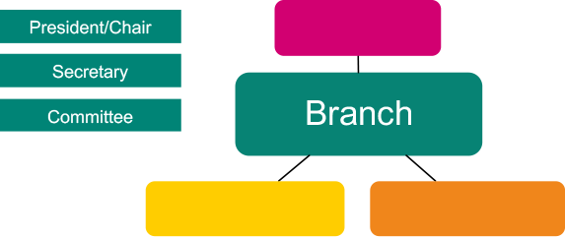
A branch is a usually made up of members who work for one employer (bargaining unit). A bargaining unit is the group of workers for whom a trade union is requesting, or has been granted, recognition.
Large branches, for example workplaces with several sites or businesses, may be broken down into sections or sub-sections.
Your branch should be organised so that every member who could be affected by negotiations carried out by branch representatives can be informed and have their say.

Why does it matter what branch you are in?
It is very important that members are in the right branch/bargaining unit so that they can speak or vote on issues that affect them. It also means that the union and its reps can better ‘group’ members together and make it easier to help them and deal with issues.

What happens when a new member joins Prospect/Bectu?
A new member is put into the appropriate branch. This is decided from the following information:
- who they work for
- their job or role
- their work location.
A member can only be in one branch. If it is not certain which branch they should be in, they go into a regional branch until it can be narrowed down or a new branch is formed.

Sectors
A sector is made up of branches with employers who have a similar business, eg energy, media and entertainment or public services.
Sectors have committees and conferences which are held every two years.

Divisions
The Bectu sector of Prospect is split into seven divisions who’s branches have either similar employers or similar freelance work. These are:
- Arts & Entertainment
- BBC
- London Production
- Regional Production
- Independent Broadcasting
- BT
- Digital
Divisions have committees and conferences held every two years, with the exception of the BT division which is annually.

Branch reps
Under the union’s rules, a branch has to elect a president or chair responsible for:
- the proper conduct of any branch meeting
- ensuring that business is kept moving and every member gets a chance to speak if they want to
- clarifying that clear decisions are reached and recorded.
Another role needed under union rules is a secretary, whose duties include:
- calling branch conferences or annual general meetings (AGM) or any other branch meeting and making the arrangements
- preparing and circulating agendas, minutes and action lists
- being the conduit between the branch and Bectu as a whole
- maintaining branch records.
To protect members’ data and to avoid sending out emails that members may not be interested in, Bectu nationally sends the majority of correspondence to branch secretaries.
In smaller branches, the secretary is usually in charge of the membership records; larger branches may have a dedicated membership secretary or organiser.
Other roles that the branch may elect include: organiser, treasurer, health and safety rep, union learning rep, equality rep, pension rep, environmental rep and case handler, see session 4.

Branch meetings
A branch meeting is where an issue can be discussed, and a democratic decision reached and voted on.
A majority decision at a branch meeting is the course of action a representative takes up with management on the members’ behalf.
Most members do not want to attend branch meetings. Decisions still need to be made on the day-to-day business of the branch. So the branch elects a committee to facilitate this.
It is very important that all the different working areas/grades/departments are represented on the committee.

How branch democracy works
It is very important that issues that affect the majority of the branch are dealt with as a priority.
Getting agreement at a meeting may not be easy. The chair will need to keep order and make sure all the sides of the argument are heard.
The committee should agree beforehand who will provide the information needed for the members to make an informed decision.
An issue is raised, and an action is voted on at a meeting.
A meeting needs to be quorate for a decision and a course of action to be made.
A quorum is enough members to be a reasonable representation of the branch – for example, 10%.
The branch usually instructs the committee to take action – this could be to call a meeting with management to discuss the issue.
In between meetings, the committee can discuss an issue that arises and decide a course of action. There may be occasions when a full branch meeting is needed.
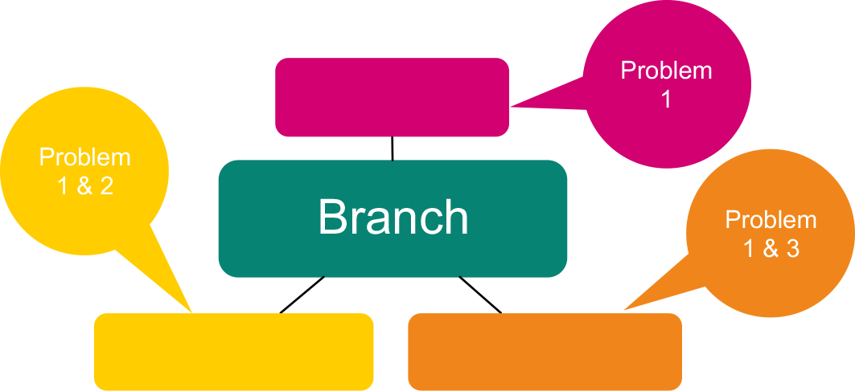
For further information on how to take an issue further in the union or to get support from other branches, see Appendix 1 and 2.

Support for branches
Branches can call on Bectu for support. Every branch in the union has an organiser and a negotiator. These staff have further support from the legal, communications and education departments.



National executive committee
The national executive committee (NEC) conducts the business of the union in accordance with the policies laid down by national conference. It manages the union’s affairs between conferences and normally meets five times a year.
The NEC consists of 28 working members, including three office-holders – the president, vice-president and deputy vice-president (the ‘presidential team’), plus the general secretary. The general secretary has no voting rights.
The NEC is elected by working members every two years, from a list of candidates nominated by branches.
NEC members do not represent particular branches or professions. They are elected to look after the interests of the whole membership.
The president, vice-president and deputy vice-president are elected every two years from among the voting members of the NEC.
The NEC establishes the sub-committees it needs for the despatch of its business. Each of them may set up panels or working parties reporting to them on particular aspects of their work. Some of these committees invite direct participation by branch reps.

NEC advisory sub-committees
The NEC has to make many decisions in the two years between national conferences. They need relevant information to be able to make those decisions. Advisory committees, made up of reps from all the sectors of Bectu, were set up to help with this.
The sub-committees are:
- Committee for organisation, recruitment and education
- Communications and campaigns
- Equal opportunities
- Health and safety
- Pensions
- Science, engineering and sustainability
- Finance and audit.

Prospect/Bectu structure
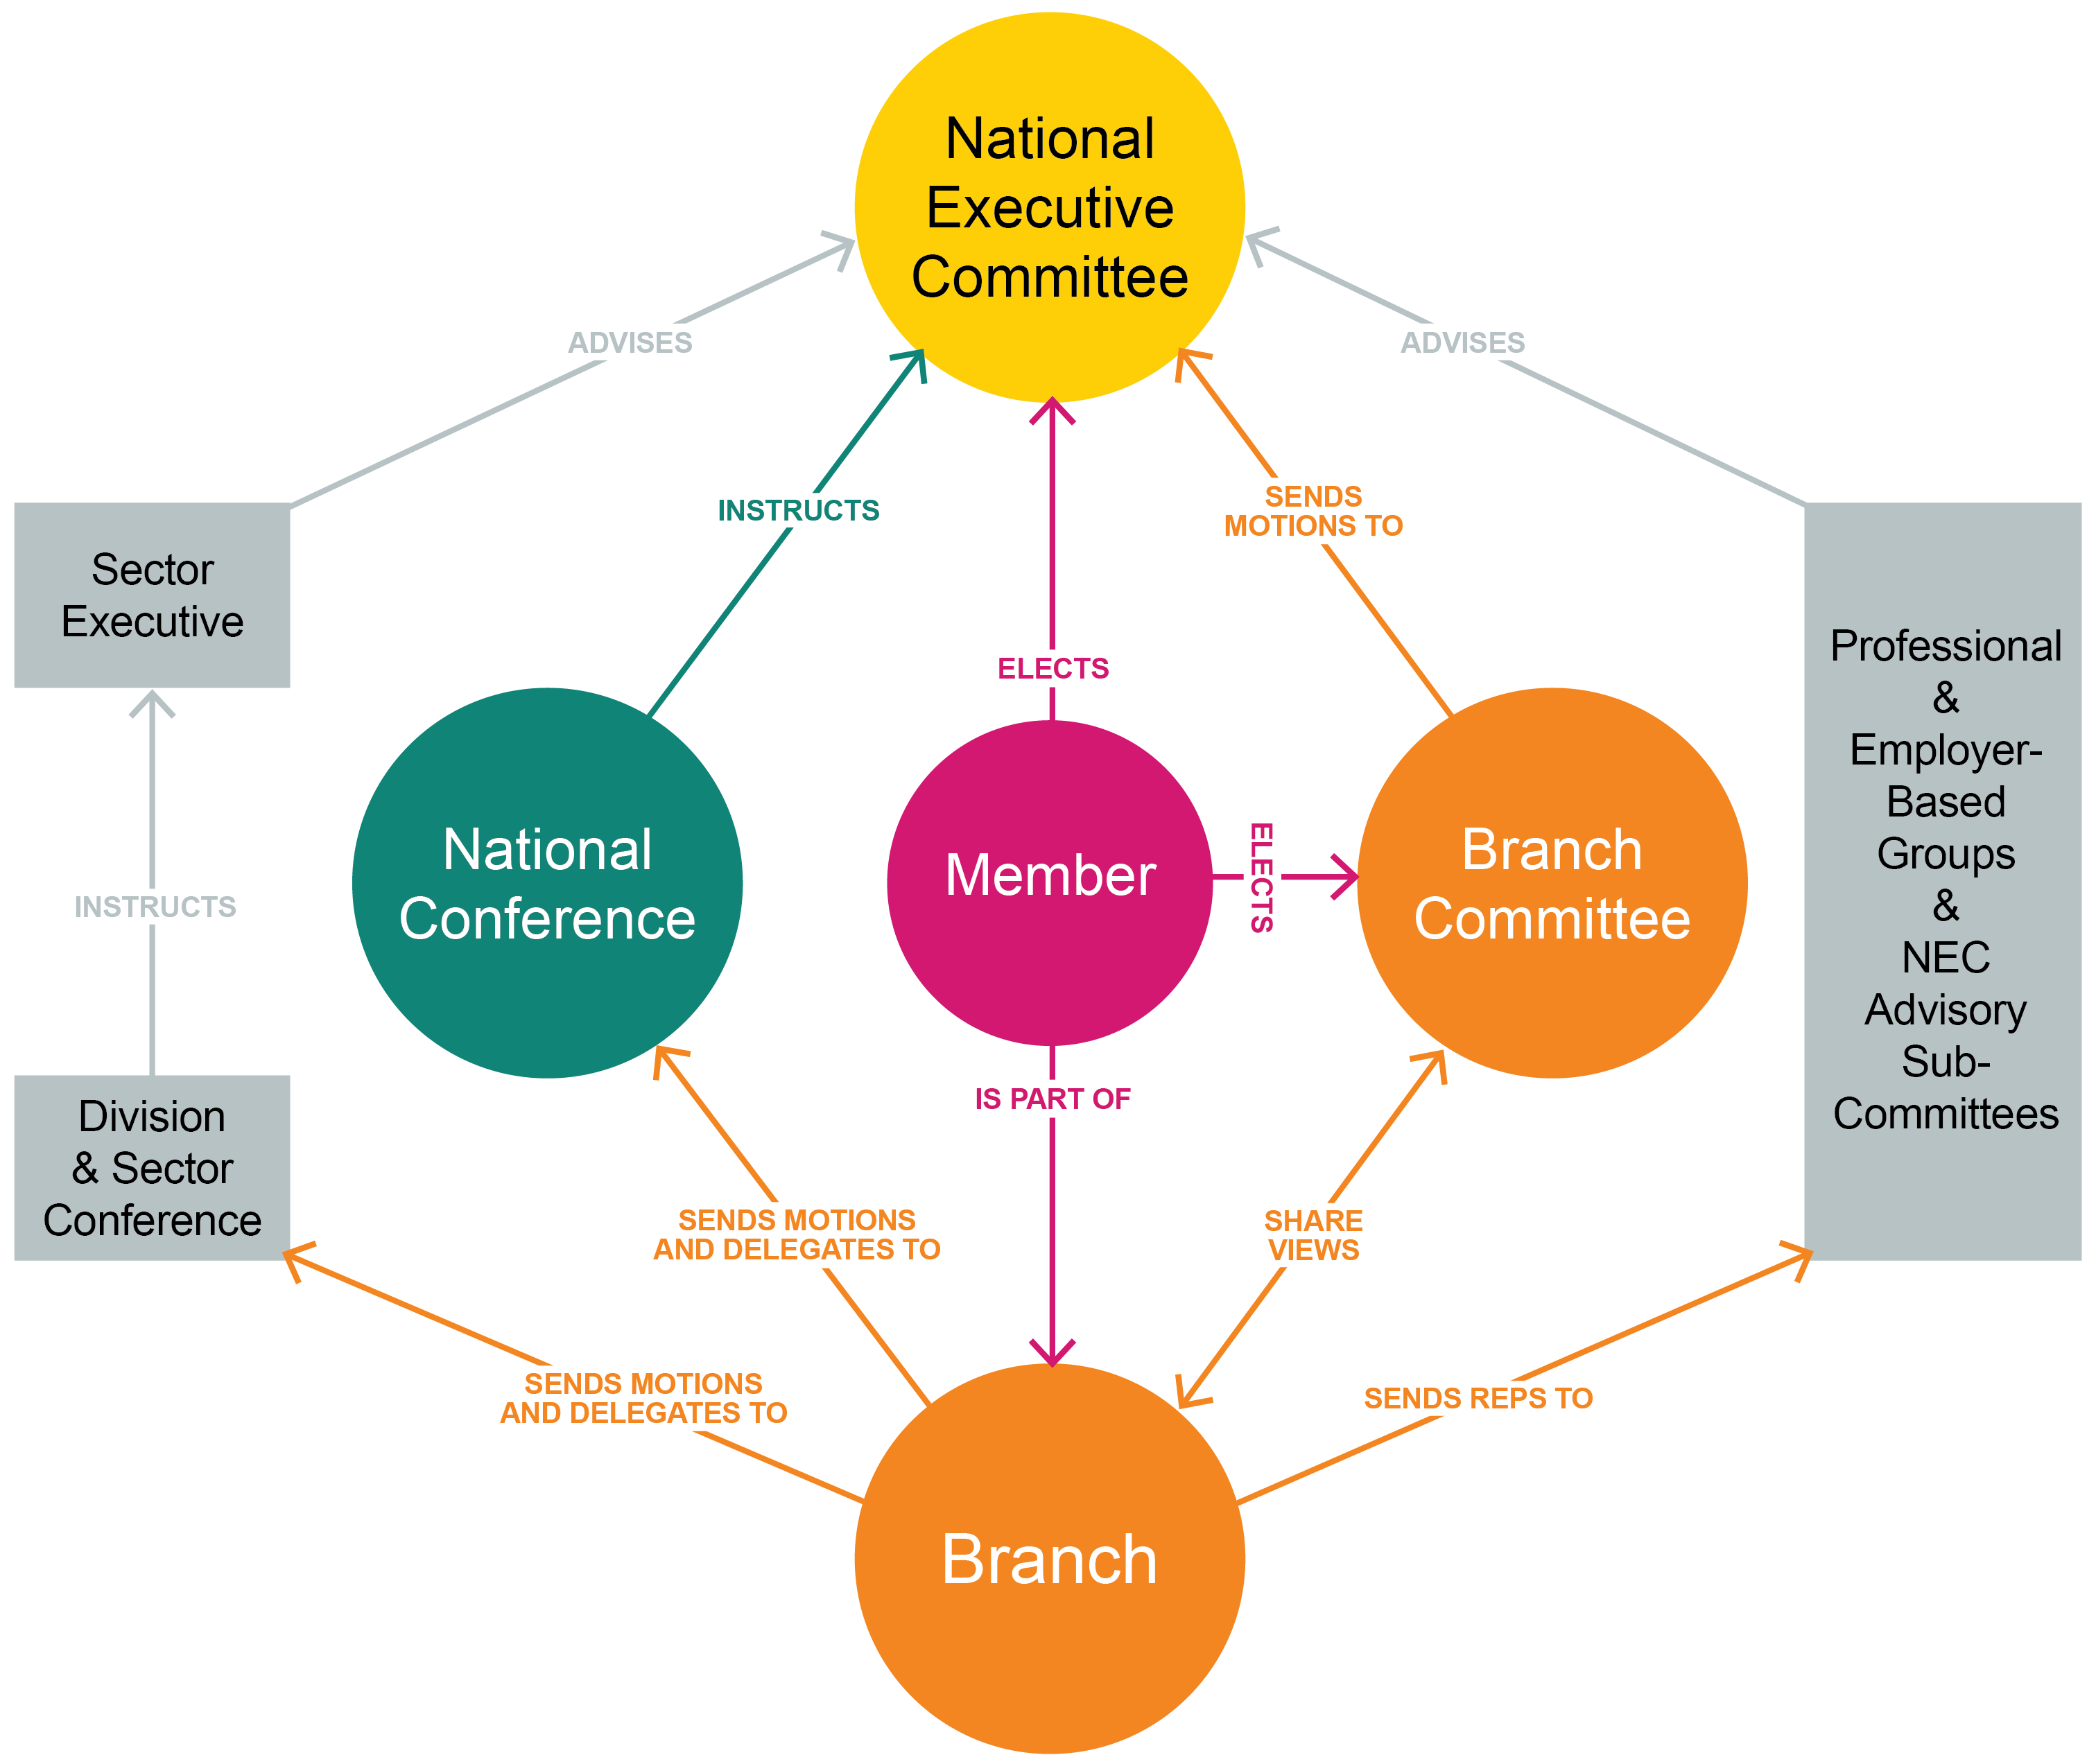

Session 4: The role of a rep
Every rep is the link between the union and its members. We are always conscious reps are volunteers. Some can give a little, others can give a lot. Each rep must find their own boundaries.
For most, the role of the local representative includes one of more of the following elements:
Advice: not necessarily able to answer all questions but knows where to look/or who to go to for the answers.
Representation and advocacy: standing by a member’s side or speaking on their behalf.
Negotiation: helping to improve local working conditions.
Liaison and consultation: passing information up, down, sideways; representing members’ views to management.
Organisation: organising the branch, strengthening its position in the workplace.
Democracy: representing members’ views in developing the union’s policies.
Bectu prides itself on its reps and the good work they do. This session looks at the role in more detail and what skills are needed.

Activity E: What do union reps do?
Working together in small groups, make a list of all the things a Bectu rep might do as part of their duties.
Make a list of the skills needed by a rep to do the tasks on the first list.
Pick the four most important tasks from your list.

Types of rep
There are many different types of rep – you can do as much or as little as you want. Not all reps have a recognised job description. Some can simply be described as local representatives: the face of the union in a particular workplace or location. But others have very specific responsibilities, usually defined in the branch rules.
Local representatives
Well-organised branches usually develop a network of local representatives to undertake a range of tasks, depending on the type of branch or workplace. These include:
- acting as a focal point for Bectu in their area
- eliciting and conveying members’ views to the branch or section
- maintaining the local noticeboard
- distributing Bectu information
- ensuring non-members are approached to join, keeping a record of approaches made and, if unsuccessful, the reason
- ensuring changes in members’ details and location are passed to the branch or section.
Reps with particular skills or interests may be willing to take on specific tasks such as maintaining the content of an eBranch.
Local reps may be known by various titles – site secretary, correspondence rep, or just ‘Bectu rep’. In the energy supply industry sector, many are known as technical reps or TRs.
Point of contact
This is not a representative role. It is a Bectu member who wants, and is able, to give a little of their time to support their branch. No training is required and there is no expectation to carry out other duties. The point of contact can help the branch extend its reach by having local contacts across its workplaces.
Branch officers
In the paragraphs that follow, for ‘branch’ you can read ‘section’ or ‘sub-section’ as appropriate.
President/chair
The president (or chair, or convenor in some Scottish branches) presides at all branch conferences or committee meetings and is responsible for:
- the proper conduct of the meeting
- ensuring that business is kept moving
- clarifying the issues under discussion
- ensuring that clear decisions are reached and recorded.
In most branches, the president is an experienced rep with a wider representational role in negotiations or consultation.
Vice-president/chair
The vice-president acts as chair in the absence of the president. Smaller branches may choose not to have a vice-president.
Secretary
This is the key role in most branches. The secretary’s duties include:
- calling branch committee meetings, branch conferences or annual general meetings and making all associated practical arrangements
- preparing and circulating agendas, minutes and action lists
- submitting to the committee matters referred to him/her by Bectu headquarters or by any member or body with which the branch is associated
- during meetings, assisting the president/chair by presenting information and introducing items for which they are responsible
- maintaining branch records
- dealing with correspondence
- liaising with Bectu headquarters.
Some branches have an assistant secretary or minutes secretary to help with administration. In most branches, the secretary is an experienced rep with a wider representational role in negotiations or consultation.
Membership and recruitment secretary/branch organiser
A membership and recruitment secretary’s duties include:
- maintaining local membership records
- liaising with Bectu headquarters on recruiting eligible people into membership
- organising recruitment in the branch and reporting regularly to the branch committee on this
- where relevant, keeping in close touch with sections about their membership position and helping them to organise their recruitment effort.
Branch organiser
The additional duties of a branch organiser include:
- mapping the workplace: establishing how many non-members there are and where
- organising and co-ordinating recruitment campaigns
- overseeing the network of local reps and identifying gaps and training needs
- developing and maintaining a branch development plan which summarises the objectives and actions needed to strengthen organisation and increase membership.
Treasurer
The treasurer’s duties include:
- the proper use, custody and accounting of the funds allocated to the branch by the national executive committee, including paying branch expenses
- preparing an annual income and expenditure account, making up a balance sheet to 31 December of each year and submitting it for audit in time for the annual conference or meeting
- supplying any additional information on finance needed by Bectu headquarters where relevant, transmitting to section treasurer’s money allocated by the branch committee.
Reps with specific legal rights
Two types of representative exist on a statutory basis, ie they have specific rights under the law.
Health and safety rep
Employers are required to create a culture of cooperation on health and safety, engaging with staff to ensure people go home safe and well from their work.
The Safety Representatives and Safety Committees Regulations 1977 allow unions to appoint health and safety representatives to get involved for the benefit of their colleagues.
Branches appoint reps, then they must notify their employer so that reps are afforded rights to:
- inspect the workplace
- escalate unresolved health and safety concerns
- engage in health and safety planning, consultation and auditing
- investigate serious incidents, work illnesses and complaints
- meet an inspector during a visit.
Union learning rep
Union learning reps have specific legal rights and powers. Their duties include:
- promoting training and development in the workplace by providing advice and information on learning initiatives
- supporting members who want to review and broaden their portfolio of skills
- helping to identify sources of training or learning provision.
Other specialist reps
Branches often appoint reps to deal with specific issues.

Equality rep
These reps play a crucial role, pressing employers to create fairer workplaces for all. Their duties can include raising awareness within the workplace of the work the union and the branch do around equality and working with branch officers to analyse information about the employer’s equality performance such as audit agreements, equal pay surveys etc.
Pension rep
These reps act as a point of contact for members’ pension queries. Pensions is a detailed and technical area so their role is often to direct members to the appropriate workplace or union contact if they cannot answer the query themselves. They also work to raise the profile of pension issues in their branch.
Environmental rep
These reps act as a conduit between management and members. Their aim is to raise awareness and participate in initiatives to minimise consumption, optimise resources, source materials sustainably and dispose of waste responsibly. They also participate in formal and informal organisational structures.
Casehandler
These are reps who support and advise members with personal cases from across the sector, not just within their own branch.

Bectu’s eSite system
Bectu gives branches/sections a way of communicating with their members which reduces the chance of a data breach when sending emails. This is done via our free eSite system.
The eSite system gives your branch or section its own website, with no need to worry about set-up, design or hosting. All you need is internet access and a web browser.
All branches have a 'starter' eBranch which gives their branch officers access to online membership lists. The same applies at section level.
Branch officers (secretary/assistant secretary, chair/vice-chair, membership and recruitment secretary/organiser) automatically get admin rights to look after their eSite, as does our new communications rep role.
For step-by-step instructions on using the Bectu eSite system, see Appendix 4.

A number of well-trained reps make a strong branch
Branch Secretary
Environmental rep
Branch Chair
Case handler rep
Health
and safety rep
Equality LGBT+ reps
Mental
health
awareness rep
Pensions
reps
Young members
rep
Negotiations
rep

Correspon-
dence
rep
Communica-
tions rep

Session 5: Reps’ rights
It is very important that a new rep feels confident in what they can and can’t do. This session looks at reps’ rights.
Your legal rights derive from the Trade Union and Labour Relations (Consolidation) Act 1992.
Under section 199 of the Act, the Advisory, Conciliation and Arbitration Service (Acas) has a duty to provide practical guidance on the time off to be permitted by an employer – see http://bit.ly/acas-time-off.

Extract from ACAS Code of Practice 3
“Entitlement
8 Employees who are union representatives of an independent trade union recognised by their employer are to be permitted reasonable time off during working hours to carry out certain trade union duties.
9 Union representatives are entitled to time off where the duties are concerned with:
- negotiations with the employer about matters which fall within section 178(2) of the Trade Union and Labour Relations (Consolidation) Act 1992 (TULR(C)A) and for which the union is recognised for the purposes of collective bargaining by the employer;
- any other functions on behalf of employees of the employer which are related to matters falling within section 178(2) TULR(C)A and which the employer has agreed the union may perform;
- the receipt of information from the employer and consultation by the employer under section 188 TULR(C)A, related to redundancy or under the Transfer of Undertakings (Protection of Employment) Regulations 2006 that applies to employees of the employer;
- negotiations with a view to entering into an agreement under regulation 9 of the Transfer of Undertakings (Protection of Employment) Regulations 2006 that applies to employees of the employer; or
- the performance on behalf of employees of the employer of functions related to or connected with the making of an agreement under regulation 9 of the Transfer of Undertakings (Protection or Employment) Regulations 2006.”
Reps’ rights are split broadly to into two categories: duties and activities.

Duties
Employees who are union representatives of an independent trade union recognised by their employer are to be permitted reasonable paid time off during working hours to carry out certain trade union duties.
Examples are pay negotiations, consultation on restructuring, or representing an individual member in a grievance.
These tasks also include time to prepare for these duties and to do other things "concerned with" them (eg briefing and consulting members before and after meetings with management, or branch committee meetings to discuss such issues).

Activities
Union reps and members are entitled to reasonable time off during working hours to carry out certain trade union activities, which are seen as different from duties.
In essence, the law recognises that unions need the participation of their members to operate effectively.
Activities might include attending meetings to discuss internal union business, organising union elections.
Members’ attendance at internal union meetings about collective bargaining issues will be classed as "activity" rather than "duty".
For reps, the same meetings may be classed as a "duty" because they are directly related to negotiating with the employer. Some rep work will, however, be classed as an "activity" – for example, anything related to internal union organisation.

Responsibilities
A union rep has to inform the employer when they wish to take paid time off for trade union duties or activities. The procedure normally found in the facilities agreement or in the recognition agreement and should provide clear guidelines on how a rep applies for time off.
Time for training can be declined if there is no cover, but a reasonable request can’t keep being denied.
Reps and employers can sometimes disagree about the interpretation of reasonable. If you are having difficulty getting time off, the first place to check is your workplace facility/recognition agreement or with your full-time officer to see what has happened in the past.
In considering what is reasonable, the following factors will be taken into account:
- the union’s need to be able to reach all of its members
- provide effective recognition
- the size of the organisation and the number of workers
- the production process
- the need to maintain a service
- the need for safety and security.

Facilities agreements
In most areas where Bectu is recognised by the employer, there will be a formal agreement describing the time off and other facilities available to the union and its reps.
The ACAS code recommends this, noting that there can be "positive advantages" for employers and trade unions in establishing agreements which reflect their own situations.
However, the absence of a formal agreement does not mean an individual can be denied their statutory entitlements.
A formal agreement can help to:
- provide clear guidelines against which applications for time off can be determined
- avoid misunderstanding
- facilitate better planning
- ensure fair and reasonable treatment.
An agreement may form part of a more general document covering the union’s recognition status – often called a Recognition and Procedure Agreement – or it may stand alone. The agreement may be longstanding, and its application may have evolved over time.

Activity F: What are your rights?
Working together in small groups, look at the following examples and decide what the rep’s rights are, what heading they should come under and where they can check this. What other options are there?
Put the following under the appropriate heading:
- recruiting members
- balloting for strike action
- acting as a primary support for a member with mental health issues
- staying vigilant and taking action on health and safety issues
- representing themselves
- representing members in disciplinary/grievances
- attending meetings to discuss internal union business
- helping a member submit a claim to an employment tribunal
- keeping an employer informed about any time off for union duties
- setting up events and attending stalls in the workplace.
- organising education opportunities
- sorting out personal differences between colleagues
- advising those who are not members of the union
- keeping members informed of union activity.

Duties | Activities
Responsibilities | Not responsible

Activity G: What would you do if…
In groups, look at the situations below and decide what course of action could be taken:
- A manager loves to tell anyone who will listen how boys are meant to be the technicians and engineers, while the girls are there to do the admin.
- A member has approached you because she witnessed another member being racially abused by another member of staff. When she complained to her manager, she was told nothing could be done as she wasn’t the one being abused.
- A number of members keep coming to you with trivial complaints.
- The union has a bad reputation with a group of workers who feel they were let down by a previous union rep; none of the group are in the union.
- I don’t agree with my performance appraisal/personal assessment – I want to challenge it.
- My boss always works late and thinks the rest of us should, too. And he calls me at weekends to ask me to work.
- Your manager isn’t very approachable regarding facility time, but they are a member of the union.
- My pay has been incorrect for the past three months, what should I do?

Session 6: Ingredients of union influence
In this session, we take a look what gives a union influence in the workplace and how reps can increase that influence.

Activity H: What are the ingredients that increase the union’s influence
You will work in groups and be given an ‘ingredient’. Discuss as a group how this ingredient’s presence helps build an effective union on the ground and what happens if it isn’t there. Try to prove why your ingredient is more important than the others.
The ingredients are:
- membership density
- engaged members
- visible profile
- constructive dialogue
- representative membership
- representatives.

The virtuous circle
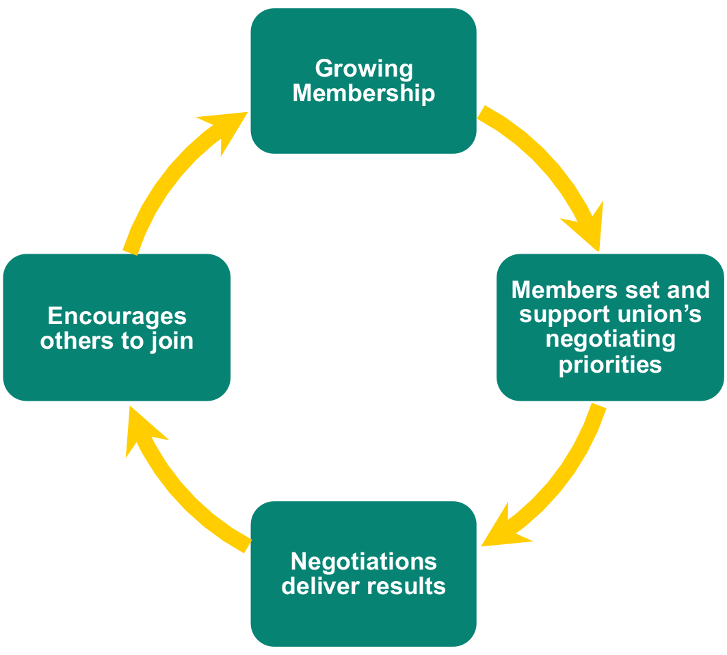
Effective local organisation – meaning reps like you – are at the heart of Bectu’s ability to keep the virtuous circle going.

Local union reps…
- are the union’s eyes and ears, picking up issues that matter to members that can be resolved by negotiation
- are the union’s voice in the workplace, getting members involved in new campaigns and keeping them informed about on-going negotiations
- give the union a positive profile – visible on notice boards, identified with important issues
- grow the union by talking about joining to colleagues who are not yet in Bectu
- keep members in touch with the wider union, eg by organising meetings and events with visiting speakers from beyond the branch.
A really important task for everyone involved in Bectu’s activities is to feed members’ views, queries, concerns and ideas back to Bectu – keeping the union in touch with members.

Activity I: Why people don’t join a union
In groups, look at ways to persuade a non-member who has a particular reason for not joining, to join.
- I can look after myself
- I get the benefits anyway
- I don’t believe in trade unions
- I had a problem a year ago and Prospect/Bectu didn’t help
- nobody has asked me to join
- the union doesn’t do anything
- I can’t afford it
- unions are always going on strike
- the management here looks after us and treats us well
- I don’t want to join.

Ten good reasons to join Bectu
- Everybody needs a voice at work. With Bectu your voice will be stronger than if you speak alone.
- Workplace cultures and processes can be complex to navigate – you need an independent expert, solely on your side.
- We will help you develop at work – we offer training, mentoring and other support, giving you skills that will help you take an active role in Bectu and benefit you in your professional life.
- We are a community of people like you – successful individuals who care about their work.
- We give members an advantage – through personal advice, legal and pension expertise.
- We negotiate with, and influence, employers and government to ensure members share in the success they generate. We are politically independent, enabling us to lobby with credibility in all quarters.
- We campaign for better workplaces and satisfying work – collaboration with other organisations gives wider influence.
- We make sure your surroundings are healthy and safe.
- We offer benefits and financial services available only to members.
- If the day comes when you have a good case to put to a court or employment tribunal, Bectu will pay your fees. Left on your own, one hour’s advice from a high-street solicitor could easily cost you more than your annual Bectu subscription.

Session 7: Building a stronger union
In this session, we look at how you think your branch is at this moment. Do you think it has the right approach and where you would like it to go in the future?

Activity J: Staff room talk
Watch the video in a big group and discuss how you felt the recruitment went.
Then in smaller groups, discuss how one of the three issues below could be taken forward and feedback to the group:
- Staff survey
- IT issues.
- unachievable targets.

Activity K: How well organised is your workplace?
Look at the questionnaire on page 15 and think about the following;
- On a scale of 1-10, how well organised would you say your workplace is?
- How is your workplace organised?
- What can be improved in the following areas:
Building membership
Communicating with members
Getting members active

Activity L: Mapping the workplace
Work in groups to complete a map of the workplace using the information provided by Slick Operations Ltd:
- give every staff member a score between one and five as to how pro-union they are. One would be considered anti-union – five being an active member.
- draw a map of this workplace showing the sections and a summary of the number of members vs non-members.
How would you go about building membership and strength in this workplace?

Name | Description | Rating 1-5
Fred | Operations team, member, complains that he has to stay beyond his finishing time. Works full time.
Martha | Sales team, non-member- very reluctantly took the recruitment pack off you. Works part-time and said that she is only here a few hours a week and so doesn’t need to join a union.
Joanne | Operations team, member, wants to know how the recruitment campaign was going and what the pay offer is going to be this year. Full time.
Rose | Sales team, member, said she always tries to get her colleagues to join up. Works full time.
Paresh | Sales team, non-member, though said he would read through recruitment pack and think about it. Works part time.
Sue | Operations team, non-member says that union is only interested in looking after the men in her department and refused to take a pack.
Rita | Technician, member but thinking about dropping out. She is concerned about the amount of work she has to do and thinks that the union does not do enough. Works full time on various shifts.
Jasmin | Operations team, member – thinks it is shocking that everyone else in operations is not a member. Works full time.
Bob | Operations team, member says that union is doing a good job and has no problems. Full time.
Bill | Technician. Non-member but took a pack and said he had thought about joining. Works full time on various shifts.
Hillary | Sales team, non-member only just started but took a recruitment pack and wanted to know about free will service. Works part time.
Ben | Sales team, non-member. Took a recruitment pack but did not say much. Works full time.
Wilma | Technician member says the department is understaffed and she has to work a lot of overtime. Works part time.
Margaret | Operations team, non-member. Has not joined as no-one has asked her. She is not sure if she will join as she has got this far without joining. Works part time.
Ruth | Sales team, member says that union doing a good job. Works full time.
Val | Sales team. Member and wants to know more about what is going on between the union and the company. Works full time.
Anne | Operations team, non-member. Took a recruitment pack and said she would probably join. Works full time.
Chris | Sales team, member but could not get hold of her as she works from home and travels around. Been a member for three years.
Javed | Technician is a member of a union from his previous job and does not want to change. Wants to keep up with information on pay negotiations. Works full time.
Julie | Sales team, non-member, refused to take a pack as only works part time.

Results

Work area | No of staff | Members | Activists | Density e.g (% or fraction) | Issues
Operations

Sales

Technical

Identifying potential activists
Union reps should always look out for members who take an interest in informal discussions and ask them to do some small task to help the union.
Those most likely to stand out are those who:
- are respected, trusted and liked by other workers
- have challenged management and shown good judgement about when to do so
- have a good work record
- organise social events
- are involved in outside community organisations
- speak up at meetings and show common sense
- have benefitted from the union
- have shown commitment to others and not just themselves
- have perhaps had involvement in a union elsewhere
- other workers turn to them for support
- have a special skill, such as a different language or computer design skills
- are self-motivated
- are representative of their fellow workers in terms of gender, age or race.

How members can help
There are many jobs that reps could ask members to do to spread the workload and get members actively involved. Here are a few examples:
- distribute union literature
- keep the noticeboard up to date
- provide information on where they work for the workplace map
- ask friends what they think or feel about an issue
- tell people what the union is doing
- get colleagues to complete a survey or petition
- ask others to join the union
- bring a friend to a meeting.

Any questions?



Putting what you’ve learnt
into practice
Spend a few minutes thinking about what you would like to do when you get back to your workplace and what you need to achieve this.
Task
Find out the name of the branch chair and engage in conversation about recognition/ facilities agreements and what they can negotiate, be informed and consult on.

Find out the name of the branch secretary.

Find out the names of the committee members, and when they meet.

Find out the name of your organiser.

Find out the name of your negotiations officer.
Sign up to the Bectu website and view your branch’s electronic communications.
How could you improve how your branch is organised?

After attending this course, what will you stop doing?

After attending this course, what will you continue to do?

Based on your new knowledge, what three practical things will you do?
1.
2.
3.
Training: Organisers’ follow-up

Appendix 1: How do you get Bectu to do something in your branch?
There are specific ways of carrying out discussions and decision making at formal meetings. These are designed to safeguard members’ rights, be ‘legal’ within the rules and transparent so members can see what is happening and why. Some of the procedural terms include:
Motion - a proposal (usually written down) put forward for discussion by at least two people, the mover and the seconder. This is how members can submit items for discussion and decisions at formal meetings. A ‘motion’ that is voted on and carried is called a ‘resolution’.
A motion:
- identifies an issue or problem
- describes an action to be taken
- identifies the people who are being asked to take the action (a conference, SEC, branch committee, etc).
A motion to a meeting should observe the following guidelines:
Preferably it should be notified to the branch secretary in advance of the meeting at which it is to be discussed. This should be in good time to be made known to members of the branch (or shop) so that they can attend the meeting.
The motion should be addressed to the person or body that has the power to deliver the request (eg the NEC)
The motion should be no more than one or two paragraphs long.
The motion should briefly explain the subject matter and context/reason for its submission.
It should end with a request for something to be done (provision of information, industrial action or change policy etc.)
Each motion should only deal with one subject/request
Examples of local policy-making motions:
In the light of complaints about a culture of bullying and harassment, we call on the branch committee to carry out a survey of members.
Given the installation of new technical equipment, we call on the safety reps to press for new risk assessments to be carried out.
While supporting the appointment of apprentices, we must negotiate a code of practice to make sure they are not exploited or used to undermine existing jobs. We call on the branch committee to negotiate such an agreement.
See Appendix 2 for more advice on writing a motion.

National conference – making or changing Bectu policies
The purpose of Bectu’s biennial national conference is to formulate policy, approve the annual report and statement of accounts, consider rule changes, and elect the standing orders committee (SOC). It is usually held in May or June and lasts for two-and-a-half days.
All branches with more than 20 members are entitled to submit motions to conference, send delegates and make nominations for the SOC and Trades Union Congress delegates. The basis of conference representation is laid down in Bectu’s rules.

Appendix 2: How to write conference motion
Whether you’re a seasoned conference delegate or new to the democratic process, the union’s standing orders committee is the ultimate arbiter of whether a conference motion is up to scratch.
MOTIONS – without them, conference would be a silent, empty hall and the union wouldn’t have any policies. Get it right and you can help shape the union’s policy. Get it wrong and the opportunity will be lost!
Motions should follow a format designed to make it as clear as possible what you/your branch want the union to do. Vague words will be seized on by the standing orders committee (SOC), who will consign your motion to conference oblivion.
Your motion must be in order ie, addressed to the right body – in this instance, national conference and the national executive committee. Anything addressed to sector or branch conference will be ruled out of order because seeking to instruct anyone other than the relevant body is an instruction that cannot be acted on.
Generally, your motion will be made up of three parts: facts; opinions and arguments; and instructions or actions.
So, taking these key elements, a motion might begin by setting out what the issue is and who it is addressed to: ‘This conference notes with concern the impact of long hours working on individuals, families and communities.’
Next come the opinions and arguments contained in the motion that you hope will gain the support of other branches, the NEC and ultimately conference delegates.
You might add: ‘Conference questions the true value obtained by excessive working hours. This may have more to do with the expectations of employers rather than productivity.’ After this you will need to spell out an instruction as to what you want done about it, with practical actions, timescales and so on.
It might read: ‘This conference instructs the national executive committee to work with whichever bodies it deems appropriate to highlight address the issues of long hours working.’
Other things to consider when drafting a motion include:
- avoid jargon or the use of acronyms without first spelling them out. You want people to support your motions, so don’t baffle them with terms they will not understand
- keep it clear, simple and make sure it is not too long
- make sure that the action you are calling for is not already policy, or recently agreed as policy, otherwise the SOC will highlight it as such and it won’t be debated
- make sure your motion is not so specific that it can be ruled out of order on grounds of sectional interest and therefore more suitable for one of the union’s sector or group conferences.
Motions are grouped into sections and ranked to take into account the time available for debate in each section. The most relevant, clearest, precise and logically-argued motions will be in the top half of the agenda.
If you bear these guidelines in mind when framing your motion, you might succeed in ensuring it is placed at the top of the relevant section in the agenda. If not the procedural guillotine will fall and your motion will not be taken.

Appendix 3: Data protection
Bectu is covered by the General Data Protection Regulations. Here are some guidelines for reps drawn up by the union’s compliance officer.
The EU data protection regulations came into force on 25 May 2018. While these are underpinned by the Data Protection Act 2018, they introduce a new suite of rights and enhance existing ones.
Enhanced rights
- right of access (right to request access to personal information, eg Data Subject Access Request)
- right of rectification (right to request correction of incomplete or inaccurate personal information)
New rights
- right to portability – allows individuals to obtain and reuse personal data for their own purposes across different services
- right to be informed – providing people with clear and concise information about what we do with their data
- right to erasure (the ‘right to be forgotten’).
You can find more information in our briefing – https://library.prospect.org.uk/id/2016/01617
Here’s a list of common-sense dos and don’ts to ensure you comply with data protection legislation
DO:
- mark all correspondence, electronic or otherwise, as private and confidential
- be aware that the Act applies to paper files, information held electronically, records of telephone conversations, audiotapes, photographs and social networking media (Facebook, twitter, LinkedIn etc)
- think of personal data held about individuals as though it were held about you
- tell people you hold personal data about them and tell them why you need to do so (fair processing). Be open with people about information held about them
- be open with people about information held about them
- respect confidentiality and the rights of the member
- review personal data in on-going cases from time to time and at least annually
- ensure all personal data is disposed of as confidential waste
- when writing reports, minutes etc, bear in mind that the member has a right to see information relating to them; even deleted emails may be retrieved and revealed to those about whom they are written
- refer all requests for access to a Bectu full-time official
- familiarise yourself with Bectu’s data destruction policy (reproduced overleaf).
DON'T:
- worry about the complexities of the Act - the Data Protection principles are simple
- reveal personal data to third parties without the data subject's permission or justification
- disclose any personal data over the telephone
- put personal data about a member on the Internet without his/her permission
- send personal data outside the European Economic Area (EEA) without taking advice from Bectu
- leave personal data insecure in any way, whether it is physical files or information held electronically
- take personal data home without ensuring that it can be securely stored
- use personal data held for one purpose for a different purpose without permission from the member.
Bectu’s data destruction policy
Destroy closed case files after:
- six years – equal pay cases
- seven years – employment related cases
- seven years – personal injury cases
- 12 years – industrial disease.
If you no longer handle cases, you must pass all files to your Bectu full-time official.

Appendix 4: Updating members using the Bectu website

Contacting branch members
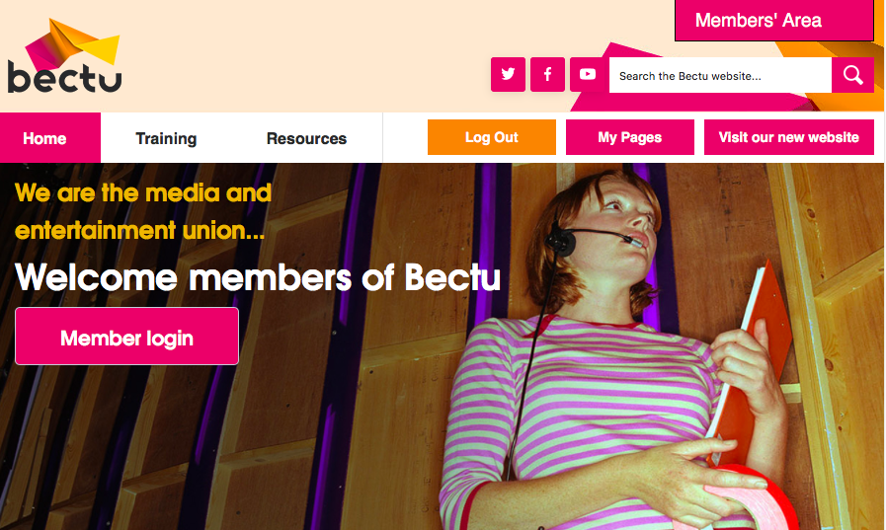
- Log in to the Bectu website and click ‘My Pages’. This will bring up the Personal Details page.
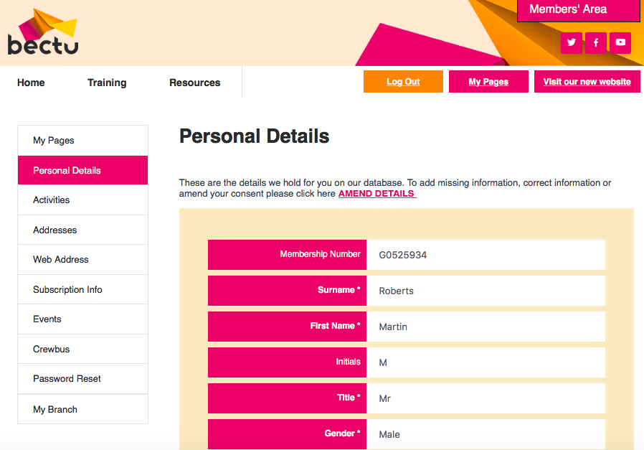
- On the Personal Details page, click ‘My Branch’.
If you have the Branch Secretary’s permission to email members, this will display the Member Search page.
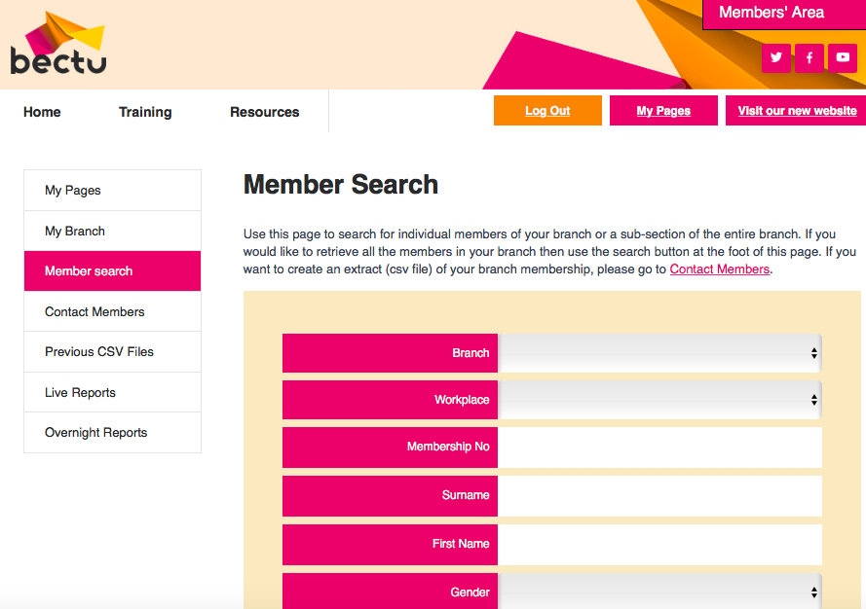
- On the Member Search page you can look up individual members.
Click ‘Contact Members’ to bring up the Contacting Members page.
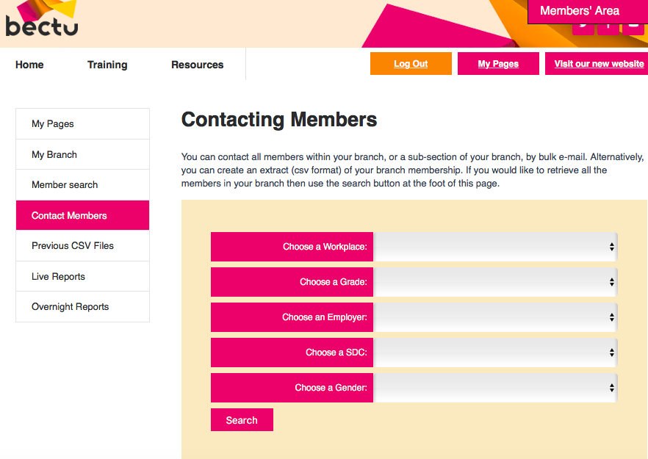
- On the Contacting Members page, use the drop-down options in the search fields to select the specific groups of members you wish to contact.
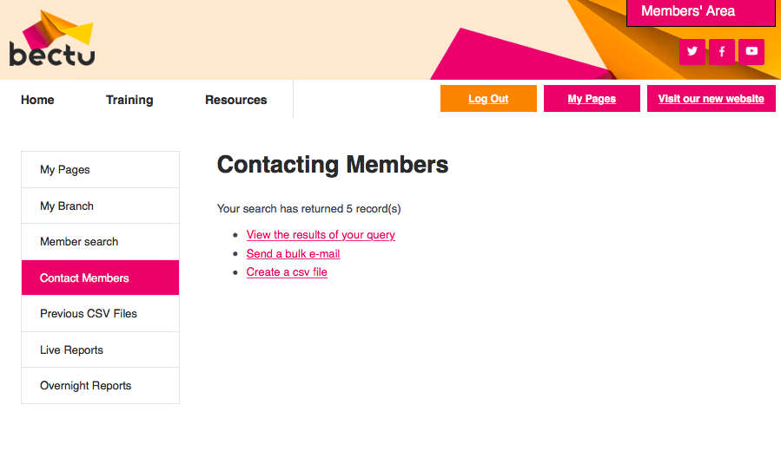
- When you have chosen the recipients, select ‘Send a bulk mail’ to send a purely text email.
If you want to send an attachment, select ‘Create a csv file’ and then copy/paste the list of email addresses into the BCC box of your personal email.
PLEASE NOTE: You must then delete the CSV file as per the General Data Protection Regulations (GDPR).
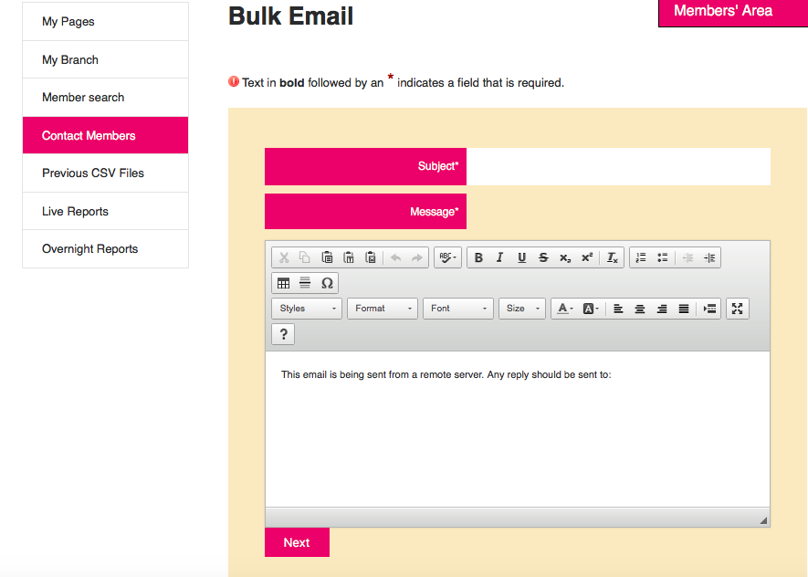
- If using the inbuilt bulk email system, you must populate the Subject and Message fields. Always add the email address you want members to reply to!
Click ‘Next’ and then ‘Confirm’ when ready to send.

Editing the branch pages
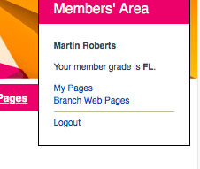
- Log in to the Bectu website, select the Members’ Area drop-dox box in the top-right of the page and click ‘Branch Web Pages’.
If you have permission to edit the branch pages, the edit buttons will appear.
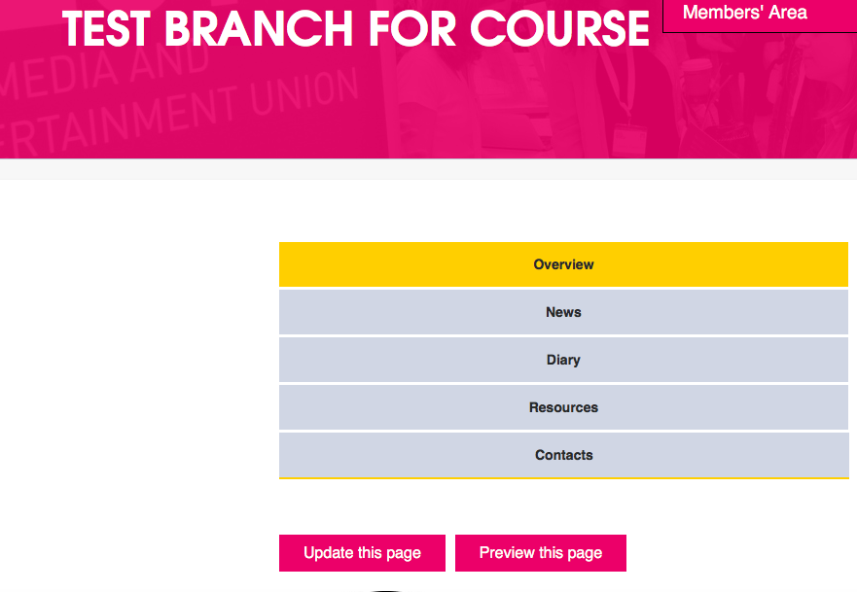
- Update the page, then tick ‘approve item automatically’ and ‘save’ at the bottom of the edit page.

Appendix 5: Useful links

Prospect
Prospect rep’s handbook – https://library.prospect.org.uk/download/2009/00650
A leaflet setting out our legal team’s successes between November 2018 and November 2019 – https://library.prospect.org.uk/download/2019/01668

Benefits and services – https://library.prospect.org.uk/download/2014/01255
Logos, templates posters and other resources – https://prospect.org.uk/ambition/
Members’ guides – https://members.prospect.org.uk/resources/guides-factcards/members-guides

Bectu
Reps area for resources - https://members.bectu.org.uk/advice-resources/reps-area
Benefits and services leaflet - www.bectu.org.uk/benefits-services

TUC
TUC – www.tuc.org.uk
Worksmart – https://worksmart.org.uk
Union reps forum – https://unionreps.org.uk
Health and safety, union effect – see www.tuc.org.uk/research-analysis/reports/union-effect
Training – www.tuc.org.uk/sites/default/files/Skils_and_training.pdf
Collective bargaining and great jobs –
www.tuc.org.uk/research-analysis/reports/great-jobs-are-union-jobs
Training benefit to economy – www.tuc.org.uk/sites/default/files/Skils_and_training.pdf

Other
ACAS code of practice 3 – http://bit.ly/acas-time-off
ACAS – www.acas.org.uk
Union wage premium – http://bit.ly/union-wage-premium
Government – www.gov.uk

