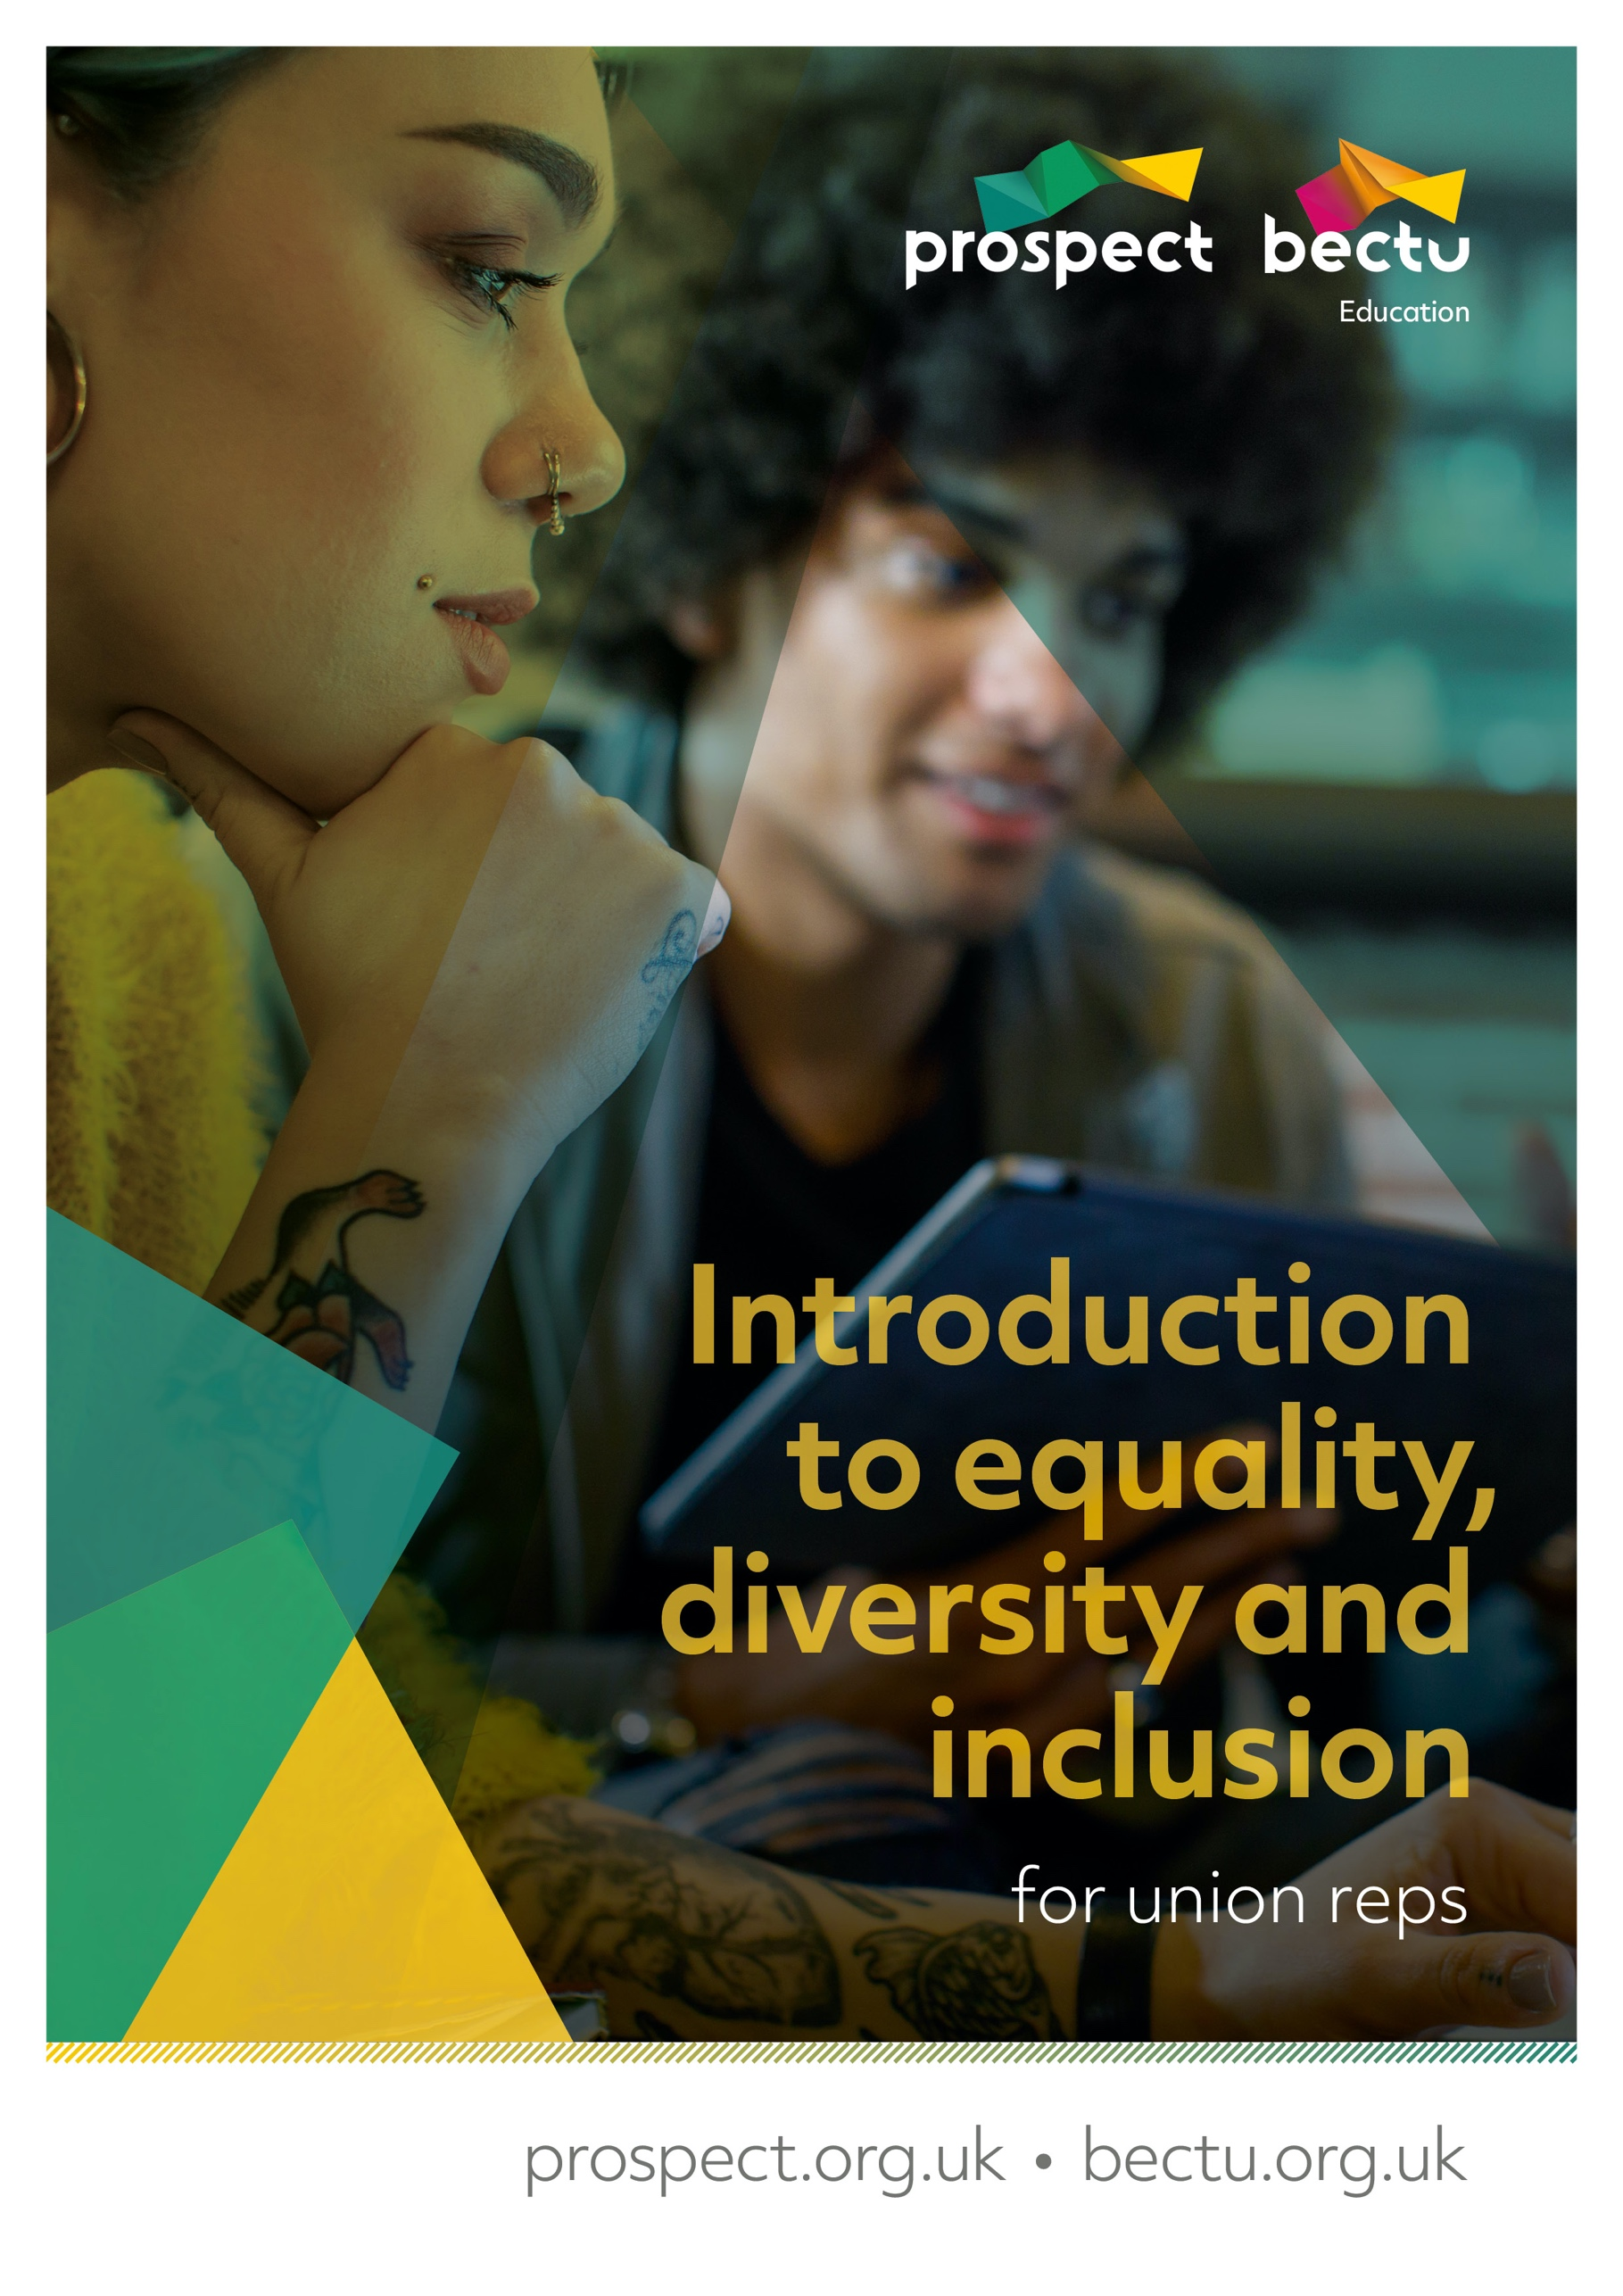

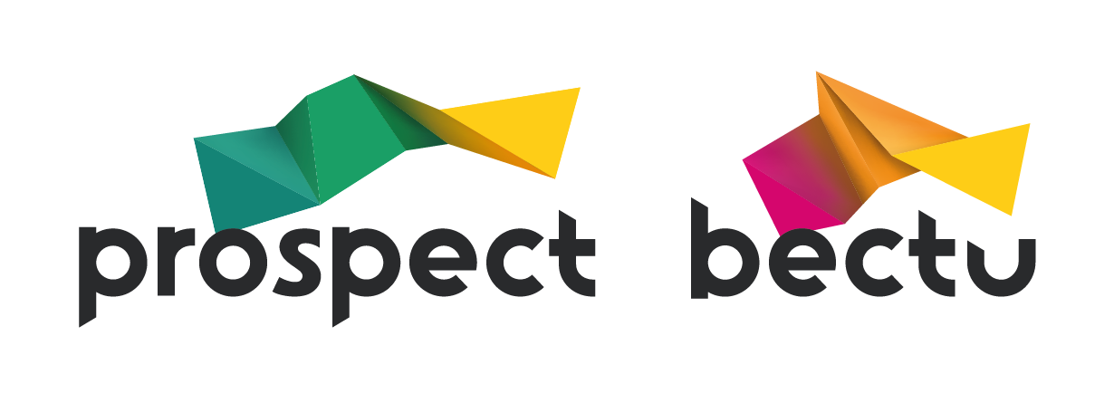
Introduction to equality, diversity and inclusion
for union reps

Contents
Welcome to the introduction to EDI course 3
Course timetable 3
About Prospect 4
Equality and diversity statement 5
What happens on trade union courses? 6
The tutor’s role 6
Your role 6
Using your knowledge and skills 7
Guide to further EDI resources 8
Resources from Prospect 8
Resources from other organisations 9
Common equalities terminology 10
Trade union terminology 12
Putting what you’ve learnt into practice 13
Appendix: Course slides 14

Welcome to the introduction to EDI course
Welcome to this introductory course for Prospect representatives on equality, diversity and inclusion (EDI) campaigning in your workplace.
This course will help give you a basic grounding in equalities legislation and the obligations on employers to tackle inequality and discrimination, as well as providing you with some ideas about how to get more active in your workplace.
The training is informal and there is no pressure on anyone to do anything they are not comfortable with. The course is intended to be introductory and does not assume any prior knowledge of equalities legislation or experience with EDI campaigning.
There will be plenty of opportunity throughout the course for questions, interaction, and discussion.

Learning outcomes
- An understanding of some of the key EDI issues in UK workplaces today
- An understanding of some of the key provisions in the Equality Act relating to employment and the legal obligations on employers
- An understanding of why trade union members have a key role to play in tackling EDI issues, and ways to start getting active in your workplace

Course timetable
- Introduction (10 mins)
- Part 1: An overview of discrimination & inequality in UK workplaces (~40 mins)
- Break (10 mins)
- Part 2: Equalities law and obligations on employers (~50 mins)
- Break (10 mins)
- Part 3: Taking action on EDI issues in your workplace (~50 mins)
- Wrap up and next steps (10 mins)

About Prospect
Most of the larger unions in the UK have grown and evolved through mergers and acquisitions with other unions, staff associations and professional bodies – either through necessity or strategy.
Prospect is no exception, having absorbed various groups of professional and specialist staff. It is now the tenth largest union in Britain out of the sixty-six affiliated to the Trades Union Congress – the umbrella body for Britain’s unions – and the most diverse.
Prospect was formed in 2001 through the merger of the Engineers and Managers Association and the Institution of Professionals, Managers and Specialists. IPMS originated from the Royal Corps of Naval Constructors of 1916, so the new union inherited extensive history.
The EMA’s power station managers and electricity distribution engineers complemented the IPMS demographic (scientists, engineers and managers in the defence, energy, heritage, environment and transport sectors) and strengthened our bargaining power.
Prospect merged with the telecoms professionals in Connect union in 2010 and with Aspect, which represents professionals in education, children’s services and social care in 2012. In January 2017, Bectu, the media and entertainment union, joined us to create a sector which includes broadcasting, cinema, film, digital media, independent production, leisure, IT and telecoms, theatre and the arts.
Despite the expansion, the union has managed to maintain four key principles of industrial relations that are consistently important to members, whichever union they originated from:
- we represent professional staff
- we are not affiliated to any party political
- one of our objectives is ‘…to promote the advancement and efficiency of industries and organisations where members are employed’
- as an affiliate, we enjoy the resources of the TUC.

Equality and diversity statement
Prospect is dedicated to providing training for all its representatives and activists that aspires to the highest standards of respect for difference and diversity.
This statement is inspired by our trade union values of justice, fairness, democracy, solidarity and equality. As a trade union, we oppose any view, action or organisation that undermines the ability of working people to act collectively to pursue their democratically determined policies and objectives.
We are opposed to discrimination against people on the basis of their gender, nationality, ethnicity, religion, disability, sexual orientation, marital status, social class, age, politics or education.
We defend the right to freedom of expression and to political opinions and beliefs except where these conflict with, or tend to undermine, the freedom of other people from discrimination on the grounds listed above.
In particular, we are opposed to sexist, racist and fascist ideologies and will not permit such views to be promoted at Prospect education events.
We will seek to ensure that all Prospect training is accessible to all who wish to attend. Recruitment to courses will be open, fair and in line with our commitments above.
All courses will allow opinions to be put forward and defended (consistent with the statement above). All members who attend Prospect courses are entitled to respect.
Members who want to raise issues relating to our commitment to equality and diversity, or if they wish to lodge a complaint about any incident or failure concerning this policy, should use the following procedure:
- any issue occurring during a course to be raised with the tutor
- if this is not practicable, or if the complaint is not dealt with to the satisfaction of the member, it should be raised with Prospect’s education officer or the education and skills manager
- if a member is not satisfied, the matter should be referred to the General Secretary.

What happens on trade union courses?
For many trade union activists, Prospect courses mark a return to education, sometimes when previous experiences have been less than positive.
Trade union education places great value on the knowledge that union reps bring to the course and seeks to enhance this by working co-operatively to gain new knowledge.
We place great emphasis on team working and involving everybody in the learning process. This not only makes learning interesting and challenging but is rooted in well-researched and tested educational methods.
As part of this approach, we will:
- encourage a cooperative approach to learning
- allow workplace experiences to be reflected and valued throughout the programme
- help you to build a useful resource pack to support your union activity
- encourage a collective approach to your role as a Prospect representative.

The tutor’s role
Trade union tutors are qualified to teach in the ‘learning and skills sector’ (adult education outside of university) and will also have extensive practical experience as trade unionists.
They should be inspiring, accessible and empowering – you should learn from them! Your tutor will:
- make sure that the expected learning outcomes are clear
- encourage and facilitate everyone’s participation
- introduce you to new ideas and concepts
- giving guidance on how to become an accredited rep
- help you understand your own preferred learning styles and ensure that everyone can participate and benefit.

Your role
The focus of trade union education is 'learning' rather than 'teaching'. The focus is on you and your colleagues as learners rather than on the tutor (although their role is absolutely vital) as teacher. In particular, we hope you will:
- feel confident to participate fully
- be able to support your colleagues
- enjoy the learning process
- add to your existing knowledge and skill
- use your new knowledge and skills to support Prospect’s aims in your workplace.
We ask that you take an active part in the course, support your fellow reps and course members when you can and be respectful of other delegates during the course – this will help you promote collective and co-operative activity at your own workplace.
We respect whatever pronoun you wish to be referred to during the course – please write it on your name card.

Using your knowledge and skills
Learning and knowledge are valuable in their own right – they need no justification but as practical people we want to encourage you to develop further.
First, we want your experience of learning with us to encourage you to engage in other forms of learning.
Second, we hope you will use your learning to make a difference at work – for the better.
To help you put your learning to good use we will provide you with a small ‘action plan’ for you to apply at your workplace. We will also support you to carry it out.

Guide to further EDI resources
In addition to the resources listed below, Prospect also runs a variety of other training courses and seminars on relevant themes, such as Allyship and How to Have Difficult Conversations. Speak to your branch organiser or full-time official to find out more. Further training courses and other resources are in development, so look out for more information about those.
Also be sure to check out the resources available on the EDI pages on the Prospect website (https://prospect.org.uk/topic/equality-and-diversity/) which are in the process of being updated with new materials.

Resources from Prospect
Below are links to some of Prospect’s resources on EDI that you may find useful (you will need to be logged in to the Prospect website to fully access these resources):
- Prospect BAME equality resource guide for members - https://library.prospect.org.uk/download/2019/01787
- Prospect briefing on equal pay - https://library.prospect.org.uk/download/2019/01625
- Prospect disability equality resource guide for members - https://library.prospect.org.uk/download/2019/01862
- Prospect guide to tackling sexual harassment in the workplace - https://library.prospect.org.uk/download/2018/01069
- Prospect checklist ‘How women-friendly is your workplace?’ - https://library.prospect.org.uk/download/2019/00373
- Prospect leaflet on setting up a LGBT+ network in your workplace - https://library.prospect.org.uk/download/2018/00216
- Prospect members’ guide to maternity rights - http://bit.ly/prospect-maternity-pay
- Prospect members’ guide to bullying & harassment - http://bit.ly/prospect-bullying
This is not an exhaustive list of the EDI resources we have available, so get in touch with your organiser, or with the Prospect Member Contact Centre if there are issues not covered by these materials that you are looking for guidance on.

Resources from other organisations

Trades Union Congress (TUC)
The TUC provides a range of great resources for workers and trade union reps on equalities issues, as well as running training courses. The link below is a good place to start in accessing their resources.
- Guide to Equality & Discrimination - https://www.tuc.org.uk/workplace-guidance/equality-and-discrimination

Equality & Human Rights Commission (EHRC)
This is a sample of the resources available from the EHRC, and is not a complete list. See the advice and guidance hub as a starting point for finding other EHRC resources.
- Advice and guidance hub - https://www.equalityhumanrights.com/en/advice-and-guidance
- Employment Statutory Code of Practice - https://www.equalityhumanrights.com/en/publication-download/employment-statutory-code-practice
- Equal Pay: Statutory Code of Practice - https://www.equalityhumanrights.com/en/publication-download/equal-pay-statutory-code-practice
- Sexual harassment and harassment at work: technical guidance - https://www.equalityhumanrights.com/en/publication-download/sexual-harassment-and-harassment-work-technical-guidance
- Guidance on the Public Sector Equality Duty - https://www.equalityhumanrights.com/en/corporate-reporting/public-sector-equality-duty

Advisory, Conciliation and Arbitration Service (ACAS)
Acas provides a wealth of resources on issues relating to all aspects of employment. The link below connects to their resource hub on equality and discrimination issues.
- Guidance on discrimination, bullying and harassment - https://www.acas.org.uk/discrimination-bullying-and-harassment

Other web resources
- Stonewall - https://www.stonewall.org.uk/
- Black Lives Matter UK - https://blacklivesmatter.uk/
- Fawcett Society - https://www.fawcettsociety.org.uk/
- The Equality Trust - https://equalitytrust.org.uk/
- Museum Detox - https://www.museumdetox.org/
- Scope - https://www.scope.org.uk/

Common equalities terminology
Below is a short glossary of some of the common equalities-related terminology currently in use. This is not an exhaustive list and reflects best-practice usage as of 2022. Be aware that because preferred equalities terminology has changed over time, and will continue to change, some of these terms may become outdated in future.

EDI – Shorthand for Equality Diversity and Inclusion. EDI is often the umbrella term given to a range of policies and approaches to deal with equalities issues. It is sometimes also called D&I (diversity and inclusion).
Protected characteristics – The Equality Act (2010) defines nine identity categories which the protections of the Act apply to. These are: age, disability, gender reassignment, marriage or civil partnership, pregnancy or maternity, race (including colour, nationality, ethnic and national origin), religion or belief, sex, sexual orientation.
Discrimination – When someone is treated less favourably, directly, or indirectly, because they have one or more protected characteristics.
Harassment – A term used to describe intimidating, degrading, or bullying behaviour. In the context of the Equality Act 2010, ‘harassment’ has a specific meaning and is defined as: unwanted conduct which has the purpose or effect of violating a person’s dignity, or creating an intimidating, hostile degrading, humiliating or offensive environment for that person. Legally, the unwanted conduct must be related to a protected characteristic to class as harassment.
Ally/Allyship – A person that actively works to challenge inequality and discrimination, and promotes a culture of inclusion through intentional, positive, and conscious efforts that support those facing oppression and discrimination.
Inclusion – The practice of providing equal access and opportunities to individuals or groups who might otherwise be excluded or marginalised. An inclusive workplace is one where everyone feels valued, respected, and recognised, and where all staff feel safe to suggest ideas and raise issues.
Intersectionality – Social categories such as race, class, and gender, can overlap and create reinforcing forms of discrimination and inequality. For example, ethnic minority women can face both gender and race discrimination relative to white men. It is important to acknowledge that everyone has their own unique experiences of discrimination and oppression.
Microaggressions – Refers to (often subtle or indirect) snubs, slights, or put downs which may be verbal or non-verbal in nature, that have the effect of causing offence or making someone feel excluded, regardless of the intentions of the perpetrator.
Micro inclusions – Refers to small, sometimes symbolic actions that make someone feel recognised and included.
Sex – Assigned to a person at birth based on primary sex characteristics and reproductive functions.
Gender – Often expressed in terms of masculinity and femininity, categories that are derived from culturally-determined norms and behaviours, and often linked to the sex assigned to a person at birth.
Gender identity – A person’s sense of their own gender, whether male, female, non-binary, or something else. A person’s gender identity may or may not correspond to the sex they were assigned at birth.
Cis/Cisgender – Someone whose gender identity is the same as the sex they were assigned at birth.
Trans/Transgender – An umbrella term for people whose gender or gender identity is not the same as, or does not sit comfortably with, the sex they were assigned as birth.
Non-binary – An umbrella term for people who feel their gender is not defined within the boundaries of the masculine/feminine gender binary.
Intersex – Someone who may have the biological attributes of both sexes or whose biological attributes do not fit with societal assumptions about what constitutes male or female.
Pronouns - Words that refer to either the people talking (like you or I) or someone or something that is being talked about (like she, they, and this). Gender pronouns (like he or them) specifically refer to people that you are talking about. All pronouns are valid.
Gender reassignment/transition – The process where a person makes changes in order to live in a way that matches their self-identified gender. This may involve medical and surgical treatment to alter the body but could also entail things like changing the way that person dresses and the pronouns or forms of address they prefer.
LGBT+ – Acronym for Lesbian, Gay, Bisexual, Transgender and people who are questioning, queer, asexual, intersex.
Asexual – Someone who does not experience sexual attraction. Some asexual people experience romantic attraction, while others do not.
Gay – A man who is attracted to other men, and more broadly a term for people who are gay or lesbian.
Bisexual – An umbrella term for attraction towards more than one gender.
Lesbian – A woman who is attracted to other women.
Pansexual – Someone whose romantic and/or sexual attraction is not limited by gender or sex.
BAME/BME – Black, Asian, and Minority Ethnic/ Black and Minority Ethnic
Ethnic minority – Refers to all underrepresented ethnic groups.
People of colour (POC) – Refers to anyone who is not white.
Religion – A protected characteristic under the Equality Act. What counts as a religion (for the purposes of the Equality Act) is ultimately for the courts to determine, but it must be an organised, clear system of beliefs. A lack of religion (e.g., atheism) is also a protected characteristic.
Philosophical belief – Alongside religion, philosophical belief is a protected characteristic. Employment tribunal rulings have set out clear tests for when something counts as a philosophical belief, and they include being a weighty and substantial aspect of human life and attaining a reasonable level of coherence and seriousness.
Social model of disability – A view of disability that argues that it is the barriers created by society that cause people with impairments or differences to be disabled, not the impairments themselves. This is the model of disability advocated by disability rights activists, and by unions like Prospect.
Medical model of disability – In contrast to the social model, the medical model holds that it is a person’s impairment or difference that makes them disabled.

Trade union terminology

ACAS – The Advisory, Conciliation and Arbitration Service – a public body that provides free and impartial information and advice to employers and employees on all aspects of workplace relations and employment law. https://www.acas.org.uk/
Bargaining unit – The 'bargaining unit' is the group of employees that will be represented by the union. The employer and the union can agree who is in this unit as part of their negotiations. If the employer and the union don’t agree, the Central Arbitration Committee (CAC) will decide.
Branch – Branches are the key organising unit in the union. Branches form the basis of representation to other advisory or policy-making bodies in the union structure.
Case handler – A rep that is trained to represent a member in a personal case.
Central Arbitration Committee (CAC) – Its main function is to adjudicate on applications for statutory recognition and derecognition of trade unions for collective bargaining purposes.
Collective agreement – Where collective bargaining has led to an agreement, for example pay increase, these agreements are called collective agreements. Collective agreements within the workplace can cover both union and non-union staff as trade unions often negotiate on behalf of the staff employed in a specific group. This group is known as the bargaining unit.
Collective bargaining – If a union is formally recognised by an employer, it can negotiate with the employer over terms and conditions. This is known as 'collective bargaining'.
Conference – Prospect’s national conference is held every two years. Delegates discuss and agree the union’s policies and priorities.
Convenor – See trade union rep.
Facilities agreement – An agreement between the employer and the union setting out the provision of facilities and facility time for trade union officials, representatives, and members.
Industrial action - usually happens when a dispute in the workplace can’t be resolved through negotiation. There are three main forms of industrial action:
- strike – where workers refuse to work for the employer
- action short of a strike – where workers take action such as working only to the terms of their contracts, overtime bans or callout bans (sometimes called work to rule).
- lock-out – a work stoppage where the employer stops workers from working.
Lay reps – Members of the union who represent their colleagues in union work in companies that have a collective bargaining agreement with Prospect.
National executive committee – Prospect’s NEC is elected every two years and is made up of representatives who make key decisions about what and how we deliver for our members.
Prospect Data Protection Compliance Officer – The person who handles data requests and data on behalf of Prospect. datacompliance@prospect.org.uk
Prospect’s Member Contact Centre (MCC)
– a service for members to have their queries answered. Tel. 0300 600 1878. info@prospect.org.uk
Trade union – An organisation made up of members (a membership-based organisation) and its membership must be made up mainly of workers.
Trade Union Congress (TUC) – The umbrella body for the majority of unions in England and Wales. It has 48 member unions representing around 5.5 million people. https://www.tuc.org.uk/
Union recognition – Employers who recognise a union will negotiate with it over members’ pay and conditions.
Union rep/shop steward – Trade union reps are elected directly by their fellow workers and act as their representatives in individual and collective dealings with management. Trade union reps aren’t paid but they do get paid time off to do their work as a rep.

Putting what you’ve learnt into practice
Spend a few minutes thinking about what you would like to do when you get back to your workplace and what you need to achieve this.
Task
Find out the name of the branch chair and engage in conversation about the EDI work going on in your branch.

Find out if your branch already has an Equality Rep.

Find out the names of the committee members, and when they meet. Find out if EDI issues are regularly on the agenda for branch meetings.

How might this training influence your work as an equality rep and your bargaining agenda going forward?

Does your branch have a plan for EDI work? If not, start a conversation with your branch committee about developing one.

Based on your new knowledge, what three practical things will you do?
1.
2.
3.

After attending this course, what will you stop doing?

After attending this course, what will you continue to do?

What other resources or training might you want to access?

Appendix: Course slides

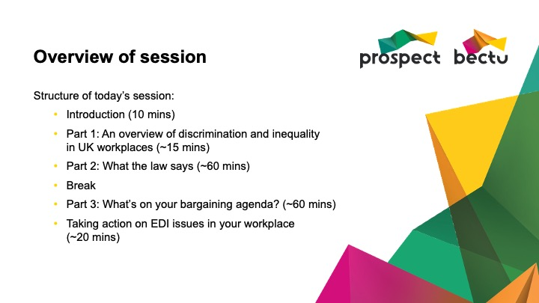 | Notes:

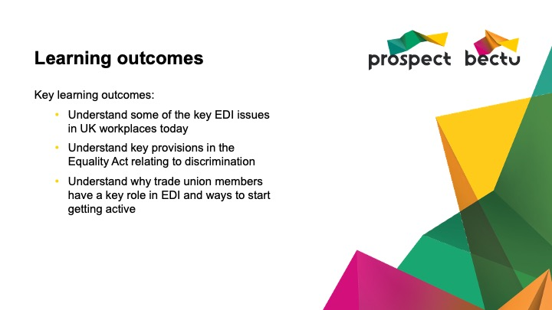 | Notes:

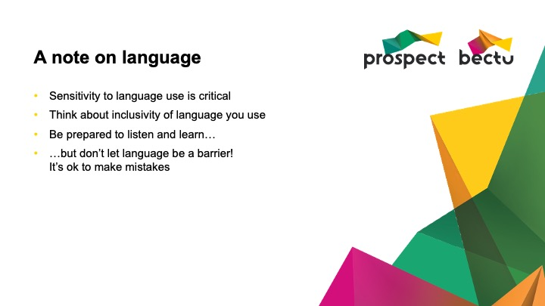 | Notes:

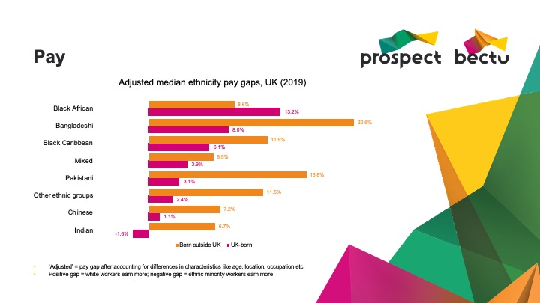 | Notes:

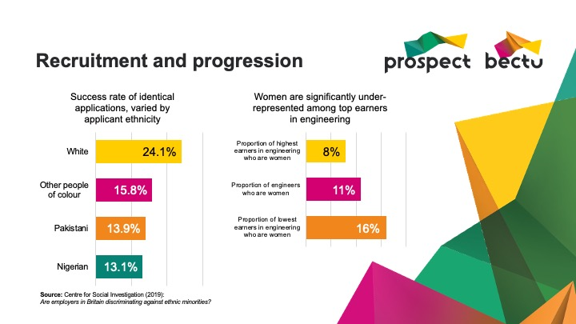 | Notes:

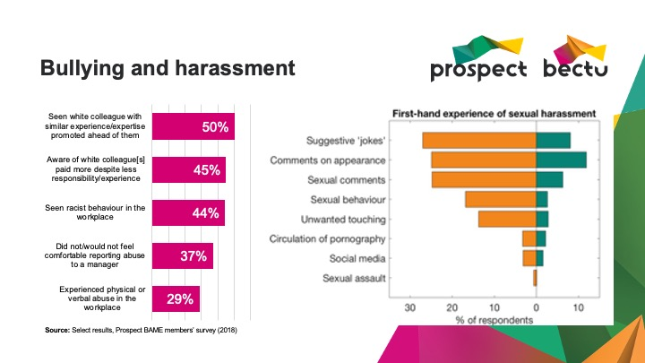 | Notes:

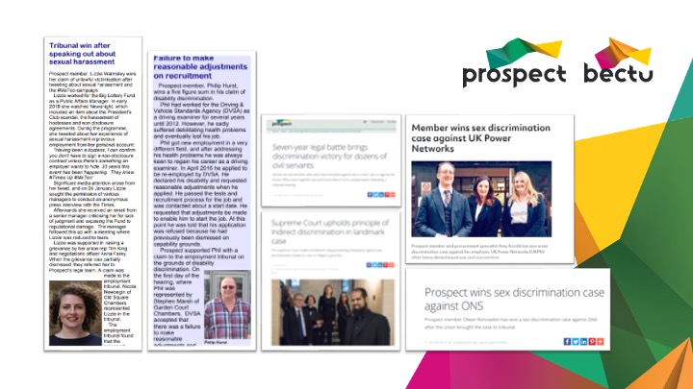 | Notes:

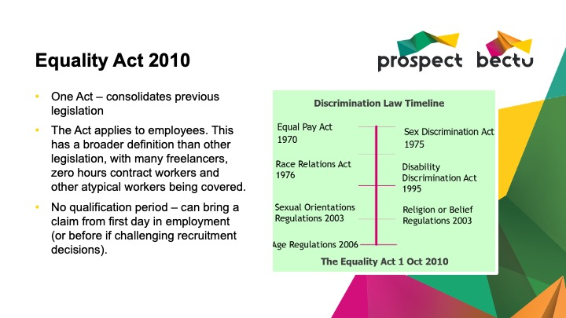 | Notes:

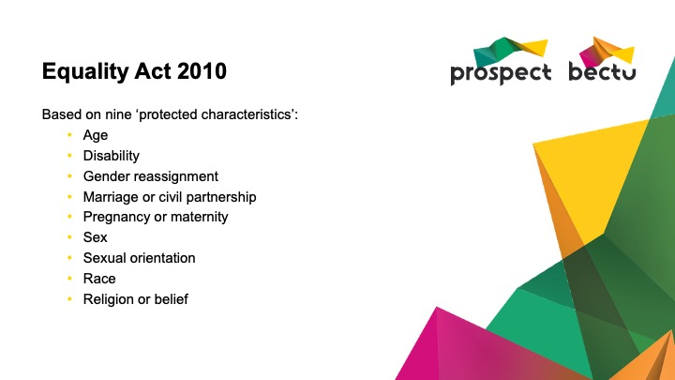 | Notes:

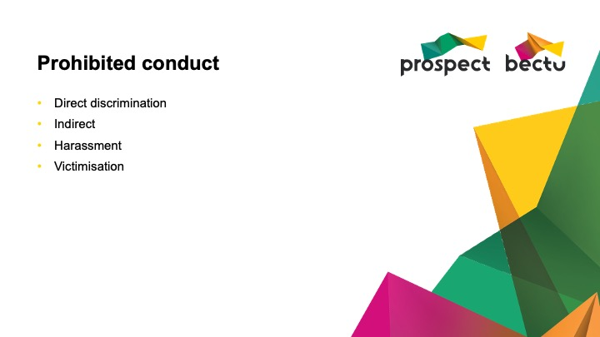 | Notes:

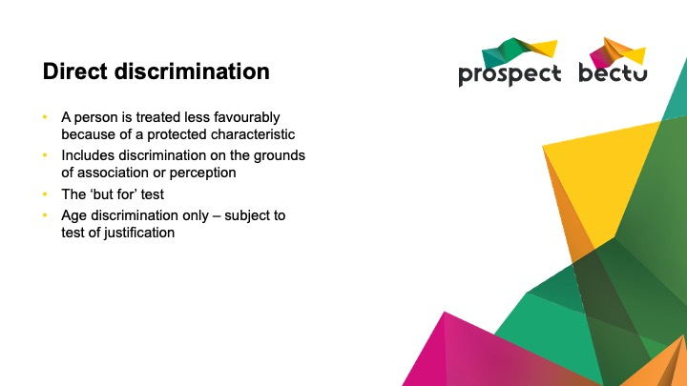 | Notes:

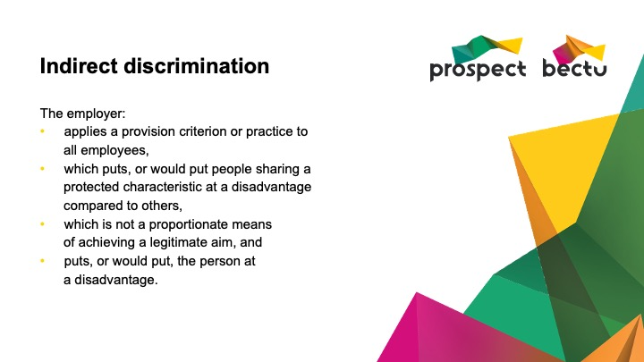 | Notes:

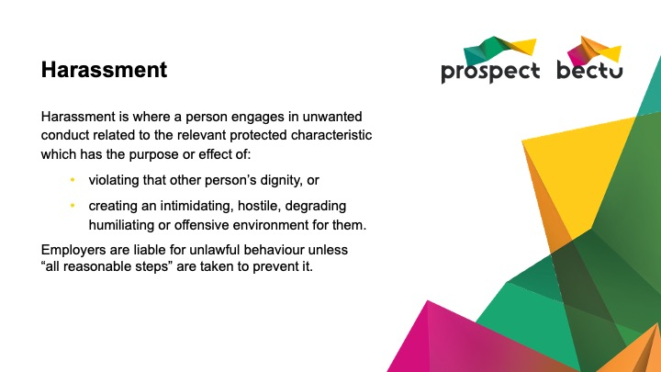 | Notes:

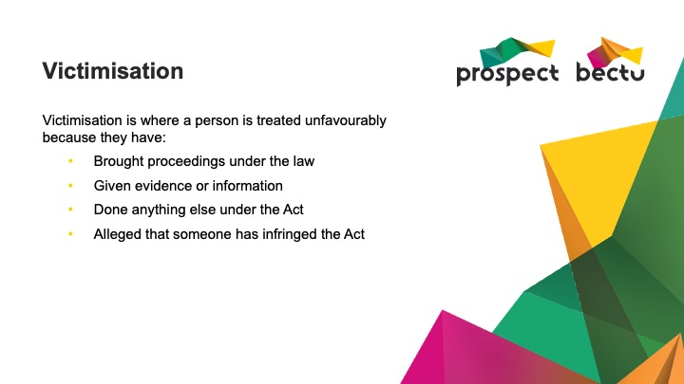 | Notes:

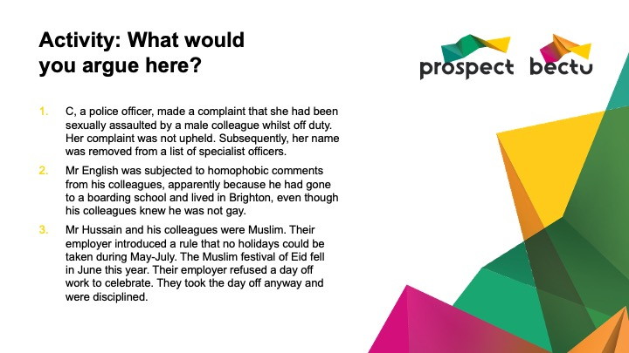 | Notes:

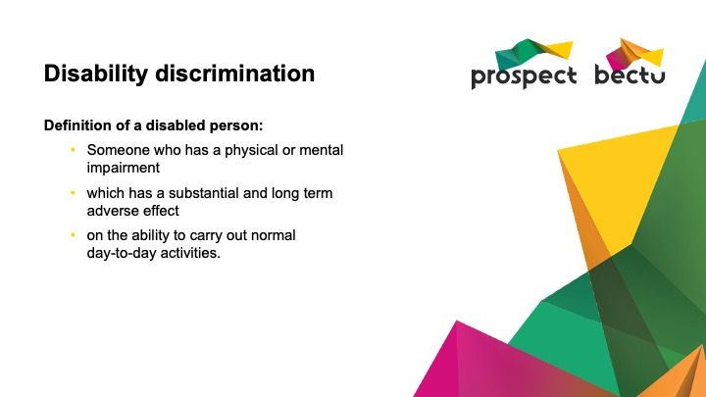 | Notes:

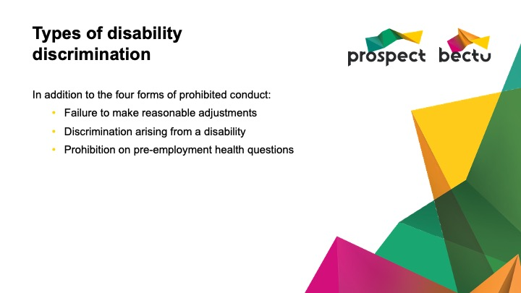 | Notes:

Notes:

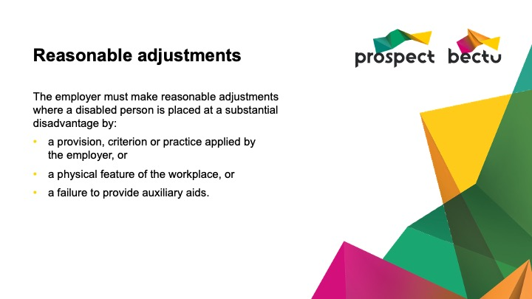 | Notes:

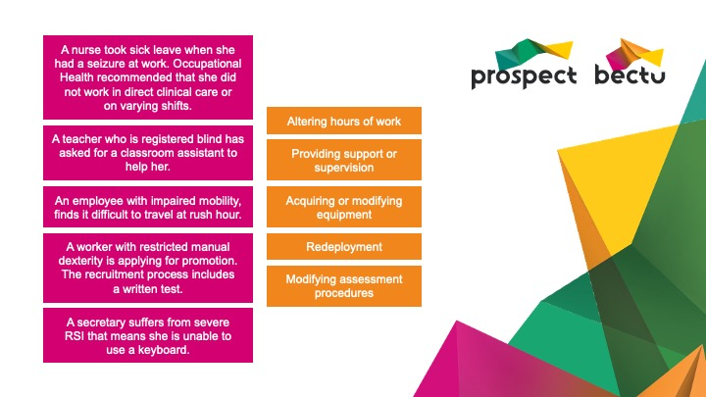 | Notes:

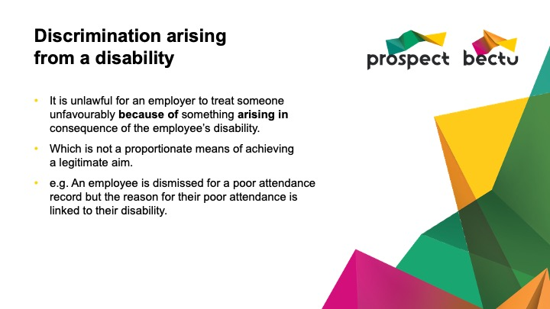 | Notes:

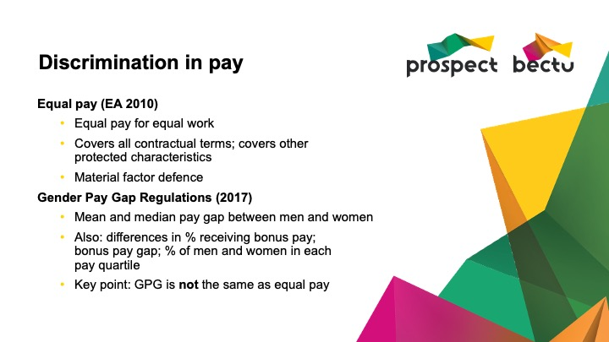 | Notes:

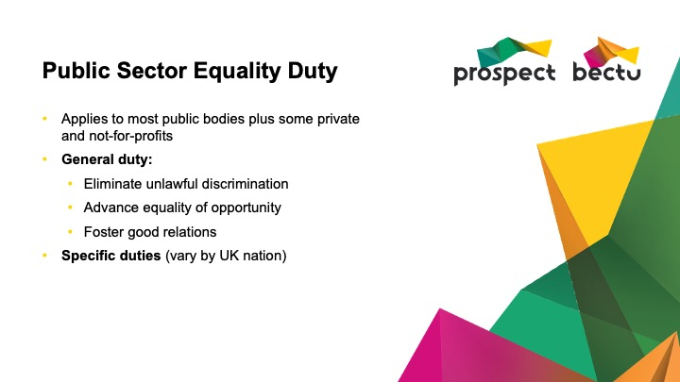 | Notes:

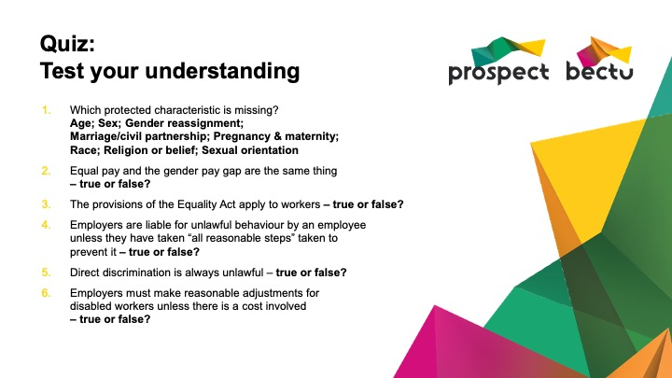 | Notes:

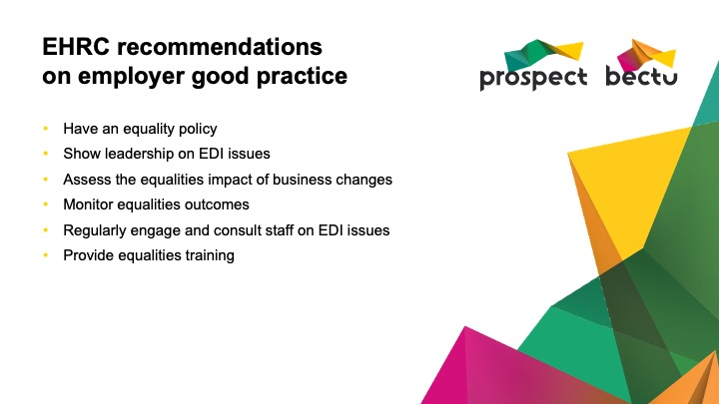 | Notes:

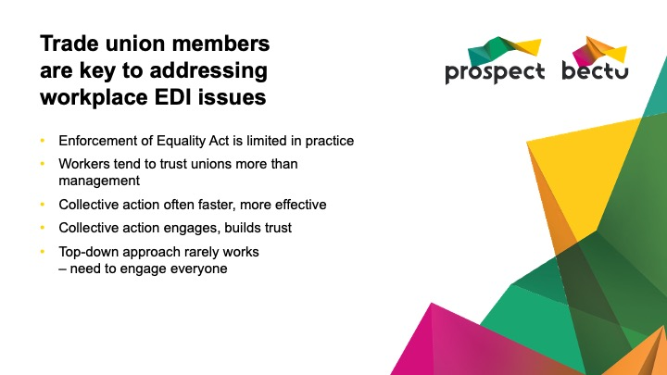 | Notes:

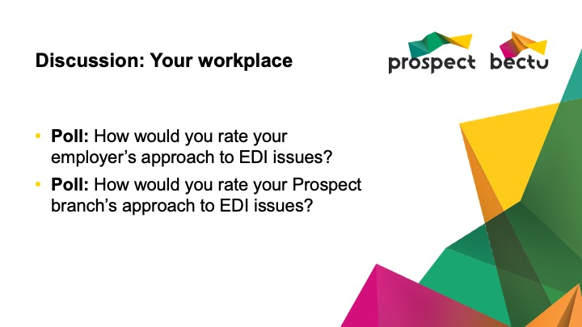 | Notes:

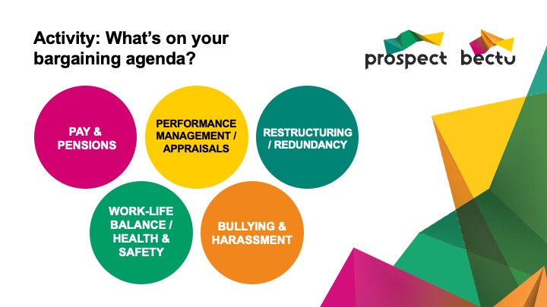 | Notes:

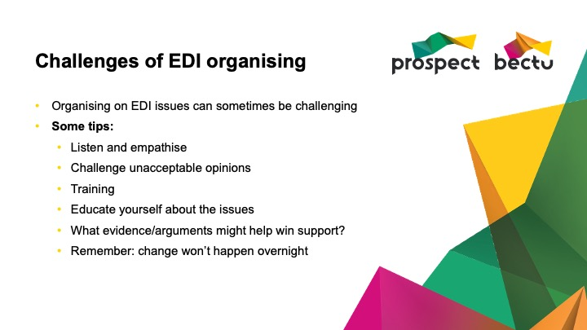 | Notes:

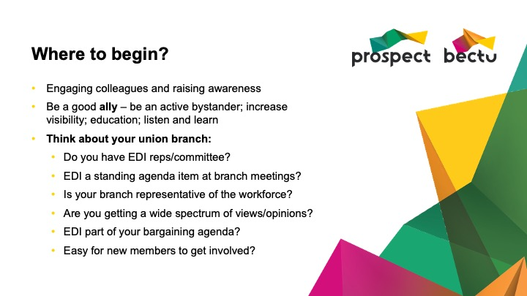 | Notes:

 | Notes:

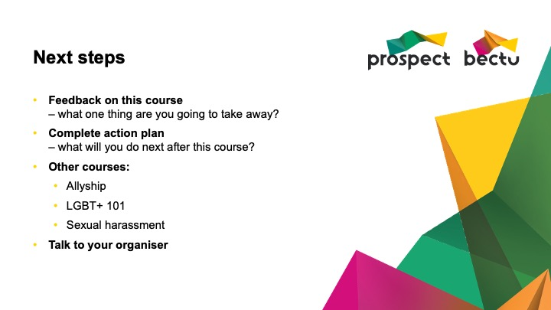 | Notes:

