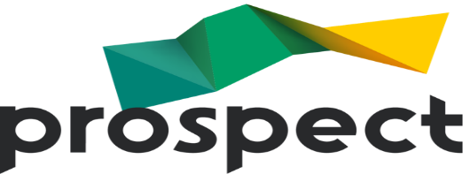

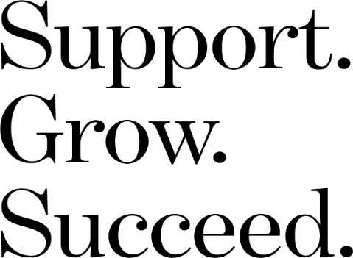
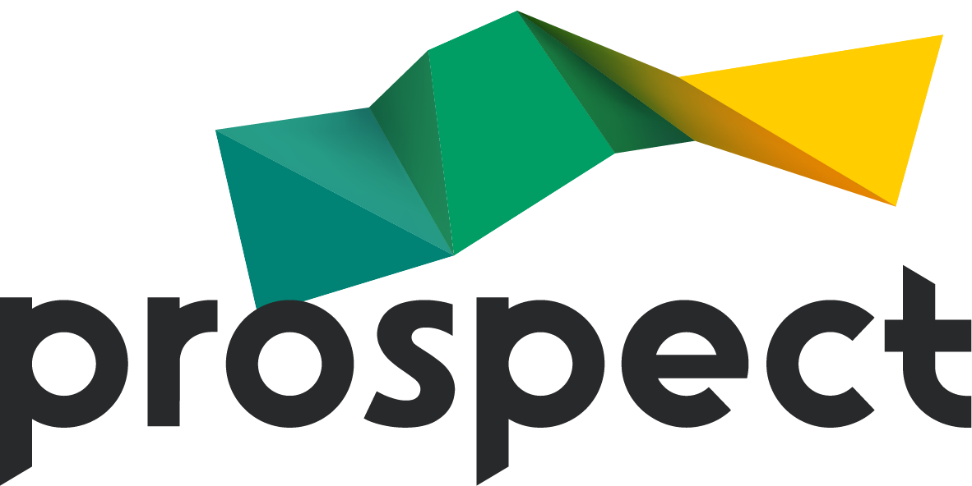


The survey will close 23rd May 2025.
Please spare a minute to complete this short survey about pay at NML. All responses are anonymous.

Ready to Join?
Prospect.org.uk



National Museums of Liverpool (NML) 2025 – Pay Survey
Prospect NML branch is campaigning for greater transparency around pay at NML.

Do you understand how pay at NML works?

