

Welcome to key skills for union reps
Welcome to this introductory course for Prospect representatives which forms part of your induction training.
As well as attending some formal training courses with us, other local union reps and full-time officers will support your ongoing development as a trade union representative.
Our aims are to welcome you to Prospect, help you understand what your union stands for and give you a clear idea of your key role within your union.
We will help you to be an effective and confident union rep able to support members, build good relationships at work and a build stronger union organisation at local level.
The training is student/learner centred and there is no pressure on anyone to do anything they are not comfortable with.
There is plenty of discussion and problem solving, as these are the most effective methods in adult learning.
Learning outcomes:
- know a what a trade union is and how to increase membership
- know the role of a rep
- know your rights as a rep
- know how the union can be a force for good in your workplace
- know the structure of Prospect and Bectu.

Course timetable
- Introductions and objectives
- What is a trade union?
- How Prospect works
- The role of a rep
- Reps’ rights
- Ingredients of union influence
- Building a stronger union
- Branch action plan/end of day housekeeping
Table of Contents
Welcome to key skills for union reps 2
Course timetable 2
Trade union terminology 5
About Prospect 6
What happens on trade union courses? 7
The tutor’s role 7
Your role 7
Using your knowledge and skills 8
Equality and diversity statement 9
Session 1: Activity A – Introductions 10
Session 2: What is a trade union 12
Recognition in the workplace 12
Your right to join a trade union 12
The general benefits of union membership 12
Activity B: Compare a trade union to other options 13
Activity C: What can a union negotiate on? 13
Activity D: Servicing or organising – describe your workplace 14
Session 3: How Prospect works 15
Watch the video – How Prospect works 15
What is a branch? 15
Why does it matter what branch you are in? 15
What happens when a new member joins Prospect? 16
Sectors 16
Branch reps 16
Branch meetings 17
How branch democracy works 17
Support for branches 18
National executive committee 18
NEC advisory sub-committees 19
Prospect structure 19
Session 4: The role of a rep 20
Activity E: What do union reps do? 20
Types of rep 20
Code of practice for Prospect representatives 24
Knowledge Hub 24
Movement bulk-mail tool 25
A number of well-trained reps make a strong branch 26
Session 5: Reps’ rights 27
Extract from ACAS Code of Practice 3 27
Duties 27
Activities 27
Responsibilities 28
Facilities agreements 28
Activity F: What are your rights? 29
Activity G: What would you do if… 31
Session 6: Ingredients of union influence 32
Activity H: What are the ingredients that increase the union’s influence 32
The virtuous circle 32
Local union reps… 33
Activity I: Why people don’t join a union 33
Ten good reasons to join Prospect 34
Session 7: Building a stronger union 35
Activity K: How well organised is your workplace? 35
Activity L: Charting the workplace 36
Identifying potential activists 38
How members can help 38
Any questions? 38
Action Plan 39
Appendix 1: How do you get Prospect to do something in your branch? 40
National conference – making or changing Prospect policies 40
Appendix 2: How to write conference motion 41
Appendix 3: Data protection 42
Appendix 4: Trade union recognition 46
Appendix 5: Useful links 52

Trade union terminology

ACAS – The Advisory, Conciliation and Arbitration Service – a public body that provides free and impartial information and advice to employers and employees on all aspects of workplace relations and employment law. https://www.acas.org.uk/
Bargaining unit – The 'bargaining unit' is the group of employees that will be represented by the union. The employer and the union can agree who is in this unit as part of their negotiations. If the employer and the union do not agree, the Central Arbitration Committee (CAC) will decide.
Branch – Branches are the key organising unit in the union. Branches form the basis of representation to other advisory or policy-making bodies in the union structure.
Case handler – A rep that is trained to represent a member in a personal case.
Central Arbitration Committee (CAC) – Its main function is to adjudicate on applications for statutory recognition and derecognition of trade unions for collective bargaining purposes.
Collective agreement – Where collective bargaining has led to an agreement, for example pay increase, these agreements are called collective agreements. Collective agreements within the workplace can cover both union and non-union staff as trade unions often negotiate on behalf of the staff employed in a specific group. This group is known as the bargaining unit.
Collective bargaining – If a union is formally recognised by an employer, it can negotiate with the employer over terms and conditions. This is known as 'collective bargaining'.
Conference – Prospect’s national conference is held every two years. Delegates discuss and agree the union’s policies and priorities.
Convenor – See trade union rep.
Facilities agreement – An agreement between the employer and the union setting out the provision of facilities and facility time for trade union officials, representatives, and members.
Industrial action - usually happens when a dispute in the workplace can’t be resolved through negotiation. There are three main forms of industrial action:
- strike – where workers refuse to work for the employer
- action short of a strike – where workers take action such as working only to the terms of their contracts, overtime bans or callout bans (sometimes called work to rule).
- lock-out – a work stoppage where the employer stops workers from working.
Lay reps – members of the union who represent their colleagues in union work in companies that have a collective bargaining agreement with Prospect
National executive committee – Prospect’s NEC is elected every two years and is made up of representatives who make key decisions about what and how we deliver for our members.
Prospect Data Protection Compliance Officer – The person who handles data requests and data on behalf of Prospect datacompliance@prospect.org.uk
Prospect’s Member Contact Centre (MCC) – a service for members to have their queries answered. Tel. 0300 600 1878 info@prospect.org.uk
Standing orders Committee – standing orders are the set rules a meeting is run by, a standing orders committee is the way those rules are upheld, any motion put to a conference is checked by this committee that it is legal and meets the agreed rules.
Trade union – An organisation made up of members (a membership-based organisation) and its membership must be made up mainly of workers.
Trade Union Congress (TUC) – the umbrella body for the majority of unions in England and Wales.It has 47 member unions representing around 5.5 million people. https://www.tuc.org.uk/
Union recognition – Employers who recognise a union will negotiate with it over members’ pay and conditions.
Union rep/shop steward – Trade union reps are elected directly by their fellow workers and act as their representatives in individual and collective dealings with management. Trade union reps are not paid but they do get paid time off to do their work as a rep.

About Prospect

Most of the larger unions in the UK have grown and evolved through mergers and acquisitions with other unions, staff associations and professional bodies – either through necessity or strategy.
Prospect is no exception, having absorbed various groups of professional and specialist staff. It is now the tenth largest union in Britain out of the 47 affiliated to the Trades Union Congress – the umbrella body for Britain’s unions – and the most diverse.
Prospect was formed in 2001 through the merger of the Engineers and Managers Association and the Institution of Professionals, Managers and Specialists. IPMS originated from the Royal Corps of Naval Constructors of 1916, so the new union inherited extensive history.
The EMA’s power station managers and electricity distribution engineers complemented the IPMS demographic (scientists, engineers and managers in the defence, energy, heritage, environment and transport sectors) and strengthened our bargaining power.
Prospect merged with the telecoms professionals in Connect union in 2010 and with Aspect, which represents professionals in education, children’s services and social care in 2012. In January 2017, Bectu, the media and entertainment union, joined us to create a sector which includes broadcasting, cinema, film, digital media, independent production, leisure, IT and telecoms, theatre and the arts.
Despite the expansion, the union has managed to maintain four key principles of industrial relations that are consistently important to members, whichever union they originated from:
- we represent professional staff
- we are not affiliated to any party political
- one of our objectives is ‘…to promote the advancement and efficiency of industries and organisations where members are employed or engaged’.
- as an affiliate, we enjoy the resources and support of the TUC.

What happens on trade union courses?
For many trade union activists, Prospect courses mark a return to education.
Trade union education places great value on the knowledge that union reps bring to the course and seeks to enhance this by working co-operatively to gain new knowledge.
We place great emphasis on team working and involving everybody in the learning process. This not only makes learning interesting and challenging but is rooted in well-researched and tested educational methods.
As part of this approach we will:
- encourage a cooperative approach to learning
- allow workplace experiences to be reflected and valued throughout the programme
- help you to build a useful resource pack to support your union activity
- encourage a collective approach to your role as a Prospect representative.

The tutor’s role
Trade union tutors are qualified to teach in the ‘learning and skills sector’ (adult education outside of university) and will also have extensive practical experience as trade unionists.
They should be inspiring, accessible and empowering – you should learn from them! Your tutor will:
- make sure that the expected learning outcomes are clear
- encourage and facilitate everyone’s participation
- introduce you to new ideas and concepts
- giving guidance on how to become an accredited rep
- help you understand your own preferred learning styles and ensure that everyone can participate and benefit.

Your role
The focus of trade union education is 'learning' rather than 'teaching'. The focus is on you and your colleagues as learners rather than on the tutor (although their role is vital) as teacher. In particular, we hope you will:
- feel confident to participate fully
- be able to support your colleagues
- enjoy the learning process
- add to your existing knowledge and skill
- use your new knowledge and skills to support Prospect’s aims in your workplace.
We ask that you take an active part in the course, support your fellow reps and course members when you can and be respectful of other delegates during the course – this will help you promote collective and co-operative activity at your own workplace.
We respect whatever pronoun you wish to be referred to during the course – please write it on your name card.

Using your knowledge and skills
Learning and knowledge are valuable in their own right – they need no justification but as practical people we want to encourage you to develop further.
First, we want your experience of learning with us to encourage you to engage in other forms of learning.
Second, we hope you will use your learning to make a difference at work – for the better.
To help you put your learning to good use we will provide you with a small ‘action plan’ for you to apply at your workplace. We will also support you to carry it out.

Equality and diversity statement
Prospect is dedicated to providing training for all its representatives and activists that aspires to the highest standards of respect for difference and diversity.
This statement is inspired by our trade union values of justice, fairness, democracy, solidarity and equality. As a trade union, we oppose any view, action or organisation that undermines the ability of working people to act collectively to pursue their democratically determined policies and objectives.
We are opposed to discrimination against people on the basis of their gender, nationality, ethnicity, religion, disability, sexual orientation, marital status, social class, age, politics or education.
We defend the right to freedom of expression and to political opinions and beliefs except where these conflict with, or tend to undermine, the freedom of other people from discrimination on the grounds listed above.
In particular, we are opposed to sexist, racist and fascist ideologies and will not permit such views to be promoted at Prospect education events.
We will seek to ensure that all Prospect training is accessible to all who wish to attend. Recruitment to courses will be open, fair and in line with our commitments above.
All courses will allow opinions to be put forward and defended (consistent with the statement above). All members who attend Prospect courses are entitled to respect.
Members who want to raise issues relating to our commitment to equality and diversity, or if they wish to lodge a complaint about any incident or failure concerning this policy, should use the following procedure:
- any issue occurring during a course to be raised with the tutor
- if this is not practicable, or if the complaint is not dealt with to the satisfaction of the member, it should be raised with Prospect’s education officer or the education and skills manager
- if a member is not satisfied, the matter should be referred to the General Secretary.

Session 1: Activity A – Introductions

The tutor will split you into pairs.
Please gather the following information from your partner:
- their name
- the company they work for
- their current work role
- why they first become involved in the union
- their current union role and how long they have been active in that role
- what they want from the course
- an interesting fact about the person (preferably not work-related).

The tutor will ask you to introduce your partner to the other course participants.
Please complete this form for the person you interview, not yourself.

Name
Company
Work role
Why they got involved in the union
Current union role
What does the person you are interviewing want from the course?
Interesting fact about the person

Session 2: What is a trade union
The definition of a trade union is: An organised association of workers in a trade, group of trades, or profession, formed to protect and further their rights and interests.

Recognition in the workplace
Employers are not obliged to bargain with unions. They can voluntarily recognise a union or a union can gain statutory recognition by meeting certain criteria and applying to the Central Arbitration Committee.
With a recognition agreement in place, the employer ‘recognises’ the union for collective bargaining purposes. Statutory recognition is limited to pay, hours and holidays. See Appendix 4: Trade union recognition for more on the recognition process.

Your right to join a trade union
You have the right to:
- choose to join, or not join, a union
- decide to leave or remain a member of a union
- belong to the union you choose, even if it’s not the one your employer negotiates with on pay, terms and conditions
- belong to more than one union.
Your employer is not allowed to:
- offer you a benefit to leave a trade union
- threaten to treat you unfairly if you don’t leave a union or stop doing union activities.

The general benefits of union membership
Unions have brought significant changes to society, including:
- a national minimum wage
- the abolition of child labour
- improved worker safety
- improved living standards by reducing the number of hours in the working week and encouraging a healthy work/life balance
- improved parental leave
- equality legislation
- better protection of migrant workers and a reduction in exploitation
- minimum holiday and sickness entitlements.
You are better off in a workplace that recognises a union because wages are higher, health and safety is better and union workplaces usually offer more training and development.
Pay – Union members, on average, secure better pay deals than those who are not part of a union. For more information on collective pay deals in recognised workplaces See Pay & bargaining news | LRD
Health and safety – see www.tuc.org.uk/research-analysis/reports/union-effect
Prospect offers a range of CPD and industry recognised training for its members Free bitesize vocational learning | Prospect
How unions and collective bargaining create great jobs – www.tuc.org.uk/research-analysis/reports/great-jobs-are-union-jobs
TUC research found that for every £1 spent on training, the economy got £12.87 back – https://www.tuc.org.uk/sites/default/files/2020-11/TheFutureUnionLearningFund.pdf
For further information and data to support this statement refer to www.tuc.org.uk/reports
When you are trying to persuade a colleague to join, always mention local issues that have been won or that the union has campaigned on. Sometimes the best thing to say is why you joined.

Activity B: Compare a trade union to other options
As a group discuss the benefits of being in a trade union as opposed to the following options:
- Facebook group or other social media groups
- workers’/employees’ forum
- single employee action
- professional body.

Activity C: What can a union negotiate on?
In your groups make a list of what a trade union can do.
In three groups, focus on one area and have one-person feedback to the rest of the group.
- What can you expect to be informed on?
- What should you be consulted on?
- What can a union negotiate on?

Activity D: Servicing or organising – describe your workplace
The tutor(s) will provide a brief explanation as to what servicing and organising means.
Read the statements overleaf and tick those which describe your branch at the moment. You may tick both sides, leave blank those that don’t apply.

Servicing model | √? | Organising model | √?
The union is seen as external – as a third party that comes in to do things and then leaves again. |  | Members see themselves as the union and do things themselves rather than ask the union to do things for them.
Union officials tell members ‘the union’ will sort out problems on their behalf. |  | Members identify their own issues, organise to solve them together and only ask for help if they need it.
The union relies on the employer to provide lists of workers’ names to the union official. |  | Union members ‘map’ the workplace themselves – names and information are provided by workers.
Relies wholly on employer for workplace access. |  | Some organising can be done outside work.
The union relies on ‘cold’ selling of membership by specialist organisers who do not work at the employer. |  | First recruiting steps are carried out by members to establish contacts, find natural leaders and uncover issues.
Union ‘sold’ to potential members on the basis of services and insurance protection. |  | Members see the union as a means to achieve direct improvements at work.
Local reps and committee members rely on full time officials to recruit and solve problems |  | Workplace organising committee formed; workers encouraged to build the union through one-to-one organising.
Recruiting is seen as separate from other activities. |  | Recruitment and organising are integrated.
Results are achieved but are likely to be short term. |  | Results obtained through sustained efforts are more likely to be permanent.
Workers blame ‘the union’ when it can’t get results. |  | Members share decisions and solve problems together with union leaders.
Members complain they pay subs and the union does nothing. |  | Members make a real contribution and identify with the union. An attack on the union is an attack on themselves.
Organisers resent members for not coming to meetings or participating. |  | The union’s image is positive and active.
Management acts while the union reacts and is always on the defensive. |  | The union has its own agenda and members are involved.

Session 3: How Prospect works
Prospect is an independent union and is not affiliated to any political party. Its objectives are set out in its rules. It exists to:
- protect and promote members’ interests
- maintain and improve their conditions of employment and relations between them and their employer
- provide and maintain services for the benefit of members.
As a union is democratic, it has to have a structure that makes that possible. The first part of that structure is the branch.

Watch the video – How Prospect works
https://vimeo.com/showcase/prospect-ed Password: education

What is a branch?
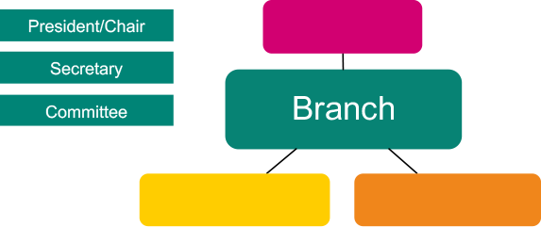
A branch is a usually made up of members who work for one employer (bargaining unit). A bargaining unit is the group of workers for whom a trade union is requesting, or has been granted, recognition.
Large branches, for example workplaces with several sites or businesses, may be broken down into sections or sub-sections.
Your branch should be organised so that every member who could be affected by negotiations carried out by branch representatives can be informed and have their say.

Why does it matter what branch you are in?
It is very important that members are in the right branch/bargaining unit so that they can speak or vote on issues that affect them. It also means that the union and its reps can better ‘group’ members together and make it easier to help them and deal with issues.

What happens when a new member joins Prospect?
A new member is put into the appropriate branch. This is decided from the following information:
- who they work for
- their job or role
- their work location.
A member can only be in one branch. If it is not certain which branch they should be in, they go into a regional branch until it can be narrowed down or a new branch is formed.

Sectors
A sector is made up of branches with employers who have a similar business, e.g. Energy, Media and Entertainment or Public Services, IT & Telecoms, Heritage, Defence and Aviation.
Sectors have committees and conferences which are held every two years.

Branch reps
Under the union’s rules, a branch has to elect a president or chair responsible for:
- the proper conduct of any branch meeting
- ensuring that business is kept moving and every member gets a chance to speak if they want to
- clarifying that clear decisions are reached and recorded.
Another role needed under union rules is a secretary, whose duties include:
- calling branch conferences or annual general meetings (AGM) or any other branch meeting and making the arrangements
- preparing and circulating agendas, minutes and action lists
- being the conduit between the branch and Prospect as a whole
- maintaining branch records.
To protect members’ data and to avoid sending out emails that members may not be interested in, Prospect nationally sends the majority of correspondence to branch secretaries.
In smaller branches, the secretary is usually in charge of the membership records; larger branches may have a dedicated membership secretary or organiser.
Other roles that the branch may elect include: organiser, treasurer, health and safety rep, union learning rep, equality rep, pension rep, environmental rep and case handler.

Branch meetings
A branch meeting is where an issue can be discussed, and a democratic decision reached and voted on.
A majority decision at a branch meeting is the course of action a representative takes up with management on the members’ behalf.
Most members do not want to attend branch meetings. Decisions still need to be made on the day-to-day business of the branch. So the branch elects a committee to facilitate this.
It is very important that all the different working areas/grades/departments are represented on the committee.

How branch democracy works
It is very important that issues that affect the majority of the branch are dealt with as a priority.
Getting agreement at a meeting may not be easy. The chair will need to keep order and make sure all the sides of the argument are heard.
The committee should agree beforehand who will provide the information needed for the members to make an informed decision.
An issue is raised, and an action is voted on at a meeting.
A meeting needs to be quorate for a decision and a course of action to be made.
A quorum is enough members to be a reasonable representation of the branch – for example, 10%.
The branch usually instructs the committee to take action – this could be to call a meeting with management to discuss the issue.
In between meetings, the committee can discuss an issue that arises and decide a course of action. There may be occasions when a full branch meeting is needed.
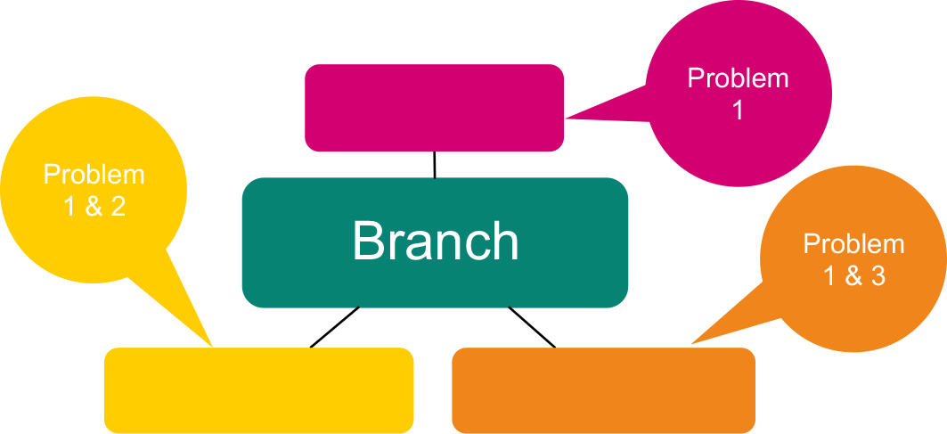
For further information on how to take an issue further in the union or to get support from other branches, see Appendix 1 and 2. With multiple problems that need to be dealt with at the same time, it may be wise to set up different working groups (made up of reps or members who have the problem, wherever possible to encourage members to be active).

Support for branches
Branches can call on Prospect for support. Most branches in the union have an organiser and a negotiator. These staff have further support from the legal, communications National Organising Team (NOU) and the Education & Skills teams.
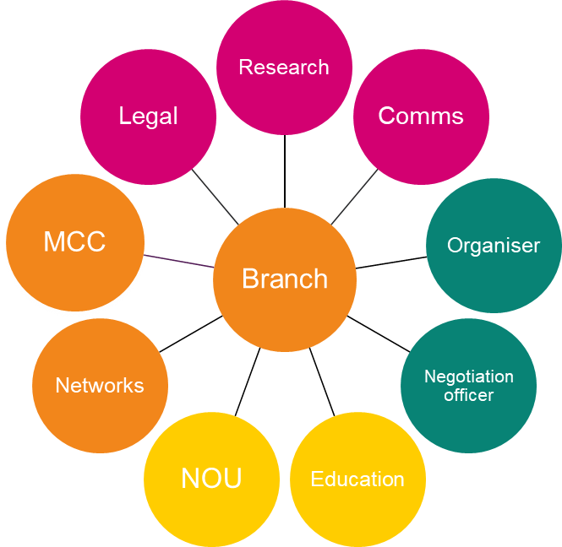



National executive committee
The national executive committee (NEC) conducts the business of the union in accordance with the policies laid down by national conference. It manages the union’s affairs between conferences and normally meets five times a year.
The NEC consists of 28 working members, including three office-holders – the president, vice-president and deputy vice-president (the ‘presidential team’), plus the general secretary. The general secretary has no voting rights.
The NEC is elected by working members every two years, from a list of candidates nominated by branches.
NEC members do not represent particular branches or professions. They are elected to look after the interests of the whole membership.
The president, vice-president and deputy vice-president are elected every two years from among the voting members of the NEC.
The NEC establishes the sub-committees it needs for the despatch of its business. Each of them may set up panels or working parties reporting to them on particular aspects of their work. Some of these committees invite direct participation by branch reps.

NEC advisory sub-committees
The NEC has to make many decisions in the two years between national conferences. They need relevant information to be able to make those decisions. Advisory committees, made up of reps from all the sectors of Prospect, were set up to help with this.
The sub-committees are:
- Committee for organisation, recruitment and education
- Communications and campaigns
- Equal opportunities
- Health and safety
- Pensions
- Science, engineering and sustainability
- Finance and audit.

Prospect structure
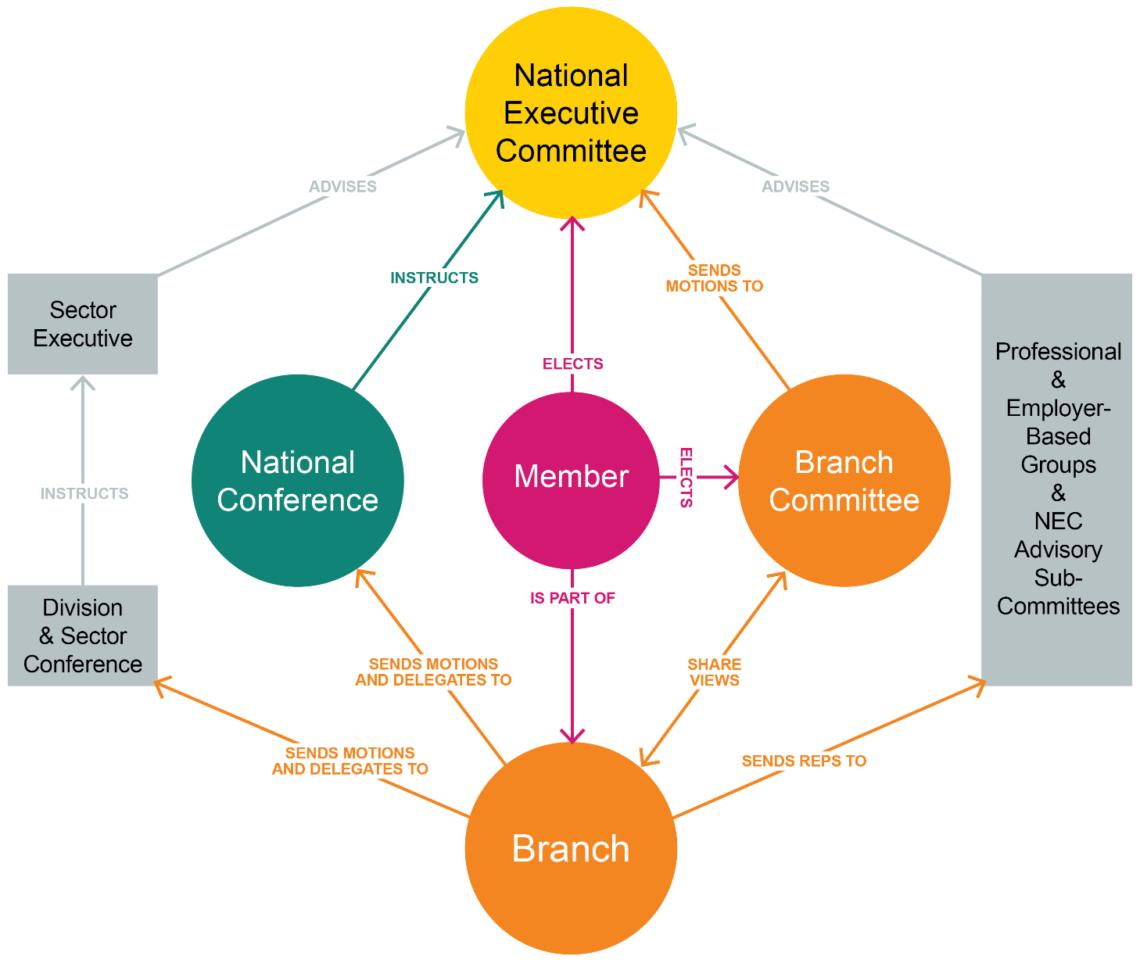

Session 4: The role of a rep
Every rep is the link between the union and its members. We are always conscious reps are volunteers. Some can give a little, others can give a lot. Each rep must find their own boundaries.
For most, the role of the local representative includes one of more of the following elements:
Advice: not necessarily able to answer all questions but knows where to look/or who to go to for the answers.
Representation and advocacy: standing by a member’s side or speaking on their behalf.
Negotiation: helping to improve local working conditions.
Liaison and consultation: passing information up, down, sideways; representing members’ views to management.
Organisation: organising the branch, strengthening its position in the workplace.
Democracy: representing members’ views in developing the union’s policies.
Prospect prides itself on its reps and the good work they do. This session looks at the role in more detail and what skills are needed.

Activity E: What do union reps do?
Working together in small groups, make a list of all the things a Prospect rep might do as part of their duties.
Make a list of the skills needed by a rep to do the tasks on the first list.

Pick the four most important tasks from your list.

Types of rep
There are many different types of rep – you can do as much or as little as you want. Not all reps have a recognised job description. Some can simply be described as local representatives: the face of the union in a particular workplace or location. But others have very specific responsibilities, usually defined in the branch rules.
Local representatives
Well-organised branches usually develop a network of local representatives to undertake a range of tasks, depending on the type of branch or workplace. These include:
- acting as a focal point for Prospect in their area
- eliciting and conveying members’ views to the branch or section
- maintaining the local noticeboards
- distributing Prospect information
- managing local websites and social media accounts
- ensuring non-members are approached to join, keeping a record of approaches made and, if unsuccessful, the reason
- ensuring changes in members’ details and location are passed to the branch or section.
Reps with particular skills or interests may be willing to take on specific tasks such as communicating with members using various digital tools which are available to branches alongside specific training.
Local reps may be known by various titles – site secretary, correspondence rep, or just ‘Prospect rep’. In the energy supply industry sector, many are known as technical reps or TRs.
Point of contact
This is not a representative role. It is a Prospect member who wants, and is able, to give a little of their time to support their branch. No training is required and there is no expectation to carry out other duties. The point of contact can help the branch extend its reach by having local contacts across its workplaces.
Branch officers
In the paragraphs that follow, for ‘branch’ you can read ‘section’ or ‘sub-section’ as appropriate.
President/chair
The president (or chair, or convenor in some Scottish branches) presides at all branch conferences or committee meetings and is responsible for:
- the proper conduct of the meeting
- ensuring that business is kept moving
- clarifying the issues under discussion
- ensuring that clear decisions are reached and recorded.
In most branches, the president is an experienced rep with a wider representational role in negotiations or consultation.
Vice-president/chair
The vice-president acts as chair in the absence of the president. Smaller branches may choose not to have a vice-president.
Secretary
This is the key role in most branches. The secretary’s duties include:
- calling branch committee meetings, branch conferences or annual general meetings and making all associated practical arrangements
- preparing and circulating agendas, minutes and action lists
- submitting to the committee matters referred to them by Prospect headquarters or by any member or body with which the branch is associated
- during meetings, assisting the president/chair by presenting information and introducing items for which they are responsible
- maintaining branch records
- dealing with correspondence
- liaising with Prospect headquarters.
Some branches have an assistant secretary or minutes secretary to help with administration. In most branches, the secretary is an experienced rep with a wider representational role in negotiations or consultation.
Membership and recruitment secretary/branch organiser
A membership and recruitment secretary’s duties include:
- maintaining local membership records
- liaising with Prospect headquarters on recruiting eligible people into membership
- organising recruitment in the branch and reporting back, keeping the branch committee informed.
- where relevant, keeping in close touch with sections about their membership position and helping them to organise their recruitment effort.
Branch organiser
The additional duties of a branch organiser include:
- mapping the workplace: establishing how many non-members there are and where
- organising and co-ordinating recruitment campaigns
- overseeing the network of local reps and identifying gaps and training needs
- developing and maintaining a branch development plan which summarises the objectives and actions needed to strengthen organisation and increase membership.
Treasurer
The treasurer’s duties include:
- the proper use, custody and accounting of the funds allocated to the branch by the national executive committee, including paying branch expenses
- preparing an annual income and expenditure account, making up a balance sheet to 31 December of each year and submitting it for audit in time for the annual conference or meeting
- supplying any additional information on finance needed by Prospect headquarters where relevant, transmitting to section treasurer’s money allocated by the branch committee.
Reps with specific legal rights
Multiple types of reps exist on a statutory basis, i.e. they have specific rights under the law.
Health and safety rep
Employers are required to create a culture of cooperation on health and safety, engaging with staff to ensure people go home safe and well from their work.
The Safety Representatives and Safety Committees Regulations 1977 allow unions to appoint health and safety representatives to get involved for the benefit of their colleagues.
Branches appoint reps, then they must notify their employer so that reps are afforded rights to:
- inspect the workplace
- escalate unresolved health and safety concerns
- engage in health and safety planning, consultation and auditing
- investigate serious incidents, work illnesses and complaints
- meet an inspector during a visit.
Union learning rep
Union learning reps have specific legal rights and powers. Their duties include:
- promoting training and development in the workplace by providing advice and information on learning initiatives
- supporting members who want to review and broaden their portfolio of skills
- helping to identify sources of training or learning provision.
Equality Rep
These reps play a crucial role, pressing employers to create fairer workplaces for all and will have statutory rights from Autumn 2026. Equality Reps in recognised workplaces will be able to request paid time to carry out their role just the same as other reps. Their duties can include raising awareness within the workplace of the work the union and the branch do around equality and working with branch officers to analyse information about the employer’s equality performance such as audit agreements, equal pay surveys etc.
Other specialist reps
Branches often appoint reps to deal with specific issues.
Pension rep
These reps act as a point of contact for members’ pension queries. Pensions is a detailed and technical area so their role is often to direct members to the appropriate workplace or union contact if they cannot answer the query themselves. They also work to raise the profile of pension issues in their branch.
Environmental rep
These reps act as a conduit between management and members. Their aim is to raise awareness and participate in initiatives to minimise consumption, optimise resources, source materials sustainably and dispose of waste responsibly. They also participate in formal and informal organisational structures.
Case handler
These are reps who support and advise members with personal cases from across the sector, not just within their own branch. To be a Prospect Case Handler you must attend and successfully complete Reps 1 and Reps 2.
Communication rep
This rep role aims to raise the profile of the union in individual workplaces through its communication with members. This role can be done by anyone who likes communicating but also enjoys creating newsletters, posters, branch hub information and digital communications.

The expected values and behaviours of all representatives.
- Respectful
- Positive
- Good listener
- Clear communicator
- A sounding board for ideas
- Non-judgemental
- Flexible
- Integrity
- Supportive
- Honest
- Able to network

Code of practice for Prospect representatives
The aim of the current code of practice is to:
- Provide you with clarity about your responsibilities to ensure the respect of others.
- Inform you about your rights if you feel you are not being treated with respect.
It places the following responsibilities
Representatives must:
- Act honestly, responsibly and with integrity.
- Communicate respectfully and honestly.
- Treat others with fairness, dignity, and respect.
- Encourage the open expression of views at meetings but accept collective responsibility for all decisions and policies once finalised.
- Not behave in ways that may cause physical or mental harm or distress to another person, such as verbal abuse, physical abuse, assault, bullying, or discrimination or harassment.

In representing Prospect, representatives must:
- Only speak or act on behalf of Prospect when authorised to do so and clarify the capacity in which you are speaking.
- Always be mindful of their responsibility to maintain and develop Prospect’s ethos and reputation.
- Declare any interests that may conflict with their role in Prospect, for example in a professional or political capacity.
- Respect confidentiality and ensure GDPR compliance in dealing with any documents, material, or devices containing confidential information.
- Not bring Prospect into disrepute, including through the use of email, social and mainstream media and other internet sites.

Knowledge Hub
Prospect gives branches/sections a way of communicating with their members which reduces the chance of a data breach when sending emails. This is done via our free Knowledge Hub system.
The Hub gives your branch or section its own website, with no need to worry about set-up, design or hosting. All you need is internet access and a web browser.
All branches have a 'starter' Branch page which gives their branch information about their reps.
Depending on their branch permissions, they will have different access to content.
For Chairs, secretaries, assistants', vice’s they will have access to manage the branch content and from this they can view members and details/membership status etc.
For membership & recruitment secretaries & organising reps, they will have access to view member lists but not manage content.
For the comms reps, they will have access to manage content (not be able to view members lists directly) but also have access to the movement tool for bulk mailing.
The Hub has the following capabilities:
1. Members-only web pages. Up to six pages, one labelled ‘public’ which is accessible to non-members.
2. Upload documents.
3. Publish brief news updates.
4. Links to the Movement tool to send mass emails to your members or reps without the need to maintain your own distribution lists.
For more information about the Knowledge Hub including a user guide, please visit:
How to use the Prospect Knowledge Hub | Prospect

Movement bulk-mail tool
Movement is the new tool to safely contact your members. Included is a video link with extra content on the course resource page
https://prospect.org.uk/movement-email-guide-for-reps/

A number of well-trained reps make a strong branch
Branch
rep
Branch Secretary
Environmental rep
Branch Chair
Case handler
Health
and safety rep
Equality LGBT+ reps
Union Learning rep
Young members
rep
Negotiations
rep

Communications rep
Membership
and recruitment secretary

Session 5: Reps’ rights
It is very important that a new rep feels confident in what they can and can’t do. This session looks at reps’ rights.
Your legal rights derive from the Trade Union and Labour Relations (Consolidation) Act 1992.
Under section 199 of the Act, the Advisory, Conciliation and Arbitration Service (Acas) has a duty to provide practical guidance on the time off to be permitted by an employer – see http://bit.ly/acas-time-off.

Extract from ACAS Code of Practice 3
“Entitlement”
8 Employees who are union representatives of an independent trade union recognised by their employer are to be permitted reasonable time off during working hours to carry out certain trade union duties.
9 Union representatives are entitled to time off where the duties are concerned with:
- negotiations with the employer about matters which fall within section 178(2) of the Trade Union and Labour Relations (Consolidation) Act 1992 (TULR(C)A) and for which the union is recognised for the purposes of collective bargaining by the employer;
- any other functions on behalf of employees of the employer which are related to matters falling within section 178(2) TULR(C)A and which the employer has agreed the union may perform;
- the receipt of information from the employer and consultation by the employer under section 188 TULR(C)A, related to redundancy or under the Transfer of Undertakings (Protection of Employment) Regulations 2006 that applies to employees of the employer;
- negotiations with a view to entering into an agreement under regulation 9 of the Transfer of Undertakings (Protection of Employment) Regulations 2006 that applies to employees of the employer; or
- the performance on behalf of employees of the employer of functions related to or connected with the making of an agreement under regulation 9 of the Transfer of Undertakings (Protection or Employment) Regulations 2006.”
Reps’ rights are split broadly to into two categories: duties and activities.

Duties
Employees who are union representatives of an independent trade union recognised by their employer are to be permitted reasonable paid time off during working hours to carry out certain trade union duties.
Examples are pay negotiations, consultation on restructuring, or representing an individual member in a grievance.
These tasks also include time to prepare for these duties and to do other things "concerned with" them (e.g. briefing and consulting members before and after meetings with management, or branch committee meetings to discuss such issues).

Activities
Union reps and members are entitled to reasonable time off during working hours to carry out certain trade union activities, which are seen as different from duties.
In essence, the law recognises that unions need the participation of their members to operate effectively.
Activities might include attending meetings to discuss internal union business, organising union elections.
Members’ attendance at internal union meetings about collective bargaining issues will be classed as "activity" rather than "duty".
For reps, the same meetings may be classed as a "duty" because they are directly related to negotiating with the employer. Some rep work will, however, be classed as an "activity" – for example, anything related to internal union organisation.

Responsibilities
A union rep has to inform the employer when they wish to take paid time off for trade union duties or activities. The procedure normally found in the facilities agreement or in the recognition agreement and should provide clear guidelines on how a rep applies for time off.
Time for training can be declined if there is no cover, but a reasonable request can’t keep being denied.
Reps and employers can sometimes disagree about the interpretation of reasonable. If you are having difficulty getting time off, the first place to check is your workplace facility/recognition agreement or with your full-time officer to see what has happened in the past.
In considering what is reasonable, the following factors will be taken into account:
- the union’s need to be able to reach all of its members
- provide effective recognition
- the size of the organisation and the number of workers
- the production process
- the need to maintain a service
- the need for safety and security.

Facilities agreements
In most areas where Prospect is recognised by the employer, there will be a formal agreement describing the time off and other facilities available to the union and its reps.
The ACAS code recommends this, noting that there can be "positive advantages" for employers and trade unions in establishing agreements which reflect their own situations.
However, the absence of a formal agreement does not mean an individual can be denied their statutory entitlements.
A formal agreement can help to:
- provide clear guidelines against which applications for time off can be determined
- avoid misunderstanding
- facilitate better planning
- ensure fair and reasonable treatment.
An agreement may form part of a more general document covering the union’s recognition status – often called a Recognition and Procedure Agreement – or it may stand alone. The agreement may be longstanding, and its application may have evolved over time.

Activity F: What are your rights?
Working together in small groups, look at the following examples and decide what the rep’s rights are, what heading they should come under and where they can check this. What other options are there?
Put the following under the appropriate heading:
- recruiting members
- balloting for strike action
- acting as a primary support for a member with mental health issues
- staying vigilant and taking action on health and safety issues
- representing themselves
- representing members in disciplinary/grievances
- attending meetings to discuss internal union business
- helping a member submit a claim to an employment tribunal
- keeping an employer informed about any time off for union duties
- setting up events and attending stalls in the workplace.
- organising education opportunities
- sorting out personal differences between colleagues
- advising those who are not members of the union
- keeping members informed of union activity.

Duties | Activities
Responsibilities | Not responsible

Activity G: What would you do if…
Individually, look at the situations below and decide what course of action could be taken:
- A member has approached you as the rep. In a recent meeting with male colleagues, this female member was asked to take the minutes. He also referred to her directly as “love” on another occasion. As the only female in the meeting, she now feels uncomfortable as it isn’t part of her role, what can she do?
- A member has approached you because they witnessed another member being racially abused by another member of staff. When they complained to their manager, they were told nothing could be done as they were not the one being abused.
- A member comes to you as they feel like their privacy is being invaded due to new CCTV being added in their area at work. This is starting to affect their mental health.
- The union has a bad reputation with a group of part time workers who feel they are under-represented as a group. None of the group are in the union.
- A member approaches you as they feel they may be discriminated against. Their boss lives and breathes work and expects the member to do so as well. As a single (marital status) employee, the member has noticed the expectation is not as great for those with families. Is there anything they can do?
Session 6: Ingredients of union influence
In this session, we take a look what gives a union influence in the workplace and how reps can increase that influence.

Activity H: What are the ingredients that increase the union’s influence
You will work in groups and be given an ‘ingredient’. Discuss as a group how this ingredient’s presence helps build an effective union on the ground and what happens if it isn’t there. Try to prove why your ingredient is more important than the others.
The ingredients are:
- membership density
- engaged members
- visible profile
- constructive dialogue
- representative membership
- representatives.
- equality and diversity

The virtuous circle
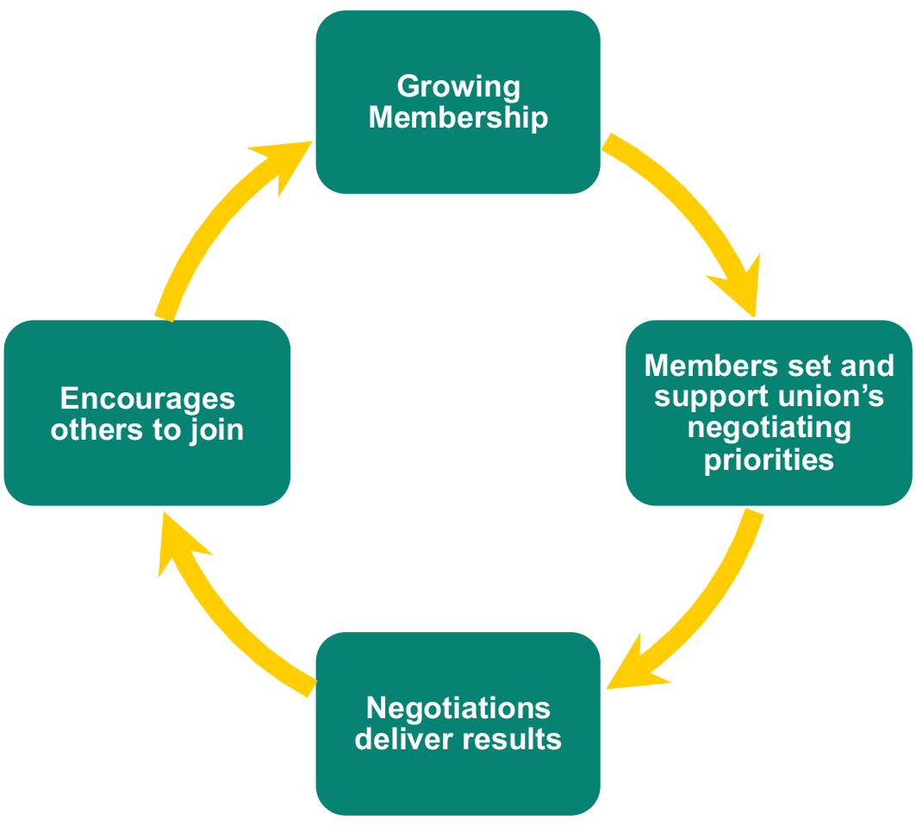
Effective local organisation – meaning reps like you – are at the heart of Prospect’s ability to keep the virtuous circle going.

Local union reps…
- are the union’s eyes and ears, picking up issues that matter to members that can be resolved by negotiation
- are the union’s voice in the workplace, getting members involved in new campaigns and keeping them informed about on-going negotiations
- give the union a positive profile – visible on notice boards, identified with important issues
- grow the union by talking about joining to colleagues who are not yet in Prospect
- keep members in touch with the wider union, e.g. by organising meetings and events with visiting speakers from beyond the branch.
A really important task for everyone involved in Prospect’s activities is to feed members’ views, queries, concerns and ideas back to Prospect – keeping the union in touch with members.

Activity I: Why people don’t join a union
In groups, look at ways to persuade a non-member who has a particular reason for not joining, to join.
- I can look after myself
- I get the benefits anyway
- I don’t believe in trade unions
- I had a problem a year ago and Prospect/Bectu didn’t help
- nobody has asked me to join
- the union doesn’t do anything
- I can’t afford it
- unions are always going on strike
- the management here looks after us and treats us well
- I don’t want to join.

Ten good reasons to join Prospect
- Everybody needs a voice at work. With Prospect your voice will be stronger than if you speak alone.
- Workplace cultures and processes can be complex to navigate – you need an independent expert, solely on your side.
- We will help you develop at work – we offer training, mentoring and other support, giving you skills that will help you take an active role in Prospect and benefit you in your professional life.
- We are a community of people like you – successful individuals who care about their work.
- We give members an advantage – through personal advice, legal and pension expertise.
- We support you to negotiate with, and influence, employers and government to ensure members share in the success they generate. We are politically independent, enabling us to lobby with credibility in all quarters.
- We support you in campaigns for better workplaces and satisfying work and offer collaboration with other organisations gives wider influence.
- We make sure you can keep your surroundings healthy and safe and advise you when they are not.
- We offer benefits and financial services available only to members.
- If the day comes when you have a good case to put to a court or employment tribunal, Prospect will pay your fees. Left on your own, one hour’s advice from a high-street solicitor could easily cost you more than your annual Prospect subscription.
Ever joined a gym?
How many of us join a gym at the start of a new year in the hope of losing those few extra pounds gained with Christmas indulgence?
How many of us see the money going out of our account each month and yet still don’t go to the gym?
We all know to get the most out of any gym membership, you pay your money and go at least 3 times a week to start to see a real difference. If we don’t go, we can’t blame the gym for why we’re not getting fit, we have to take some responsibility ourselves.
Joining a union is the same, to get the most out of the union membership – you need to be an active member. Often members will blame the union for why an issue hasn’t been resolved but often don’t offer suggestions of how it could be resolved or realise they are part of the union they are blaming and therefore need to take some responsibility.
Five key points to successful membership.
1. Attend meetings as regularly as you can or send a spokesperson if you can’t attend.
2. Raise issues with your branch, we often assume that the branch will know what is happening but how will they if no one tells them – always raise an issue even if it isn’t urgent, it should be part of the branch’s agenda and action should be created from it to help you resolve it. Communication is a two-way street.
3. Sign up for the benefits via the website and amend your communication preferences. Did you know, a good proportion of new members never sign up to the website and so are missing out on many cost-effective savings. Also, many members get a fed up of being overloaded with emails often not with any relevance to the work they do or the union interests they have. Member can amend their own settings as soon as they sign into the website.
4. If you feel unhappy with the union or have a problem, let us know. We want to improve how our members see us and so let us know what we do right, but also what we do wrong.
5. If you leave your workplace and join another similar workplace, the chances are you can transfer your union membership rather than leaving and re-joining.

Session 7: Building a stronger union
In this session, we look at how you think your branch is at this moment. Do you think it has the right approach and where you would like it to go in the future?

Activity K: How well organised is your workplace?
Following on from the answers you gave in the questionnaire on page 15, reflect and see how you can apply the following and think about the following;
- On a scale of 1-10, how well organised would you say your workplace is?
- Do you know who you are representing? (tick all applicable)
Workplace, area, grades, teams, sections, sub-sections, offices, departments, other (please state)
- Utilising the above information, how might this change your following answers:
Building membership (1-10 scale, where is your membership at now)
Communicating with members (1-10 scale, where is your communication at now)
Getting members active (1-10 scale, how active are the members now)

Activity L: Charting the workplace
This activity is to build on the organisation of your branch/section. This could include engaging with members, recruiting non-members, and identifying potential activists. It’s worth remembering one of the reasons non-members haven’t joined a union is because no one has asked them. (Link on Prospect website below)
https://prospect.org.uk/news/12-reasons-not-to-join-a-trade-union-and-why-theyre-wrong
The management in your workplace have put forward some proposed changes for consultation to you, as the union rep. You have circulated an email to members asking for their views/feedback. The chart below details each member and their response. Using this information, devise a strategy to organise the members of each department and effectively feedback to management.
Consider the following points.
- How can the branch co-ordinate dialogue between the various departments?
- How can the branch use this consultation for recruitment?
- What message do the branch want to communicate to the management?

The Management are proposing the following:
- Those departments (Admin, Sales and Research) currently working on a rota of 3 days in the office and 2 days working from home, return to the office full time, like other departments.
- The Operations department are currently working on a 24-hour rolling shift pattern of 12 hours per shift 2 days on 3 days off, to the new proposed shift pattern of 8 hour shifts 6 days on 4 days off.

Name | Description | Rep | Department
Fred | Complains that the proposed new shift pattern will lead to fatigue | Yes | Operations
Martha | Wants to know if there will be a pay offer if we go over to the new shift pattern | Yes | Operations
Joanne | Is worried that changing the shift pattern seriously effects their childcare provision, may look for another job |  | Operations
Rose | Does not want to change shift pattern |  | Operations
Paresh | I work part-time, I am not sure how it affects me? |  | Operations
Sue | I work part-time, I don’t want any change, may have to look for another job |  | Operations
Rita | Is concerned about the amount of work she must do already and thinks it will get worse with the changes. |  | Operations
Jasmin | Does not understand what the proposed changes will mean. |  | Operations
Bob | Wants to put forward that the department would work better working 3 days at home and 2 in the office, as the noise is distracting in the office. | Yes | Research
Bill | Happy to go to the office full time as finds it hard to work from home. |  | Research
Hillary | Our department has to go into the office full time so think other departments should go in as well. |  | Finance
Ben | Did not reply to the email |  | Finance
Wilma | Works part time and wants to continue with working some days from home. |  | Admin
Margaret | Works part time, wants to keep the 2 days working from home | Yes | Admin
Ruth | Did not reply to the email |  | Admin
Val | How can we stop going back full time into the office? |  | Sales
Anne | Want to keep to the flexible system |  | Sales
Chris | Did not reply to the email |  | Sales
Javed | Not happy with proposed changes |  | Sales
Julie | Would like a branch meeting to discuss the proposal |  | Sales

Results
Work area | Members  in Dept | Total  in dept | Reps | Density (% or fraction)
Operations | 8 | 20 | 2 | 8/20 or 40%
Research | 2 | 10 | 1 | 2/10 or 20%
Finance | 2 | 4 | 0 | 2/4 or 50%
Admin | 3 | 4 | 1 | 3/4 or 75%
Sales | 5 | 5 | 0 | 5/5 or 100%

Identifying potential activists
Union reps should always look out for members who take an interest in informal discussions and ask them to do some small task to help the union.
Those most likely to stand out are those who:
- are respected, trusted and liked by other workers
- have challenged management and shown good judgement about when to do so
- have a good work record
- organise social events
- are involved in outside community organisations
- speak up at meetings and show common sense
- have benefitted from the union
- have shown commitment to others and not just themselves
- have perhaps had involvement in a union elsewhere
- other workers turn to them for support
- have a special skill, such as a different language or computer design skills
- are self-motivated
- are representative of their fellow workers in terms of gender, age or race.

How members can help
There are many jobs that reps could ask members to do to spread the workload and get members actively involved. Here are a few examples:
- distribute union literature
- keep the noticeboard up to date
- provide information on where they work for the workplace map
- ask friends what they think or feel about an issue
- tell people what the union is doing
- get colleagues to complete a survey or petition
- ask others to join the union
- bring a friend to a meeting.



Action Plan
Spend a few minutes thinking about what you would like to do when you get back to your workplace and what you need to achieve this.
Task
Find out the name of the branch chair and engage in conversation about recognition/ facilities agreements and what they can negotiate, be informed and consult on.

Find out the name of the branch secretary.

Find out the names of the committee members, and when they meet.

Find out the name of your organiser.

Find out the name of your negotiations officer.
Sign up to the Prospect or Bectu website and view your branch’s electronic communications.

Reflecting on activity D and activity K, how could you improve how your branch is organised?

Does your branch have a development plan?

After attending this course, what will you stop doing?

After attending this course, what will you continue to do?

Based on your new knowledge, what three practical things will you do?

1.
2.
3.
Training: Organisers’ follow-up

Appendix 1: How do you get Prospect to do something in your branch?
There are specific ways of carrying out discussions and decision making at formal meetings. These are designed to safeguard members’ rights, be ‘legal’ within the rules and transparent so members can see what is happening and why. Some of the procedural terms include:
Motion - a proposal (usually written down) put forward for discussion by at least two people, the mover and the seconder. This is how members can submit items for discussion and decisions at formal meetings. A ‘motion’ that is voted on and carried is called a ‘resolution’.
A motion:
- identifies an issue or problem
- describes an action to be taken
- identifies the people who are being asked to take the action (a conference, SEC, branch committee, etc).
A motion to a meeting should observe the following guidelines:
Preferably it should be notified to the branch secretary in advance of the meeting at which it is to be discussed. This should be in good time to be made known to members of the branch (or shop) so that they can attend the meeting.
The motion should be addressed to the person or body that has the power to deliver the request (eg the NEC)
The motion should be no more than one or two paragraphs long.
The motion should briefly explain the subject matter and context/reason for its submission.
It should end with a request for something to be done (provision of information, industrial action or change policy etc.)
Each motion should only deal with one subject/request
Examples of local policy-making motions:
In the light of complaints about a culture of bullying and harassment, we call on the branch committee to carry out a survey of members.
Given the installation of new technical equipment, we call on the safety reps to press for new risk assessments to be carried out.
While supporting the appointment of apprentices, we must negotiate a code of practice to make sure they are not exploited or used to undermine existing jobs. We call on the branch committee to negotiate such an agreement.
See Appendix 2 for more advice on writing a motion.

National conference – making or changing Prospect policies
The purpose of Prospect’s biennial national conference is to formulate policy, approve the annual report and statement of accounts, consider rule changes, and elect the standing orders committee (SOC). It is usually held in May or June and lasts for two-and-a-half days.
All branches with more than 21 members are entitled to submit motions to conference, send delegates and make nominations for the SOC and Trades Union Congress delegates. The basis of conference representation is laid down in Prospect’s rules.

Appendix 2: How to write conference motion
Whether you’re a seasoned conference delegate or new to the democratic process, the union’s standing orders committee is the ultimate arbiter of whether a conference motion is up to scratch.
MOTIONS – without them, conference would be a silent, empty hall and the union wouldn’t have any policies. Get it right and you can help shape the union’s policy. Get it wrong and the opportunity will be lost!
Motions should follow a format designed to make it as clear as possible what you/your branch want the union to do. Vague words will be seized on by the standing orders committee (SOC), who will consign your motion to conference oblivion.
Your motion must be in order ie, addressed to the right body – in this instance, national conference and the national executive committee. Anything addressed to sector or branch conference will be ruled out of order because seeking to instruct anyone other than the relevant body is an instruction that cannot be acted on.
Generally, your motion will be made up of three parts: facts; opinions and arguments; and instructions or actions.
So, taking these key elements, a motion might begin by setting out what the issue is and who it is addressed to: ‘This conference notes with concern the impact of long hours working on individuals, families and communities.’
Next come the opinions and arguments contained in the motion that you hope will gain the support of other branches, the NEC and ultimately conference delegates.
You might add: ‘Conference questions the true value obtained by excessive working hours. This may have more to do with the expectations of employers rather than productivity.’ After this you will need to spell out an instruction as to what you want done about it, with practical actions, timescales and so on.
It might read: ‘This conference instructs the national executive committee to work with whichever bodies it deems appropriate to highlight address the issues of long hours working.’
Other things to consider when drafting a motion include:
- avoid jargon or the use of acronyms without first spelling them out. You want people to support your motions, so don’t baffle them with terms they will not understand
- keep it clear, simple and make sure it is not too long
- make sure that the action you are calling for is not already policy, or recently agreed as policy, otherwise the SOC will highlight it as such and it won’t be debated
- make sure your motion is not so specific that it can be ruled out of order on grounds of sectional interest and therefore more suitable for one of the union’s sector or group conferences.
Motions are grouped into sections and ranked to take into account the time available for debate in each section. The most relevant, clearest, precise and logically-argued motions will be in the top half of the agenda.
If you bear these guidelines in mind when framing your motion, you might succeed in ensuring it is placed at the top of the relevant section in the agenda. If not the procedural guillotine will fall and your motion will not be taken.

Appendix 3: Data protection
Prospect is covered by the General Data Protection Regulations. Here are some guidelines for reps drawn up by the union’s compliance officer.
The EU data protection regulations came into force on 25 May 2018. While these are underpinned by the Data Protection Act 2018, they introduce a new suite of rights and enhance existing ones.
Enhanced rights
- right of access (right to request access to personal information, eg Data Subject Access Request)
- right of rectification (right to request correction of incomplete or inaccurate personal information)
New rights
- right to portability – allows individuals to obtain and reuse personal data for their own purposes across different services
- right to be informed – providing people with clear and concise information about what we do with their data
- right to erasure (the ‘right to be forgotten’).
You can find more information in our briefing – https://library.prospect.org.uk/id/2016/01617
Here’s a list of common-sense dos and don’ts to ensure you comply with data protection legislation
DO:
- mark all correspondence, electronic or otherwise, as private and confidential
- be aware that the Act applies to paper files, information held electronically, records of telephone conversations, audiotapes, photographs and social networking media (Facebook, twitter, LinkedIn etc)
- think of personal data held about individuals as though it were held about you
- tell people you hold personal data about them and tell them why you need to do so (fair processing). Be open with people about information held about them
- be open with people about information held about them
- respect confidentiality and the rights of the member
- review personal data in on-going cases from time to time and at least annually
- ensure all personal data is disposed of as confidential waste
- when writing reports, minutes etc, bear in mind that the member has a right to see information relating to them; even deleted emails may be retrieved and revealed to those about whom they are written
- refer all requests for access to a Prospect full-time official
- familiarise yourself with Prospect’s data destruction policy (reproduced overleaf).
DON'T:
- worry about the complexities of the Act - the Data Protection principles are simple
- reveal personal data to third parties without the data subject's permission or justification
- disclose any personal data over the telephone
- put personal data about a member on the Internet without his/her permission
- send personal data outside the European Economic Area (EEA) without taking advice from Prospect
- leave personal data insecure in any way, whether it is physical files or information held electronically
- take personal data home without ensuring that it can be securely stored
- use personal data held for one purpose for a different purpose without permission from the member.
Prospect’s data destruction policy
Destroy closed case files after:
- six years – equal pay cases
- seven years – employment related cases
- seven years – personal injury cases
- 12 years – industrial disease.
If you no longer handle cases, you must pass all files to your Prospect full-time official.

Appendix 4: Trade union recognition


Employment Law


Briefing No: 019 • Updated on 1 April 2026
Union Recognition

This briefing outlines the process for applying for union recognition under the statutory process.

We look at the key stages below:

- Preliminary issues
- The bargaining unit
- Request to the employer
- Admissibility tests
- Application form
- Reviewing the bargaining unit
- Proceeding to ballot
- The ballot result
INTRODUCTION

The statutory trade union recognition procedure has been in place now for over thirty years. Over that time Prospect and BECTU have had several successful applications, but of course it is always best to gain recognition voluntarily.

The legislation is in Schedule A1 of the Trade Union and Labour Relations (Consolidation) Act 1992. The Schedule is complex and long, it covers recognition and de-recognition. Schedule 6 of the Employment Rights Act 2025 amended this regime with effect from 6 April 2026.

There are also the Information and Consultation of Employees Regulations (ICE), which provide for much more limited consultation in areas where we are unable to secure recognition. These Regulations provide for a limited amount of information and consultation to take place regarding key matters affecting the employees (such as redundancy, redeployment and restructuring) and will apply whether or not the employer recognises a union.

The Central Arbitration Committee (CAC) is the body that makes decisions on recognition applications. The CAC produces very clear and helpful guidance on the processes, along with copies of the application forms, on its web site at www.cac.gov.uk. This guidance is essential to consider before making an application. The site also lists all current applications and past decisions.

PRELIMINARY ISSUES

The first thing is to do the ground work in terms of recruitment of members and organising to ensure we have an effective base for pursuing a claim for recognition with the employer. In order to gain recognition the union needs to be able to show that the majority of staff want recognition and key to this is building membership density.

Another key factor at the very beginning of the process is to be clear who will be directly involved in the application for the union, usually the negotiator, organiser and EA/SEA. Many of the actions required by the CAC require a very fast turnaround, so we need to ensure that we will be in a position to respond quickly to any correspondence or actions required.

While the CAC procedure is aimed at being practical and straightforward, there are several legal pitfalls and a large body of precedent, so we recommend you always work with your legal officer.

In Prospect all cases where we expect to make a statutory application must be raised with a member of the SMT at the start of the process.

Pay Hours and holidays

The legislation only provides statutory recognition in respect of bargaining over pay hours and holidays, whereas most Prospect agreements cover a much wider range of issues, including all terms and conditions, equality, pensions and learning.

However, even where using the statutory route to recognition, we would still aim for the usual broad coverage of the final agreement.

21 or more workers

An application for recognition can only be made under the statutory process where there are 21 or more workers employed by the company or organisation. In calculating the threshold, each worker counts regardless of whether they work full time or part time.

The legislation applies to the broader definition of ‘worker’ rather than employee, so atypical workers such as consultants, freelances, and homeworkers will count towards the threshold.

No existing union recognition

An application can only be made if the employer does not already recognise a union for this group of workers (whether or not the union is independent). This avoids inter union disputes, but can also be abused by an employer who decides to recognise a ‘sweetheart’ union to block a genuine attempt. In these circumstances the only thing to do would be to attempt to de-recognise the other organisation, using the process in the legislation, and then seek recognition.

Competing applications and joint applications

The legislation excludes claims where there is a competing application for recognition covering workers in the same (or an overlapping) bargaining unit, if both unions have the required percentage of membership. If two unions make a claim, but only one has the required percentage of membership then that union’s application can proceed. However if both unions have the required percentage of membership then neither claim can proceed. It will be important to ensure that there are positive inter-union relations to circumvent any difficulties.

However, if an employer voluntarily recognises a non-independent union, an independent union can still apply for recognition.

There is however the option of a joint application, so that two unions could apply for the same bargaining unit on the basis of representing different workers. They would need to demonstrate that they would be able to work together in the future should recognition be granted. In practice this is unlikely to be a problem.

Bar on further applications for 3 years

If an application for recognition gets through the initial admissibility tests for the CAC (see below), then no further application for that bargaining unit can be made for a further three years. This does mean that we would need to be sure of the likely success of the application before proceeding, because if a ballot for recognition is lost it will be a long time before we (or any other union) could apply again.

Unfair practices

There has long been a ban on unfair practices by both sides during the course of a ballot. Since 6 April 2026, that ban applies to the entirety of the recognition process.

There is a statutory Code of Practice on Access and Unfair Practices during ballots for Trade Union Recognition and De-recognition. This predates the 2026 reforms, but should still be referred to pending an update to this code or further guidance from the CAC.

THE BARGAINING UNIT

The next issue will be to determine the bargaining unit that we are seeking recognition for. This could be the whole of the company or organisation, or it could be limited to certain groups of workers or locations.

It is really important to identify the bargaining unit correctly from the earliest stage. We need to be able to clearly define the unit, so there is little doubt as to which workers fall into the scope (as this can have a significant impact on meeting the admissibility tests, see below).

In determining the bargaining unit the CAC will need to rule on whether the union’s chosen unit is ‘compatible with effective management’. This must be determined taking account of the following factors:

- The views of the employer and union
- Existing national and local bargaining arrangements
- The desirability of avoiding small fragmented units
- Characteristics of workers in the proposed bargaining unit and any other relevant employees
- The location of the workers.

It is important to note that case law has held that the CAC does not have to determine the appropriateness of the bargaining unit by deciding on the most suitable unit. Rather the test must be whether the union’s proposal is a viable unit that meets the statutory requirements, and most importantly that it is compatible with effective management.

REQUEST TO EMPLOYER

Once the preliminary issues have been considered the union can make a request for recognition to the employer. The request must:

- Be in writing
- Identify the union
- Identify the proposed Bargaining Unit
- State it is made under Schedule A1 of TULR(C)A 1992.

The CAC guide recommends that the union has proof of sending.

The employer is required to respond to the union’s request within 10 working days. The response must either state they accept or reject the application, or the employer can propose that there are negotiations through ACAS.

Where the parties agree to ACAS involvement an additional 20 days are allowed for this to happen before a final response must be made by the employer.

If the employer rejects the union’s application there is no role for ACAS, and the union should make the formal application to the CAC.

If the employer proposes to involve ACAS but the union rejects this, or does not respond to the proposal within 10 days, the union will not be able to proceed with an application to the CAC.

From 10 April 2026 onwards, unions must submit a copy of their formal request to the employer and the employer’s response when making an application to the CAC.

ADMISSIBILITY TESTS

If the employer rejects the union’s application or fails to respond within the time limits the next stage is to make a formal application to the CAC. The CAC then apply a number of tests to see whether the application is admissible under the terms of the legislation.

The CAC can only let an application proceed if they determine all following tests of admissibility have been met:

- The application has been made on the proper form
- A copy of the union’s formal request for recognition and any response from the employer has been sent with the form
- The application has been received by the employer
- The union has a certificate of independence from the Certification Officer
- The employer employs at least 21 workers overall
- There is no competing application from another union
- There is not an existing recognition agreement for this bargaining unit
- At least the “required percentage” of workers in the bargaining unit are already members (to be between 2% and 10%, but not yet set out in the legislation)
- Where it is a joint application, that the unions can show they will co-operate
- There has not been a previous application for the same bargaining unit in the last three years

The CAC must be satisfied at this first stage that the required percentage of membership is met.

THE APPLICATION FORM

The application form to the CAC is on their website, and this form must be used. The form must provide:

- The number within the proposed bargaining unit in union membership
- Details of the proposed bargaining unit.

The application will be copied to the employer with supporting documents. But you do not need to disclose any names of members (and it is best not to). The names will need to be disclosed to the CAC for them to check the application later on, but this will be treated in confidence by the CAC and only the numbers will be disclosed to the employer.

The form asks for the number in union membership in the bargaining unit. You should provide the number and could provide an extract from membership data with the names and personal details redacted.

The CAC will allocate a case worker, who will be responsible for all the administrative stages of the application. The CAC caseworker will need to have the full details of membership records, including names, in order to check the details against the employer’s staff records. But this should not be included with the application form.

The Employer will be asked to respond to the union’s claim, and this response will be sent to the union. The Employer will also have to provide names, dates of birth and category of worker for each of the workers in the bargaining unit within 5 working days of being notified of the application by the CAC.

The CAC may ask for more information from both parties before determining whether the admissibility tests have been satisfied, and they could decide to have a hearing on any point. They will then make a formal determination.

As mentioned above, once the application has been accepted at this initial stage by the CAC the union is barred from applying for recognition with the same (or substantially similar) bargaining unit for three years.

Finally, once the CAC accepts the application, there is a limited time period for the union to request access to the workers. The union must notify the CAC and the employer of their request within 5 working days of the day after the CAC notifies the union that their application has been accepted. As soon as the decision to run the ballot is announced, the union should contact the employer to make arrangements for meetings of members and access to the workplace.

REVIEWING THE BARGAINING UNIT

Once the CAC has accepted there is an admissible application by the union, they will notify the union and employer. It is possible for the parties to reach a ‘semi-voluntary’ agreement for recognition at this stage. If they do that, it will be an end to the CAC process.

The CAC at this stage will determine if the proposed Bargaining Unit is appropriate, taking account of the factors above and may require further information from both sides. There may also be a CAC hearing to decide this point.

If the CAC do not accept the union’s proposed bargaining unit, they can determine a different unit and the application can proceed on that basis. For example the CAC may add in a further group of workers.

If the Bargaining Unit is different to the union’s original proposal then the CAC must reconsider the admissibility tests on the basis of the new bargaining unit.

PROCEEDING TO A BALLOT

If the majority of workers in the bargaining unit are members of the union, the CAC can declare that the union is recognised, without holding a ballot. If there is not a majority membership then the CAC must determine there should be a full ballot of the workers.

However, even where there is over 50% union membership the CAC may still order a ballot. This will be where the CAC is satisfied that it would be in the interests of good industrial relations to have the ballot.

Before the April 2026 reforms, the CAC would also call for a ballot if they had evidence that a significant number of members did not want recognition, or if they believe that the circumstances that members joined leads to doubts that they want recognition. Employers would often try to obtain this sort of information to force a ballot. Whilst the formal requirement for the union to show membership has been removed, it is not yet clear what the CAC will make of this kind of evidence from employers. The union should therefore be mindful that employers may still seek to obtain and rely on evidence that workers do not want recognition. Similarly, a free-membership offer from the union could influence the decision to have a ballot so caution should be applied.

If recognition is not agreed by this stage, the CAC will appoint a Suitable Independent Person (SIP) to provide communications from the union to the workers. The employer must comply with this, by providing names and contact details of all the workers in the bargaining unit to the SIP.

The union pays for the communications to be issued by the SIP and can ask for as many mailings as they want. This can of course be supplemented by mailings to members direct from Prospect and we can ask members to pass on information to non-members.

The CAC will appoint a scrutineer to run the ballot, this will be a Qualified Independent Person (QIP), for example it may be the Civica or Popularis. The ballot can be either held at the workplace or by post.

The employer is obliged to co-operate with the QIP, by providing workers details for the ballot to be run.

The employer must not offer inducements to workers to vote against recognition or take any action against workers for this purpose.

Note that any workers who join the bargaining unit after the day on which the CAC receives the application will not be eligible to vote.
THE BALLOT RESULT

In order to be recognised the union must achieve a vote in favour of recognition from a majority of those who vote.

If the union succeeds in the ballot we would usually be able to then agree the details of a recognition agreement, however if this cannot be agreed then the CAC can order the method of bargaining, under the Trade Union Recognition (Method of Collective Bargaining) Order 2000, which sets out minimum procedures.

MORE INFORMATION

This briefing only provides a summary of the process, and it will be important to refer to the full CAC guidance in actual cases. Particularly the briefing concentrates on the earlier stages of the process, and more detail should be sought were necessary.

The pre-2026 CAC Guide for the Parties is at https://www.gov.uk/government/uploads/system/uploads/attachment_data/file/484083/Part_I_Guide_for_the_Parties__January_2015_.pdf. This will be updated once new guidance is provided.

In Northern Ireland the law on recognition is the same, but instead of bringing claims to the CAC there is the Industrial Court - https://www.industrialcourt.gov.uk/sites/industrialcourt/files/media-files/statutory_recognition_guidance_for_parties_-_march_2009-2.pdf

Appendix 5: Useful links

Prospect
Prospect rep’s handbook – https://library.prospect.org.uk/download/2009/00650
GDPR guidance Guide to data protection for Prospect reps
A leaflet setting out our legal team’s successes between November 2023 and November 2024 -
https://union.prospect.org.uk/resource/a-year-with-prospect-legal-october-2024.html

Contact the LegalLine on 0800 587 1278 for free initial advice covering non-employment legal issues

Benefits and services – Prospect benefits and services leaflet
Logos, templates posters and other resources – https://prospect.org.uk/ambition/
Members’ guides Get support | Prospect
Recruitment guides - Pensions and retirement | Prospect
Branch communications - https://library.prospect.org.uk/id/2020/00919
Sexual harassment - Sexual Harrassment SHSS@prospect.org.uk 0207 902 6647
TUC
TUC – www.tuc.org.uk
Worksmart – https://worksmart.org.uk
Health and safety, union effect – see www.tuc.org.uk/research-analysis/reports/union-effect
Training – www.tuc.org.uk/sites/default/files/Skils_and_training.pdf
Collective bargaining and great jobs –
www.tuc.org.uk/research-analysis/reports/great-jobs-are-union-jobs
Other
ACAS code of practice 3 – http://bit.ly/acas-time-off
ACAS – www.acas.org.uk
Pay and bargaining news –Pay & bargaining news | LRD
Government – www.gov.uk

